2022

# 1/31/2022, 2/16/22, 3/22/22

# 软件测试总结——常见的面试问题（一）

<https://blog.csdn.net/zhangkaiyazky/article/details/102525628?utm_medium=distribute.pc_relevant.none-task-blog-2~default~baidujs_title~default-0.pc_relevant_default&spm=1001.2101.3001.4242.1&utm_relevant_index=3>

# 2021年最强软件测试工程师Linux面试题及答案

<https://blog.csdn.net/weixin_53519100/article/details/113437177?ops_request_misc=%257B%2522request%255Fid%2522%253A%2522164368715116780271961060%2522%252C%2522scm%2522%253A%252220140713.130102334.pc%255Fall.%2522%257D&request_id=164368715116780271961060&biz_id=0&utm_medium=distribute.pc_search_result.none-task-blog-2~all~first_rank_ecpm_v1~rank_v31_ecpm-4-113437177.first_rank_v2_pc_rank_v29&utm_term=%E6%B5%8B%E8%AF%95%E8%BD%AF%E4%BB%B6%E5%B7%A5%E7%A8%8B%E5%B8%88%E9%9D%A2%E8%AF%95Linux&spm=1018.2226.3001.4187>

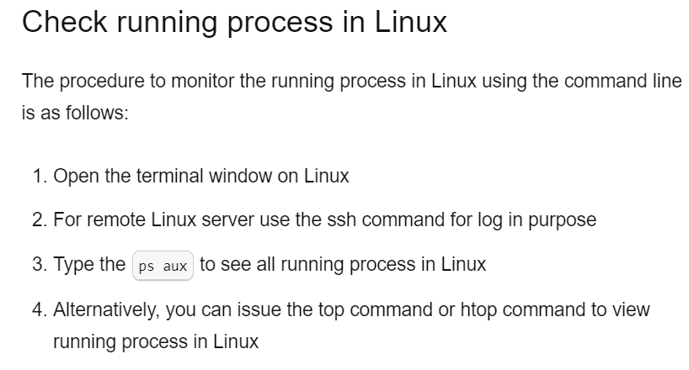

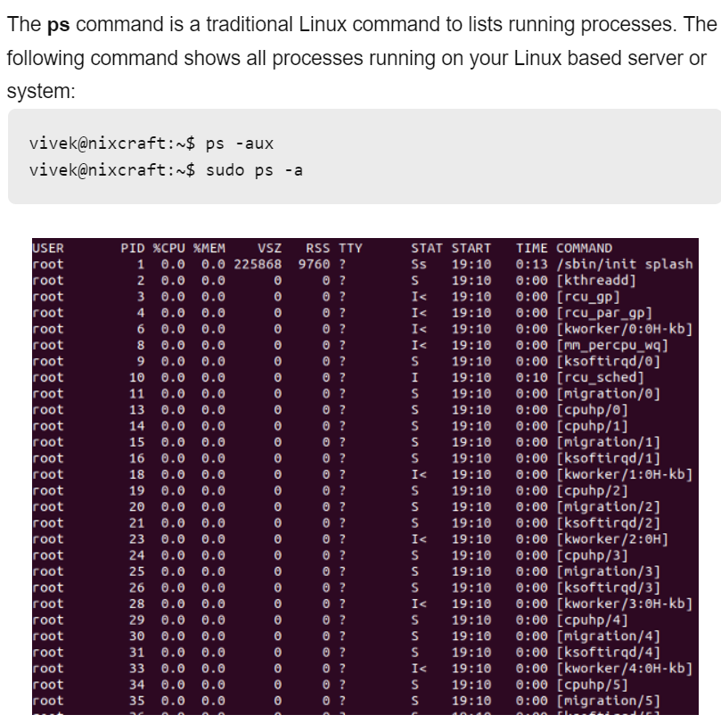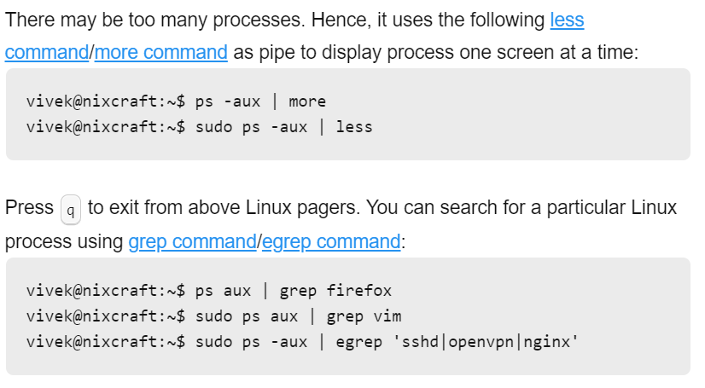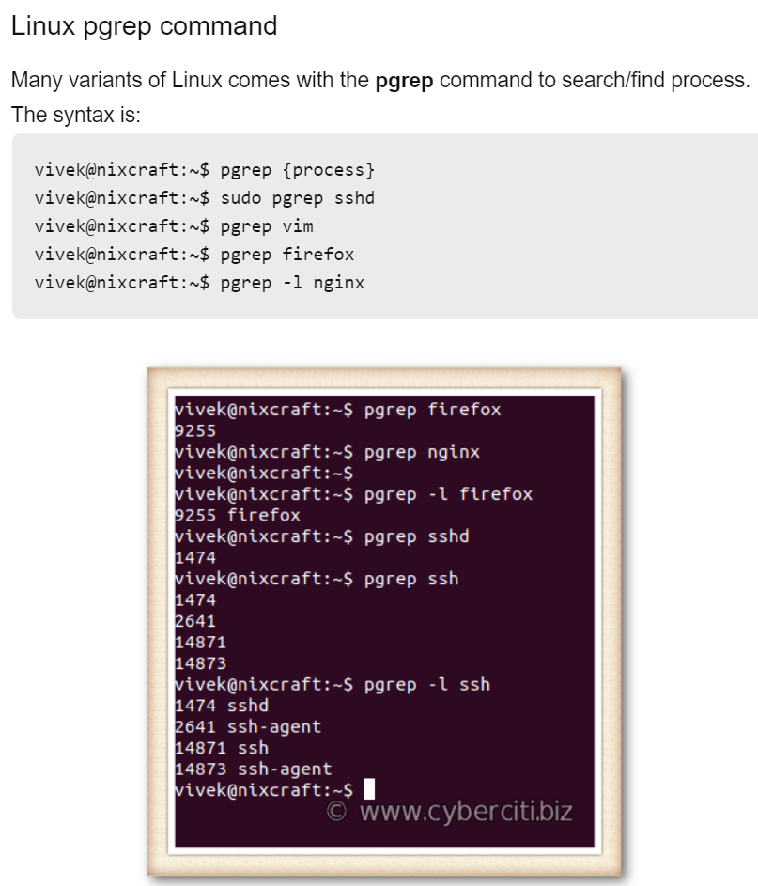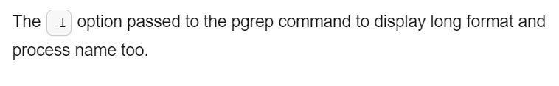

1. Open files.

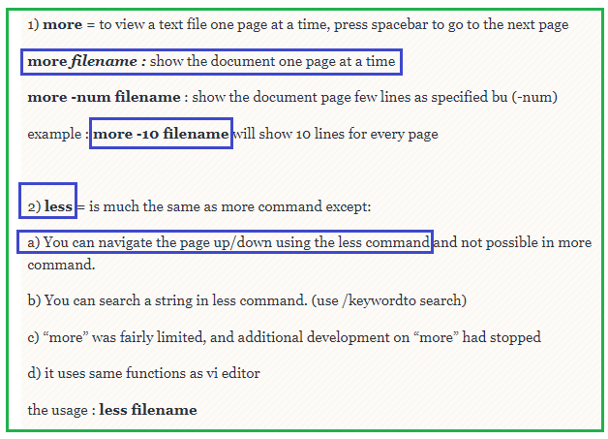

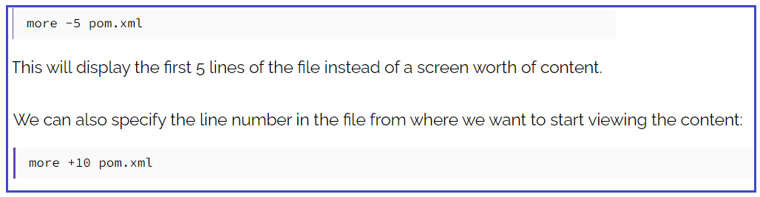

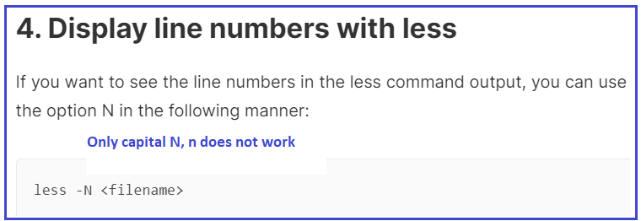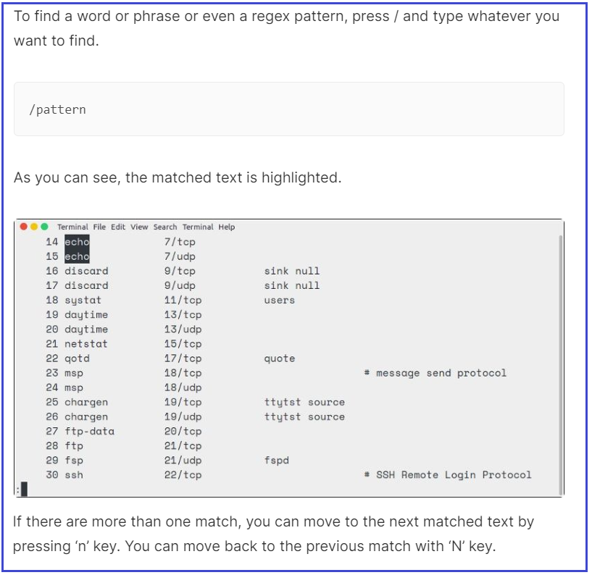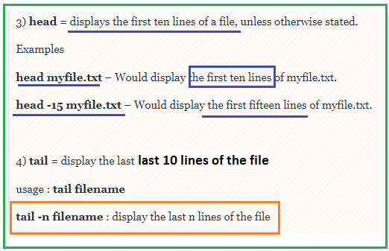

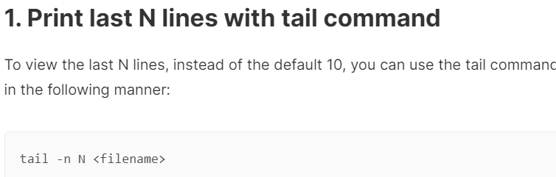

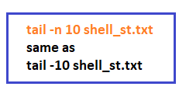

tail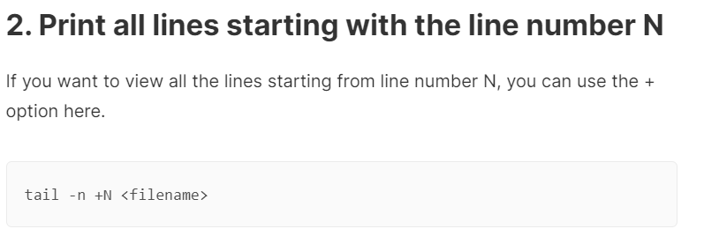

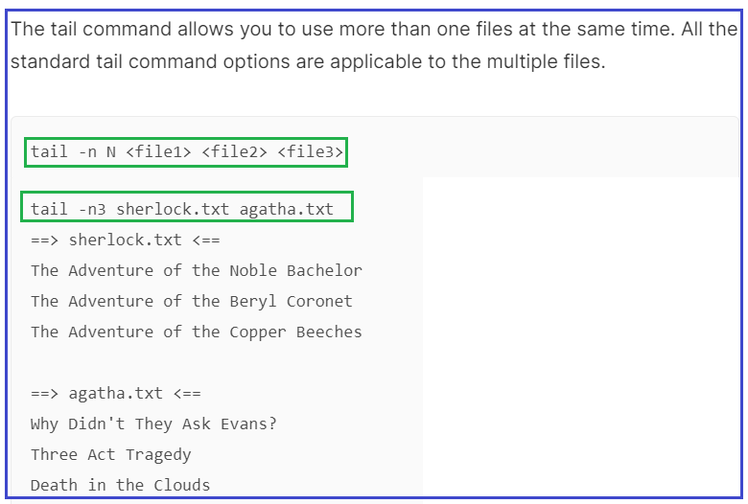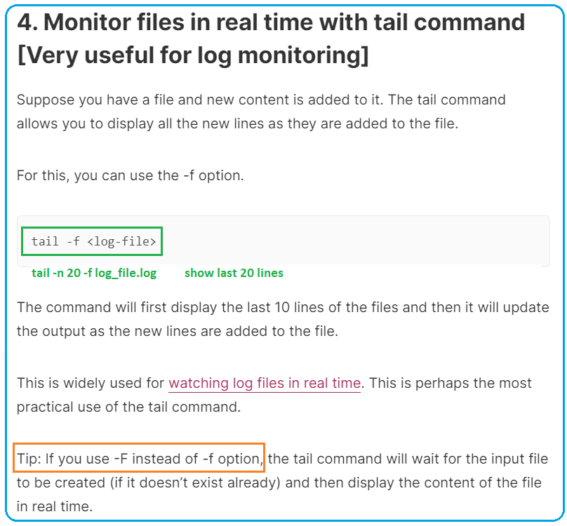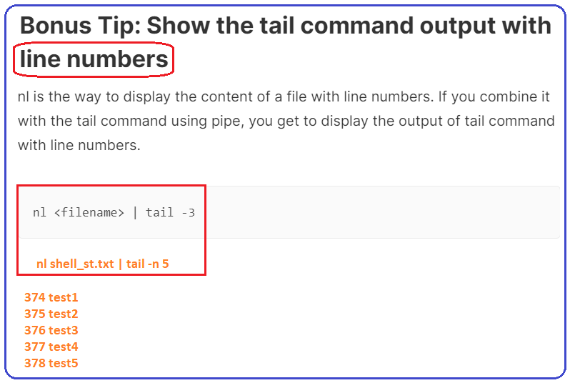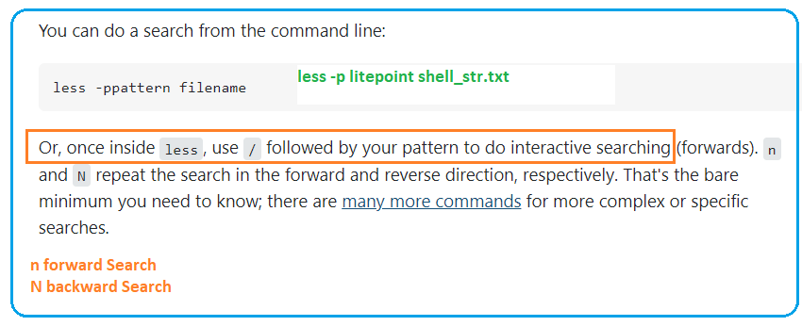

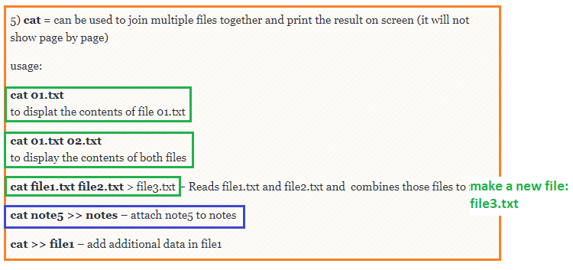

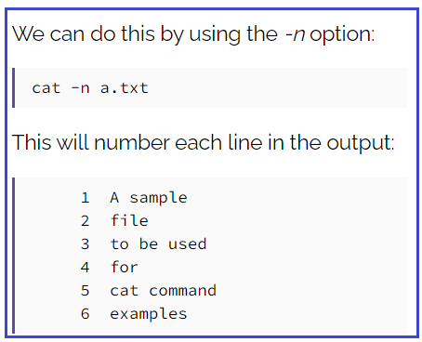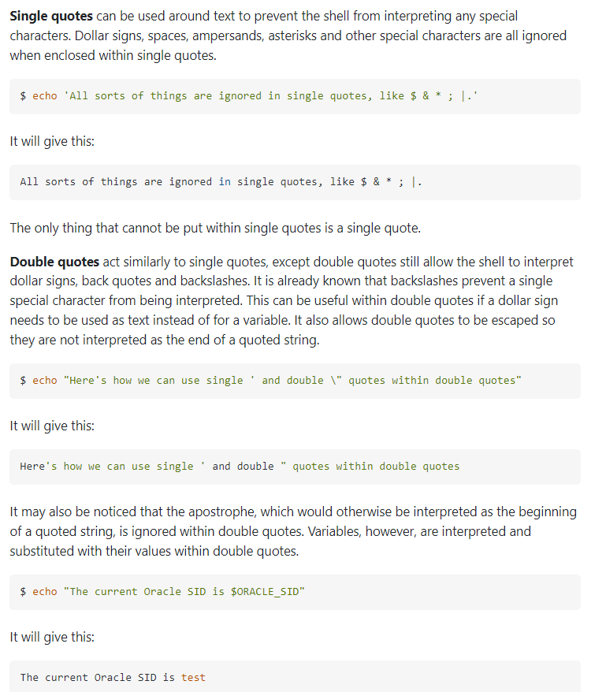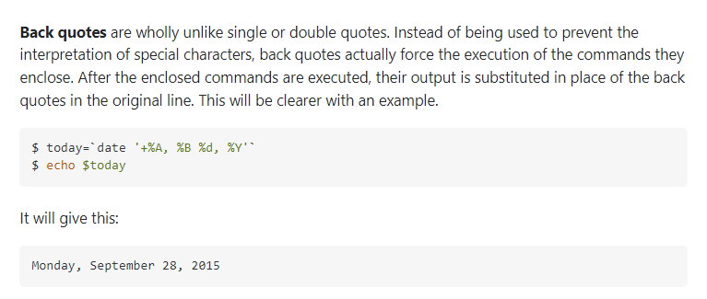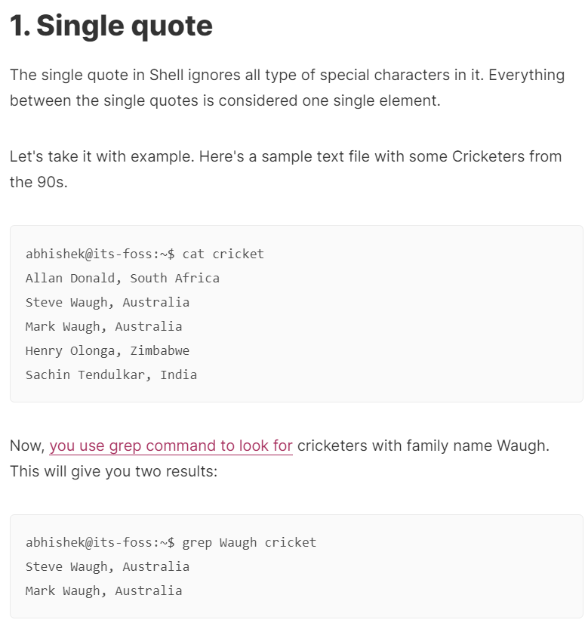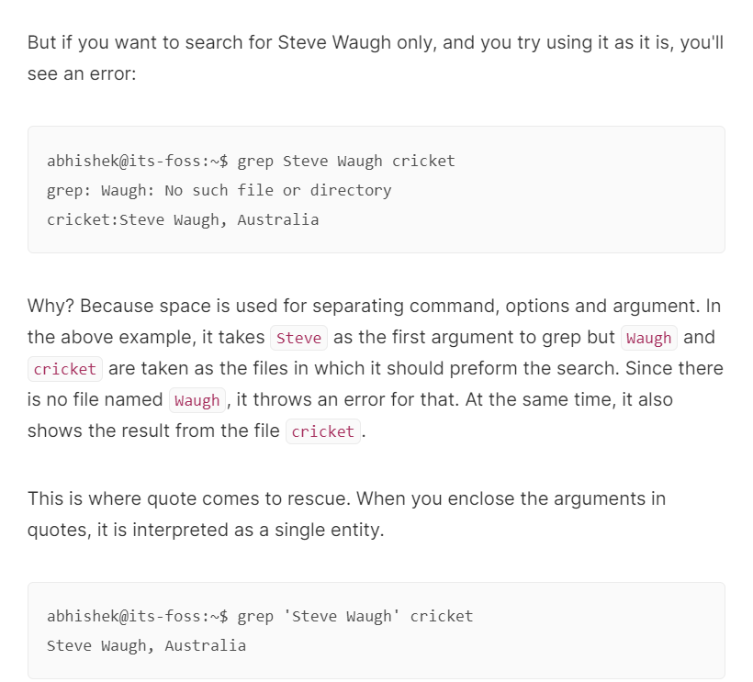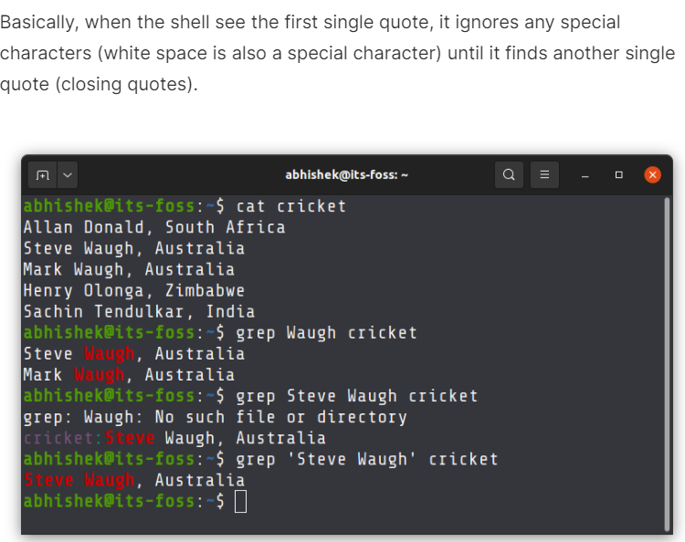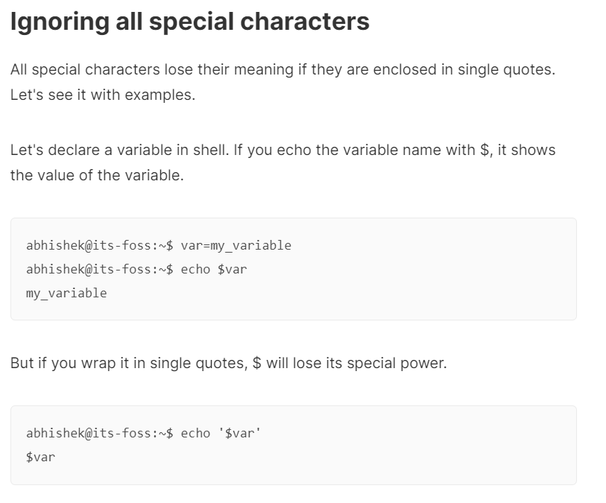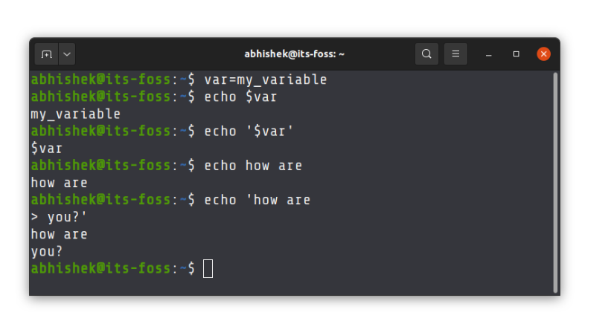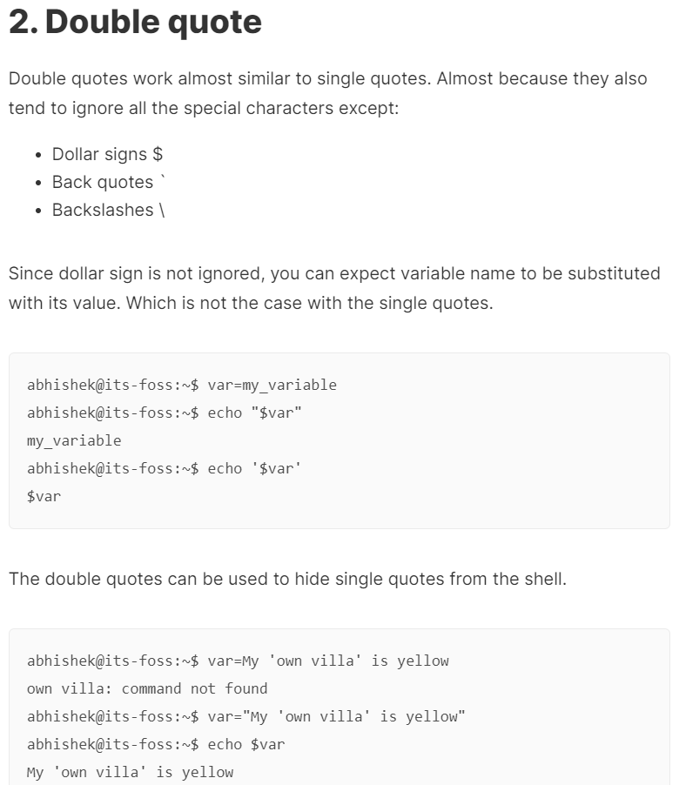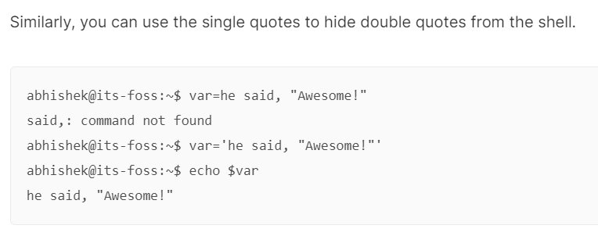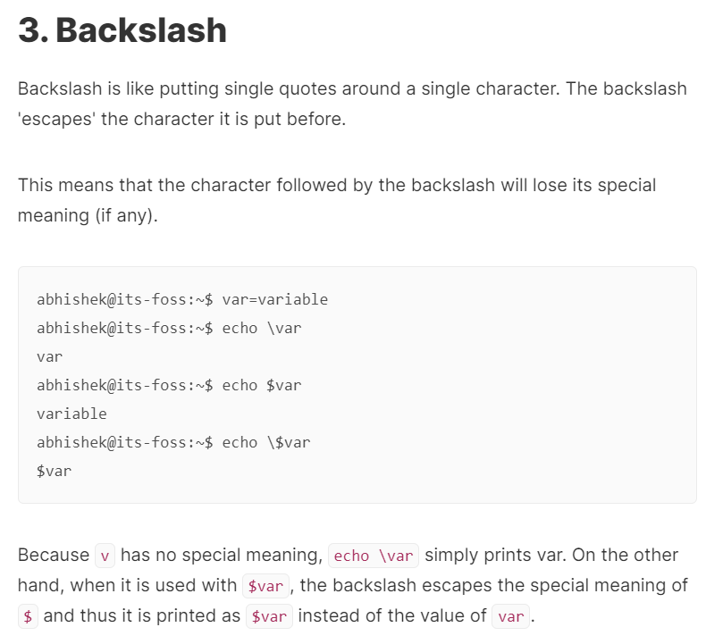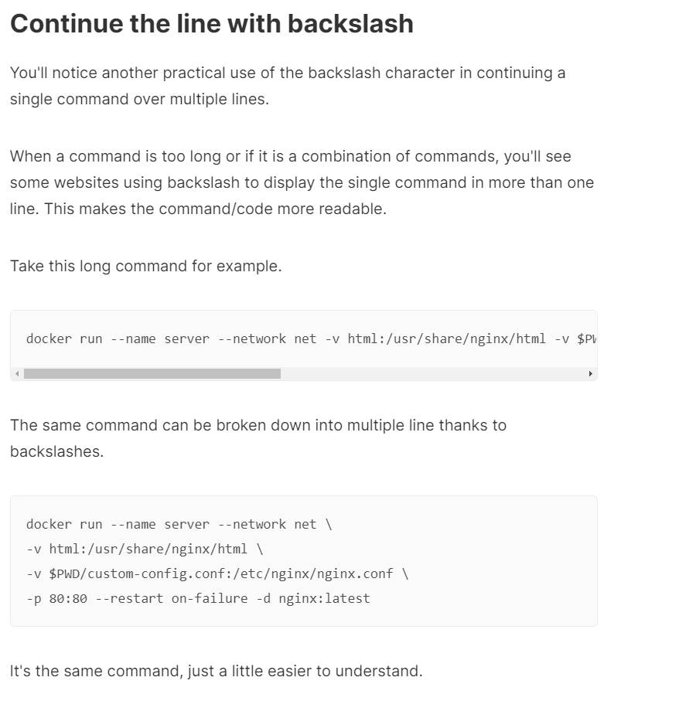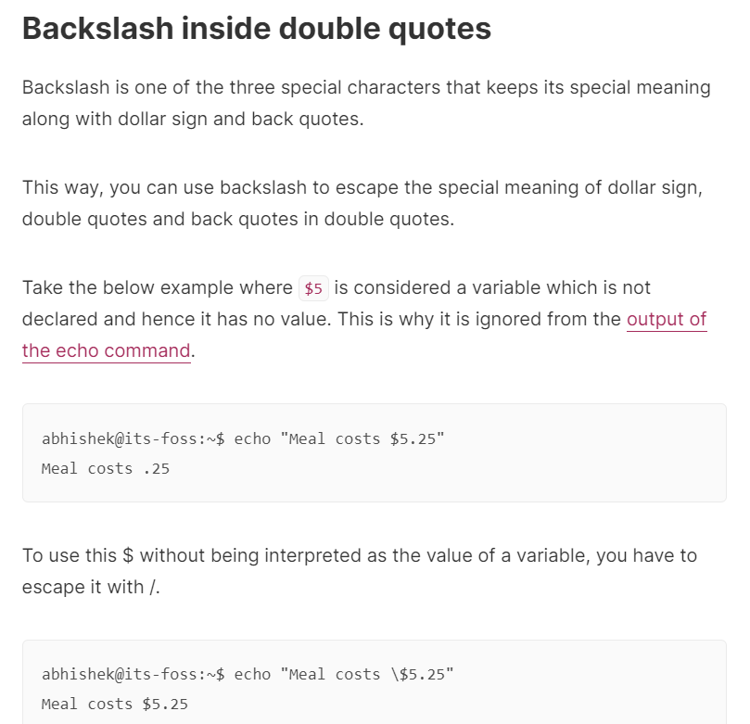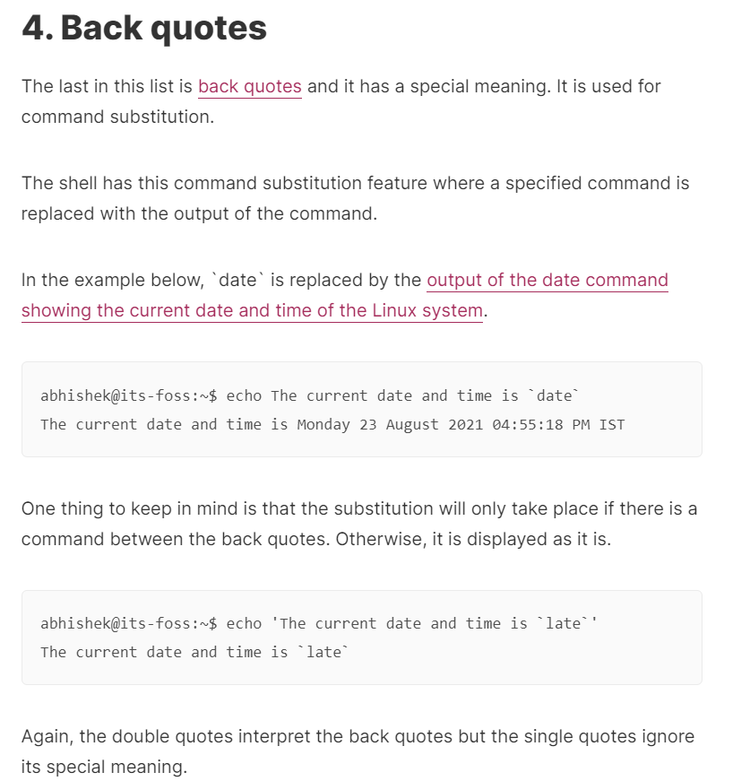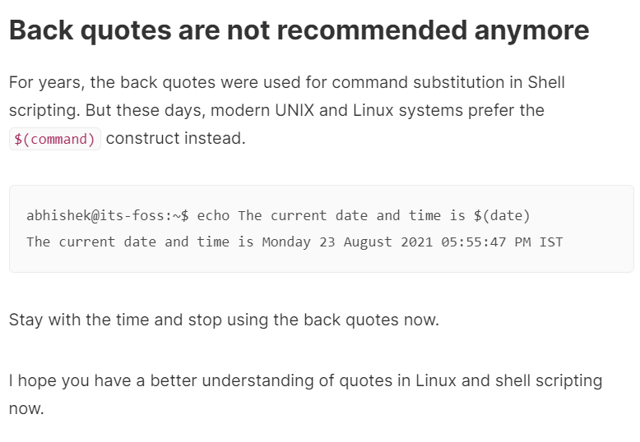

1. **Grep**

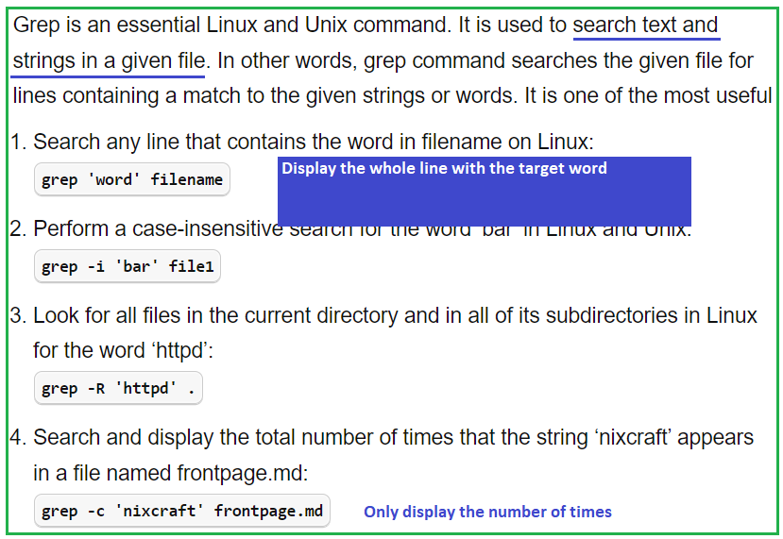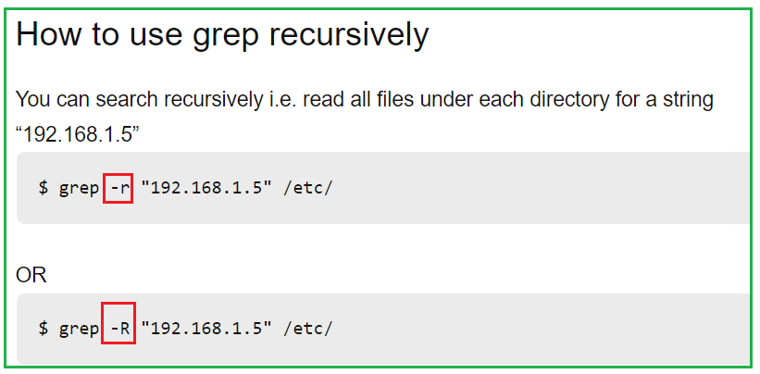

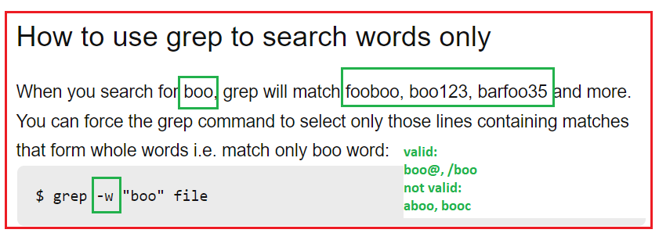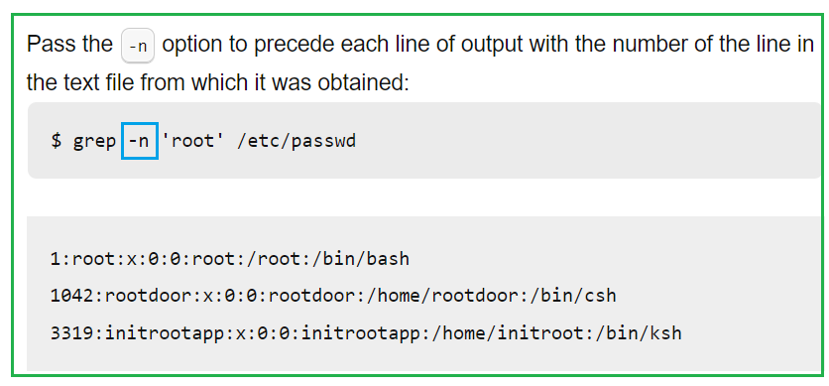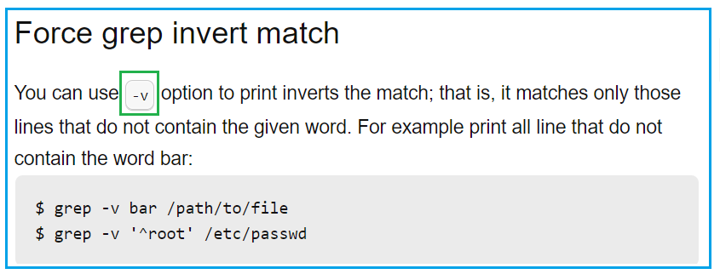

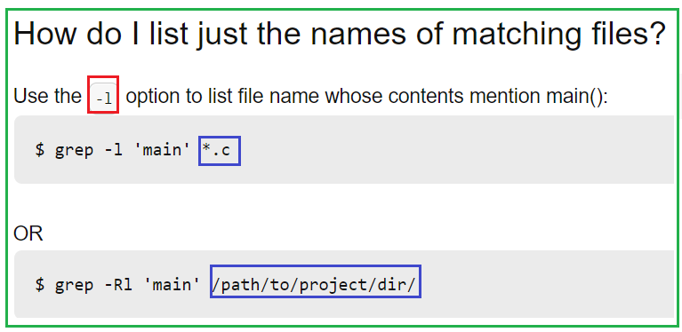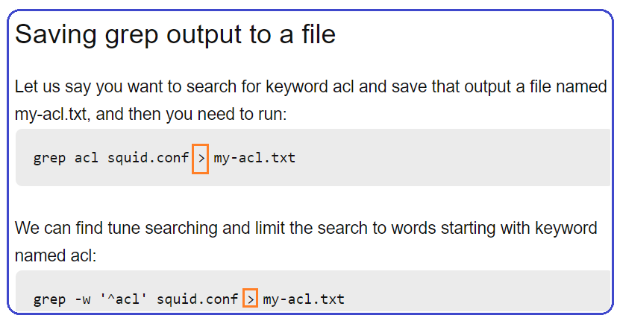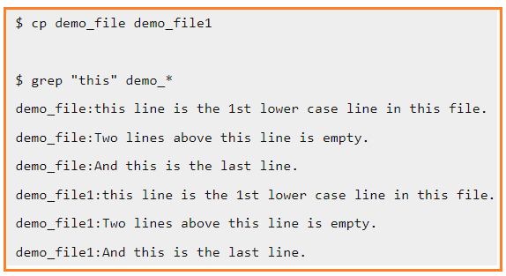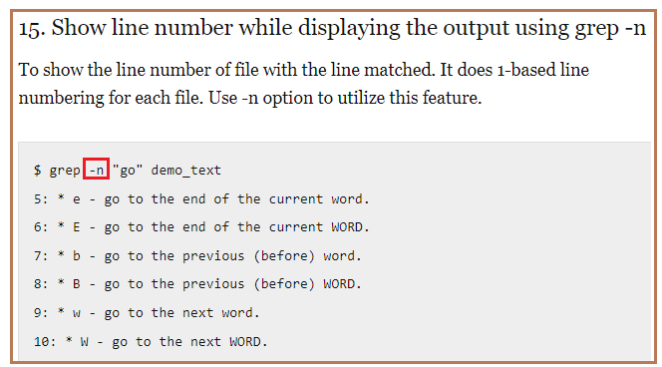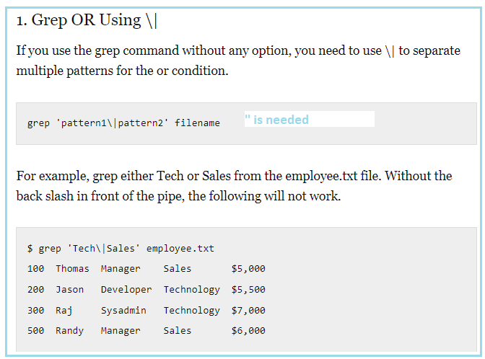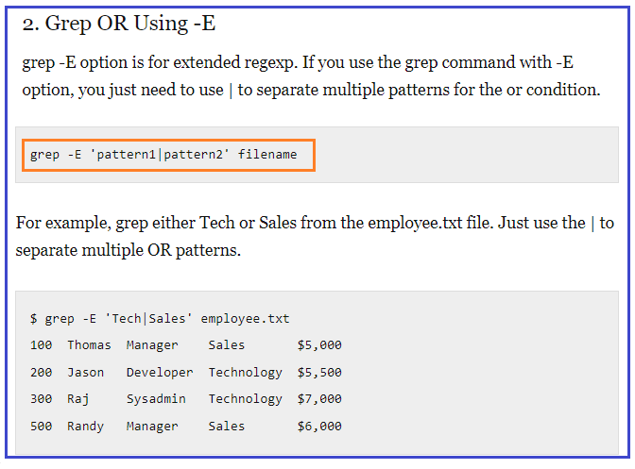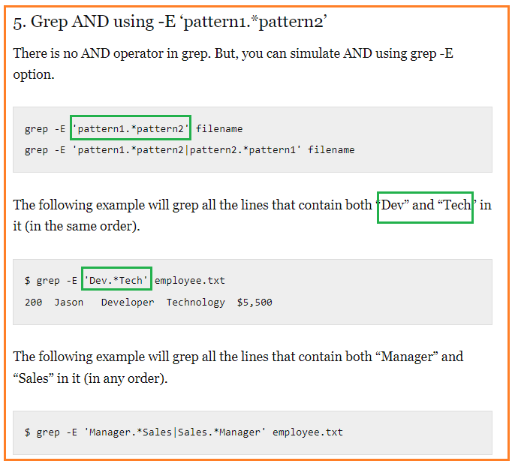

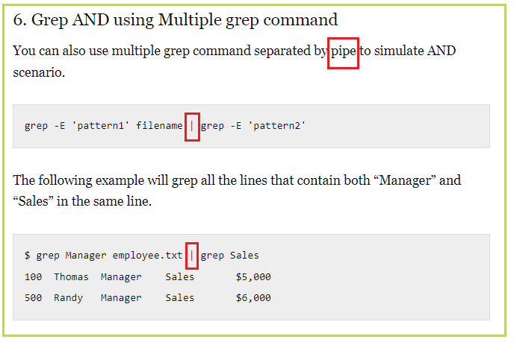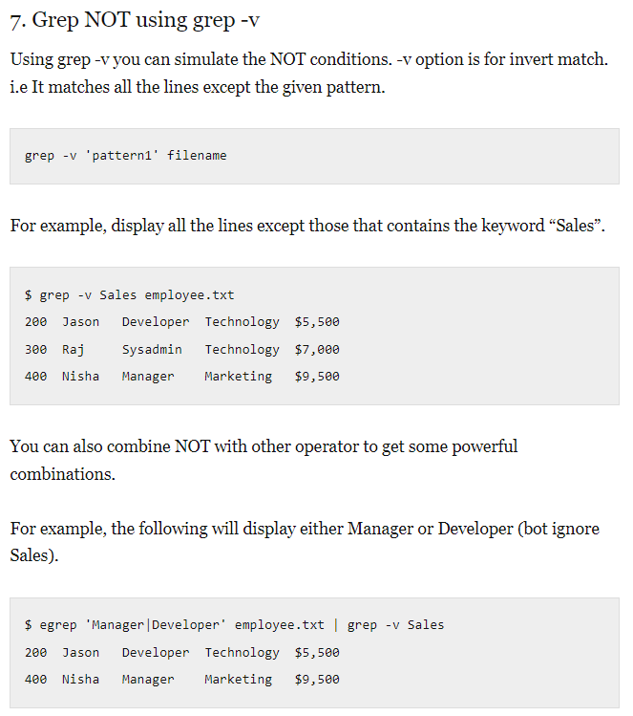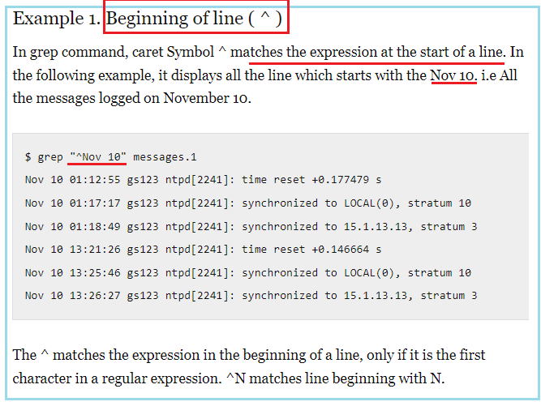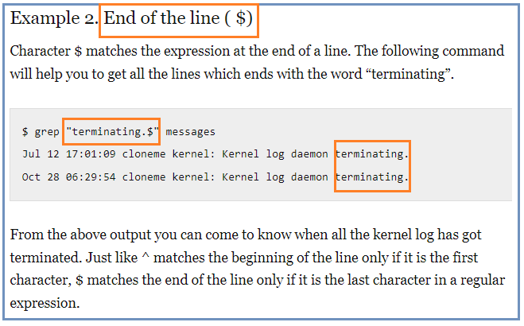

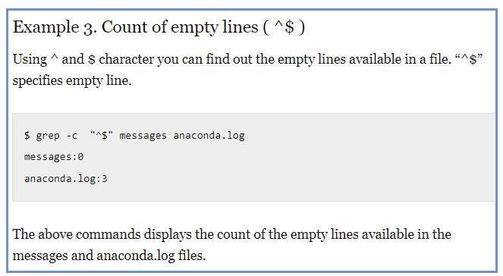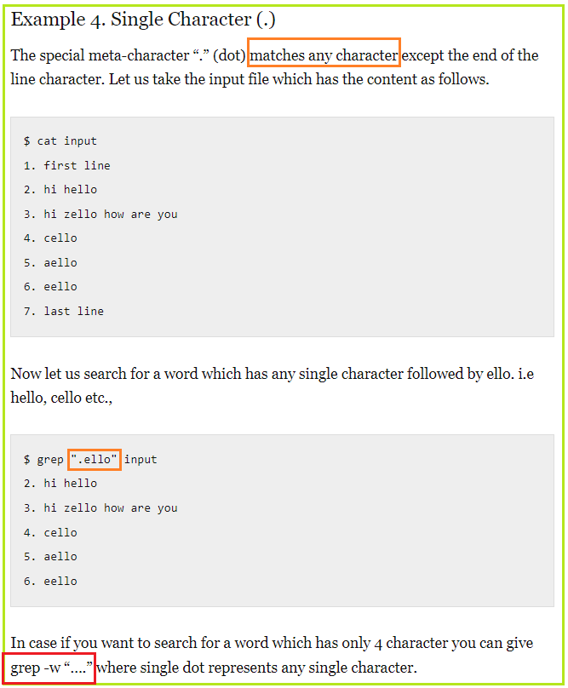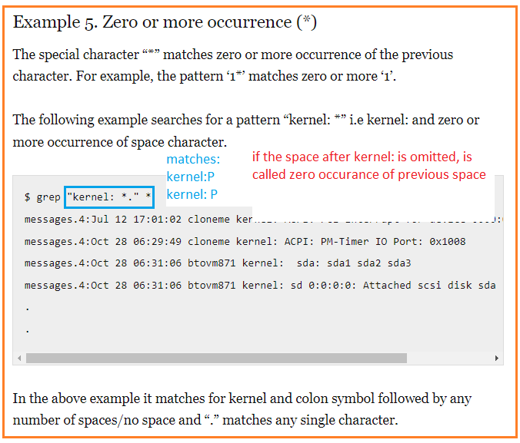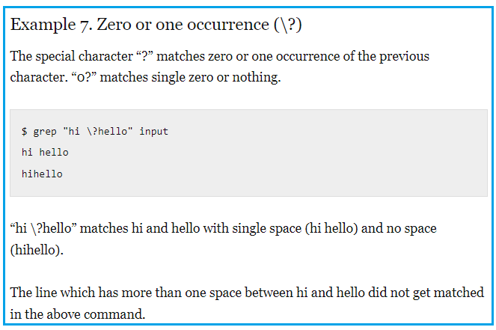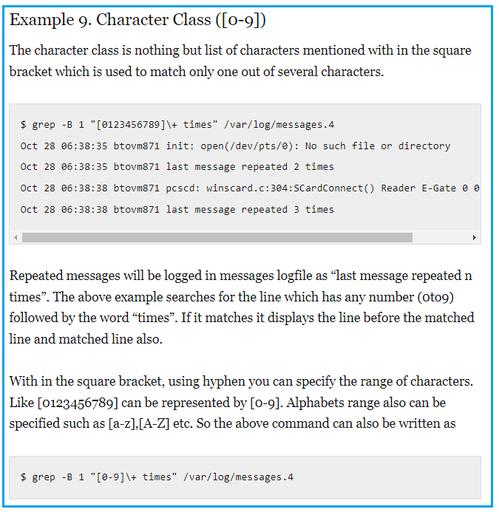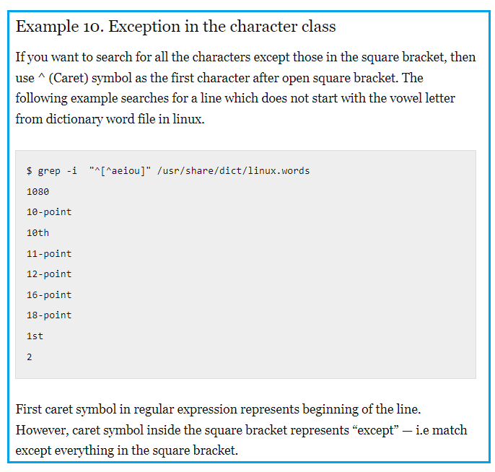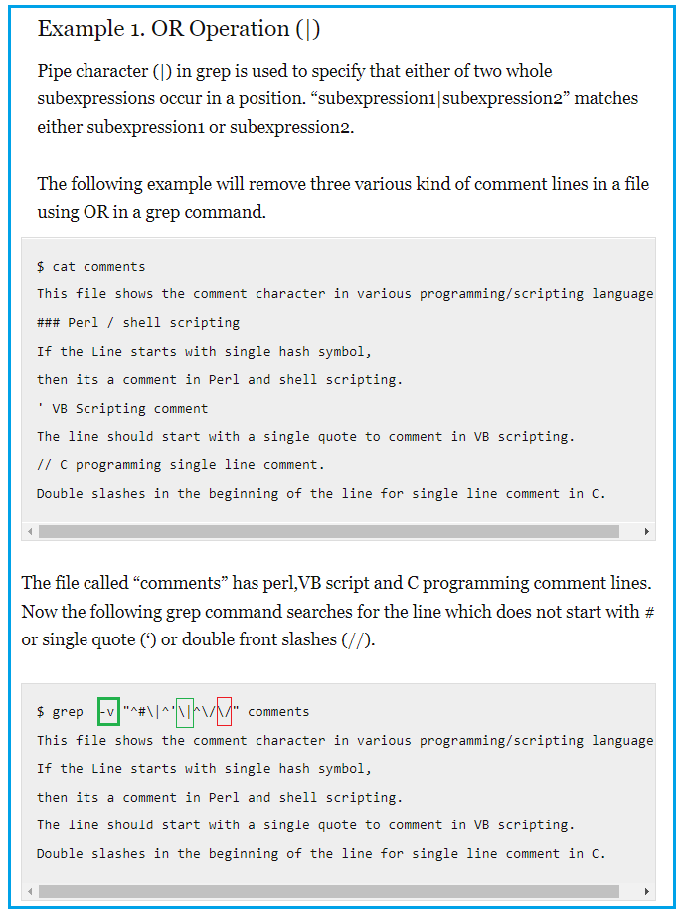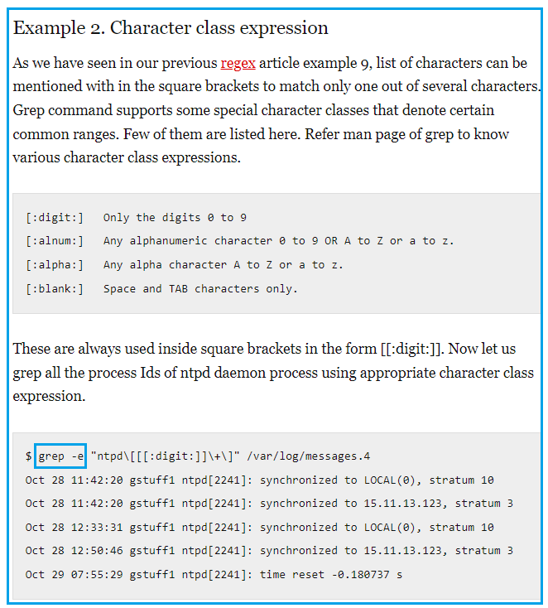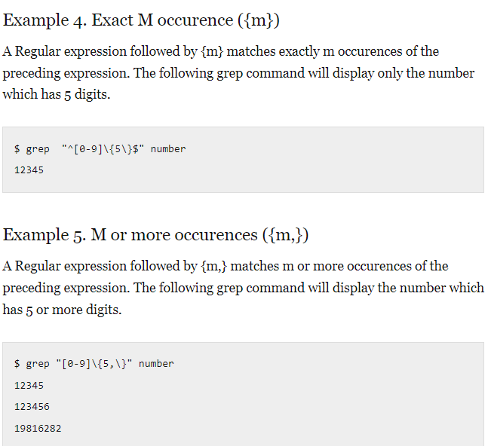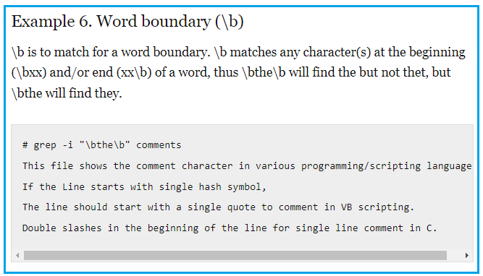

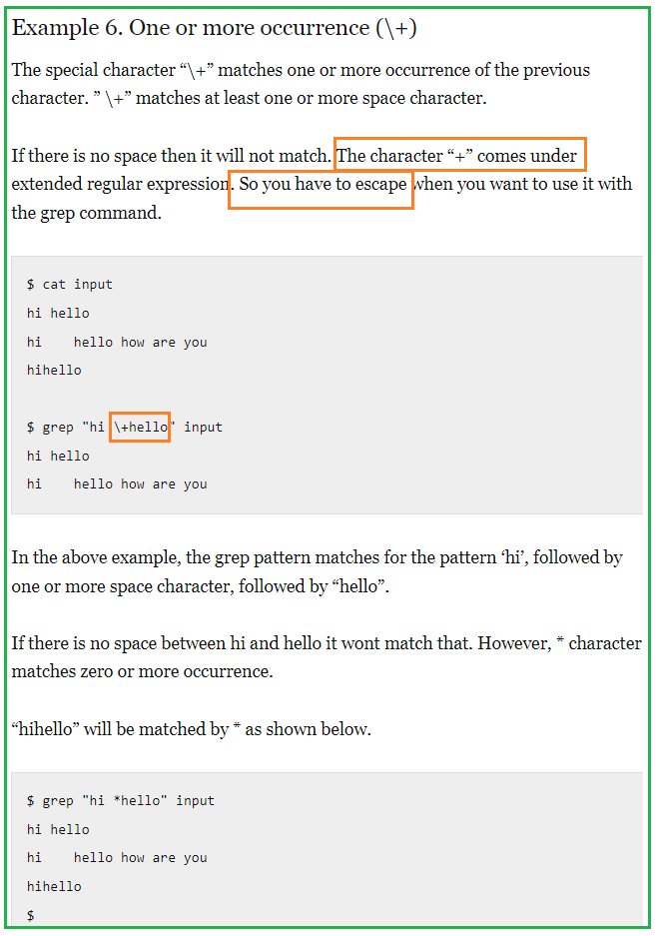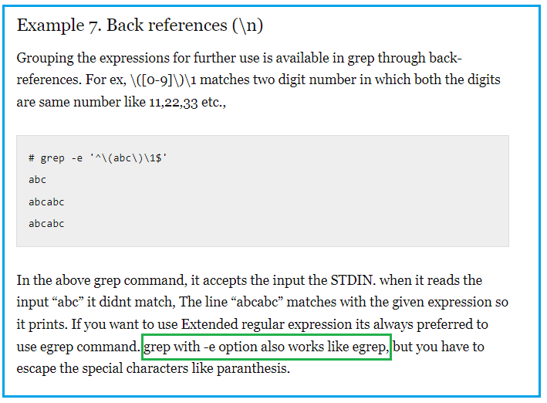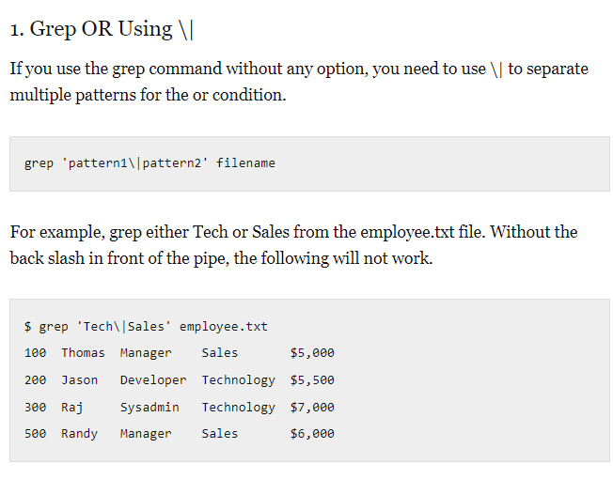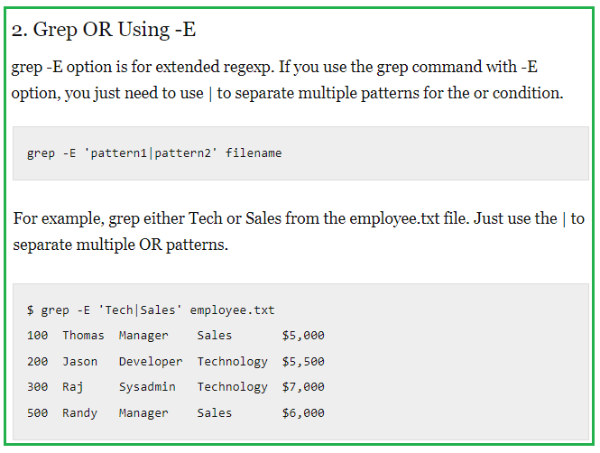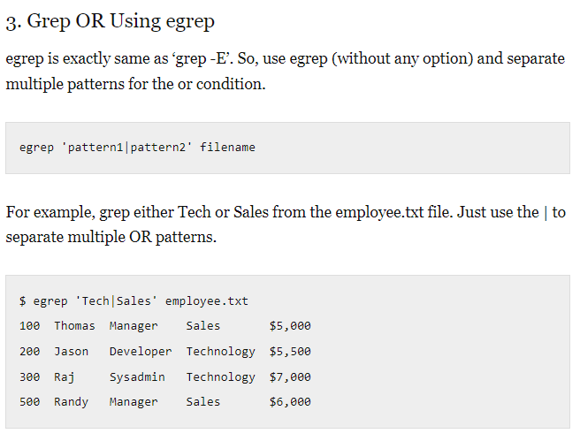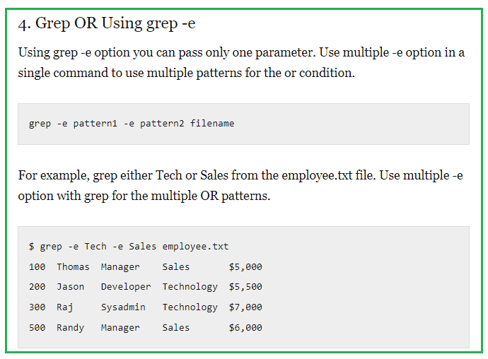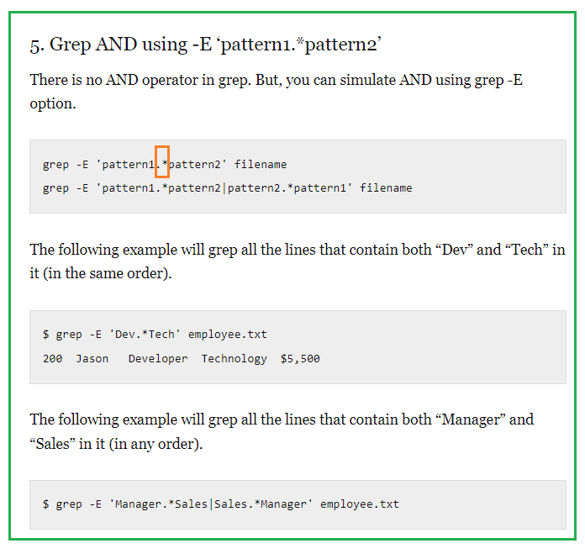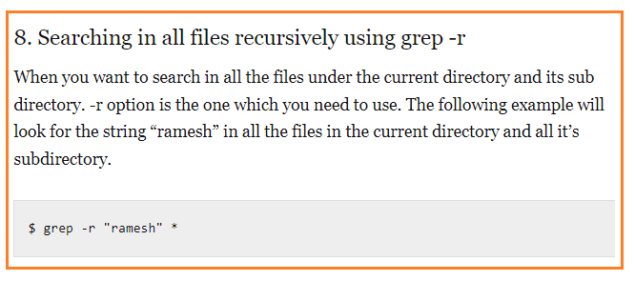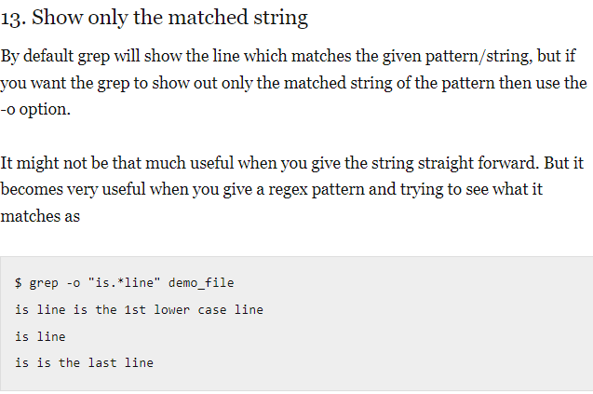

1. **Find**

The find command is used to search and [locate the list of files and directories](https://www.tecmint.com/install-locate-command-to-find-files-in-centos/) based on conditions you specify for files that match the arguments.

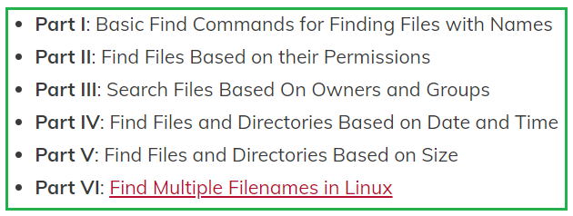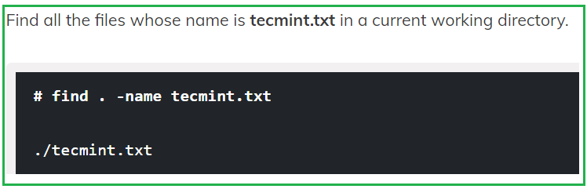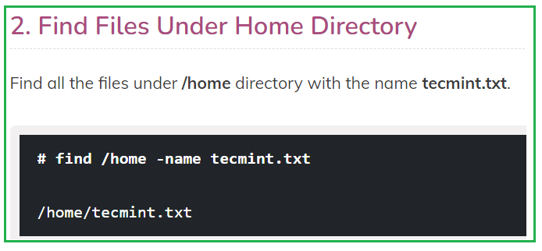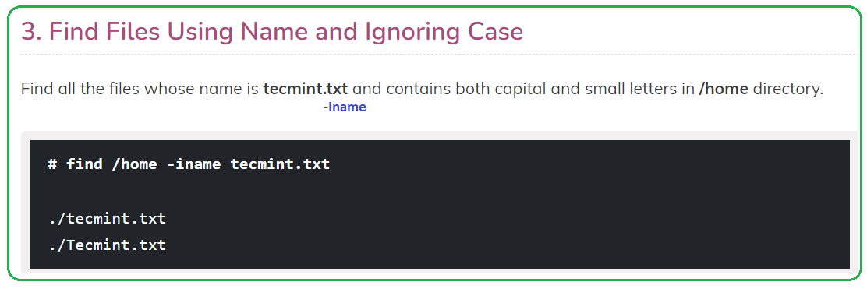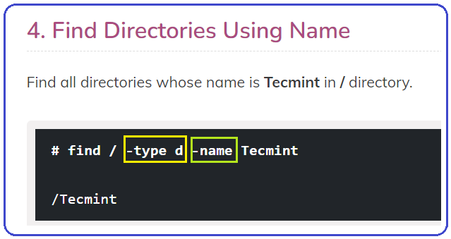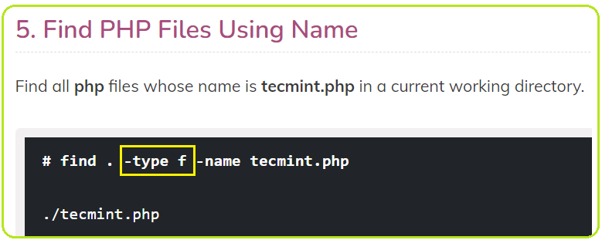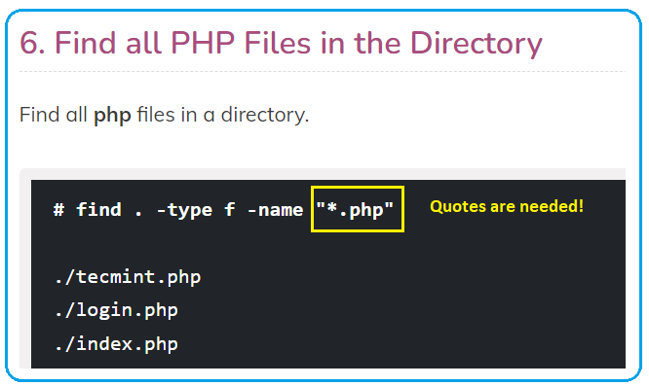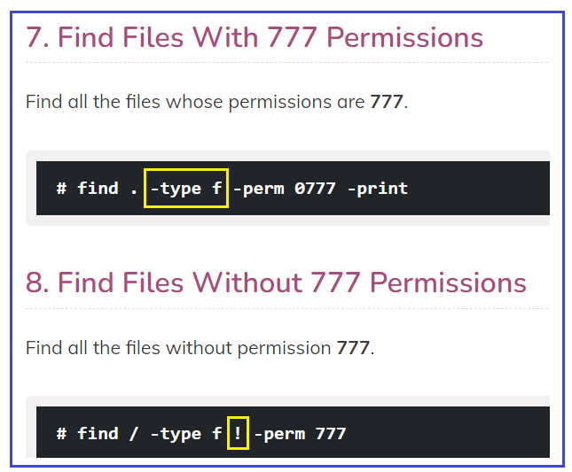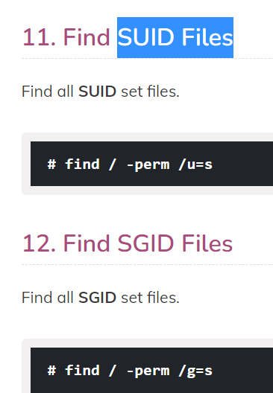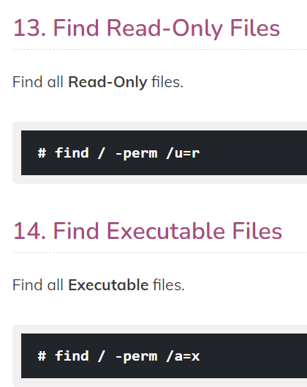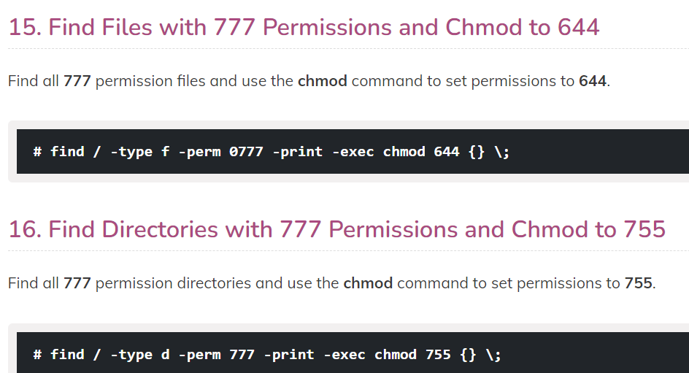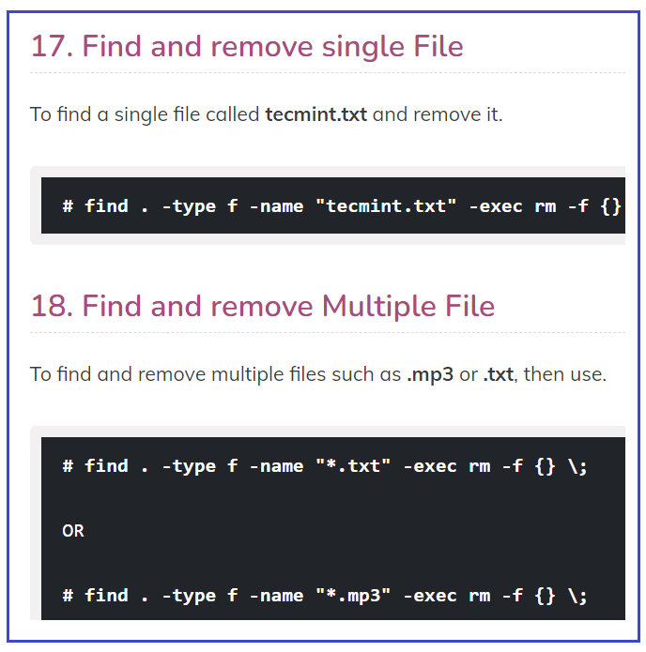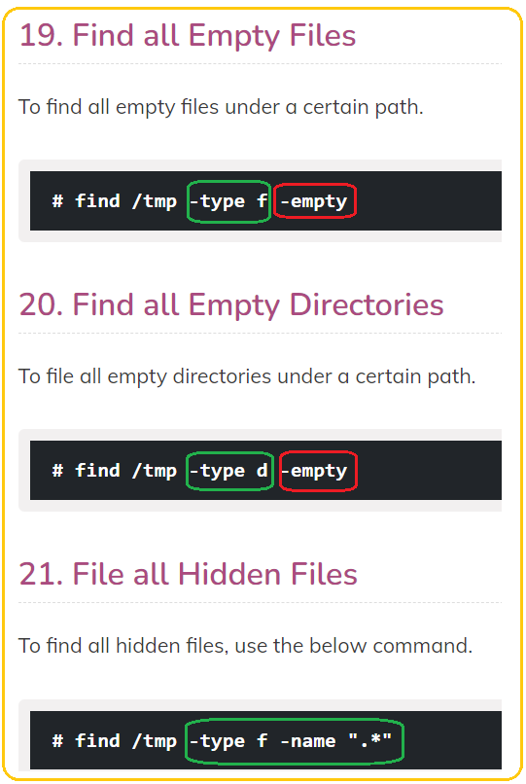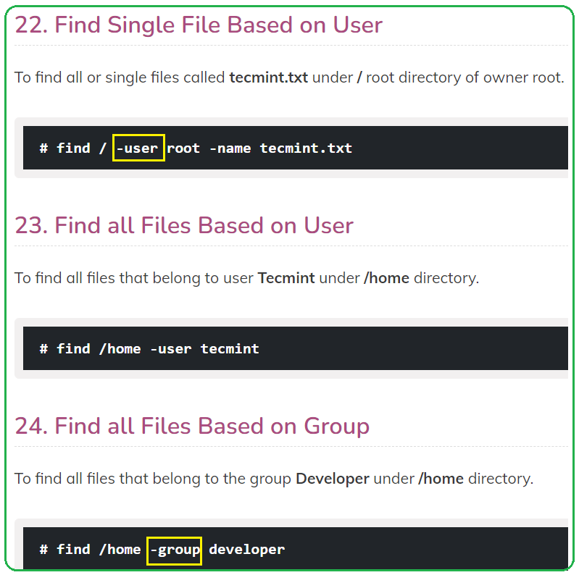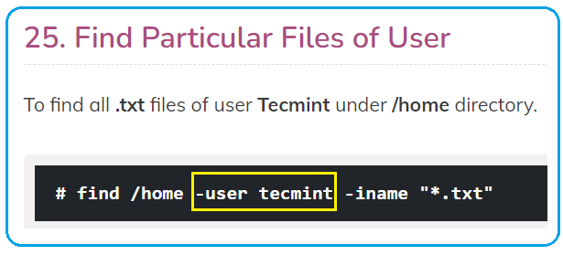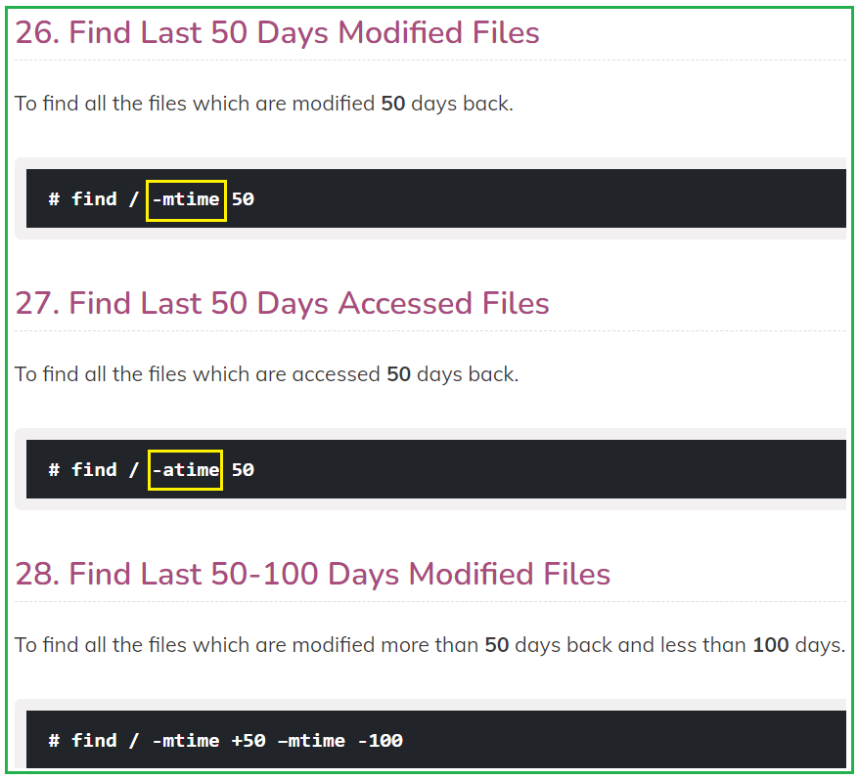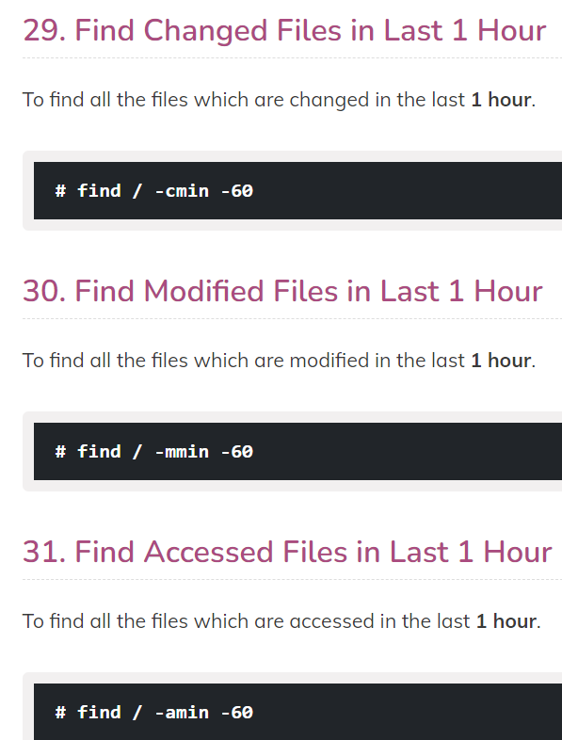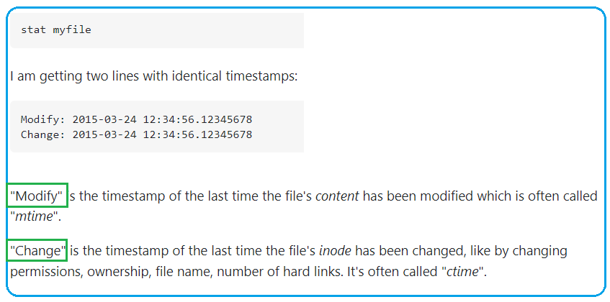

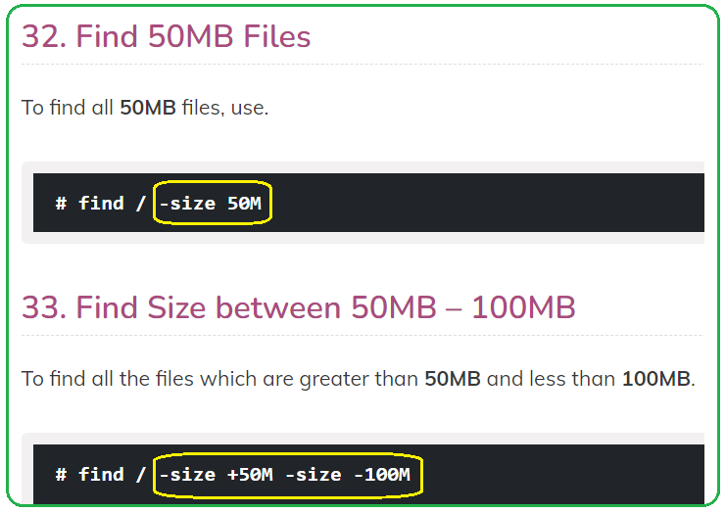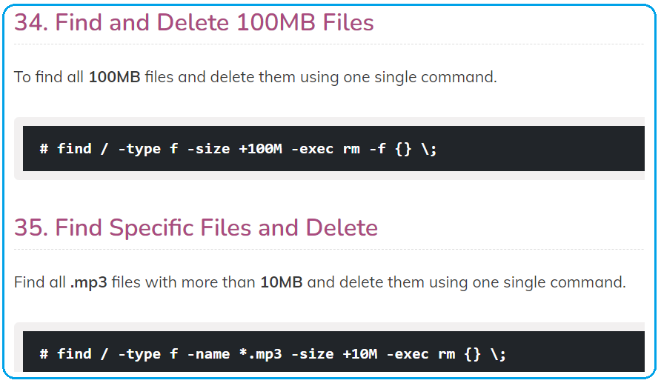

1. **touch**

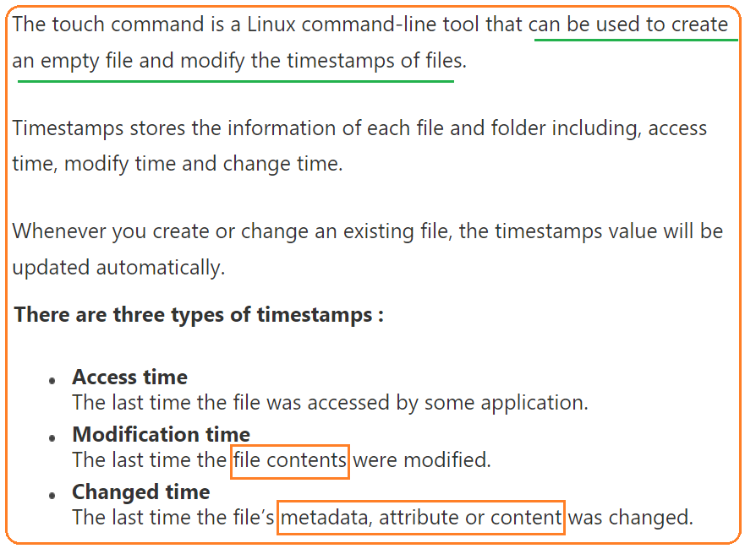

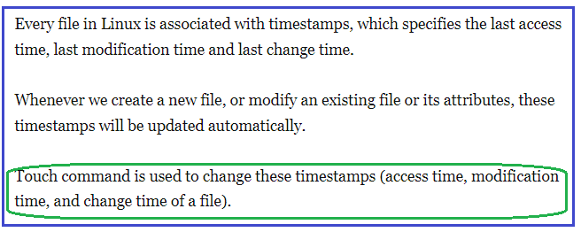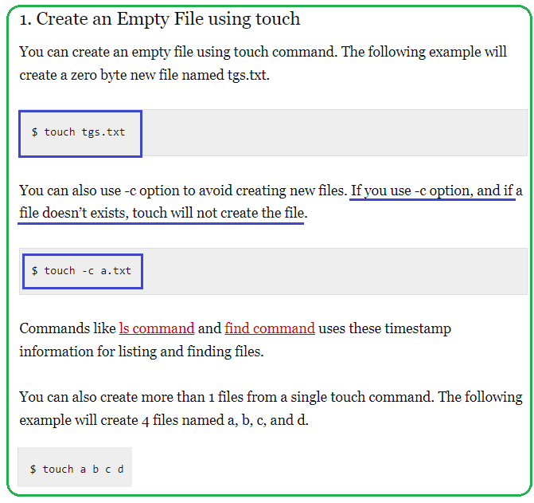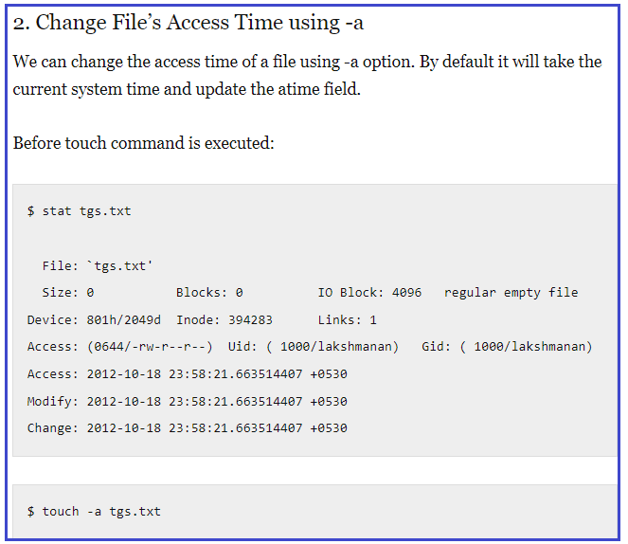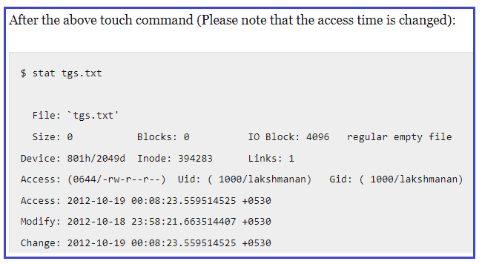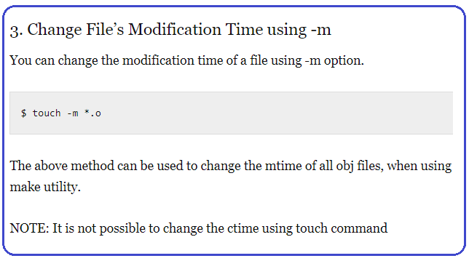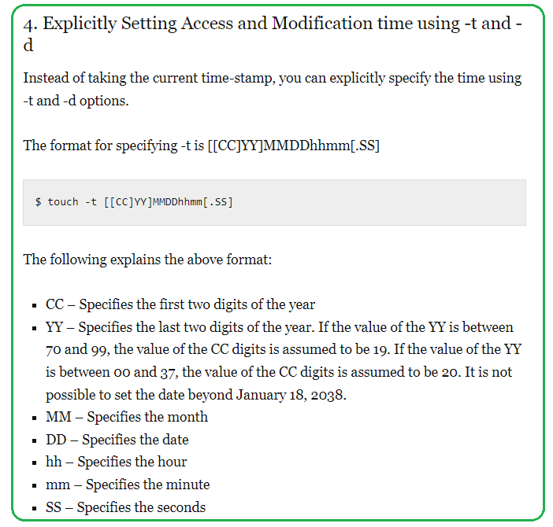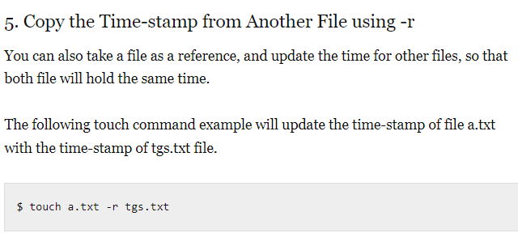

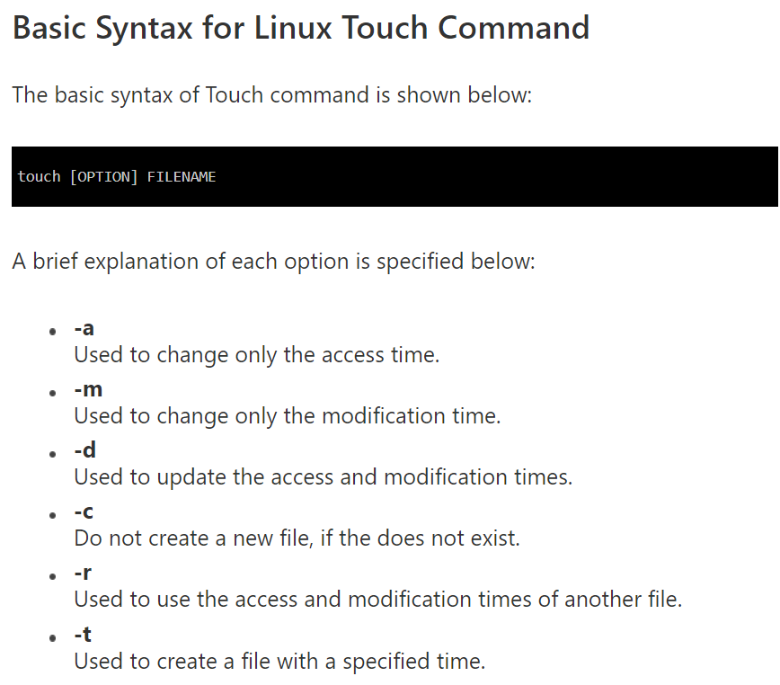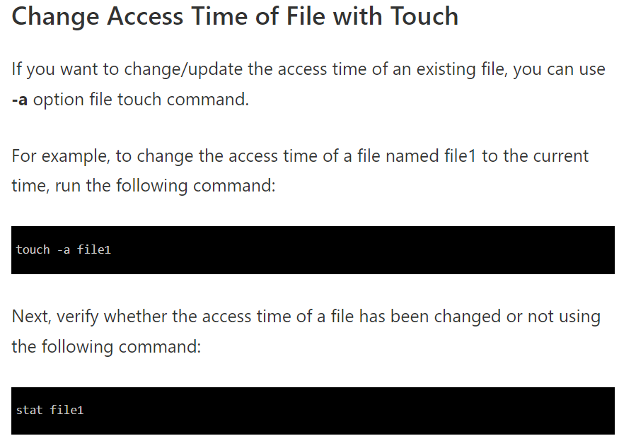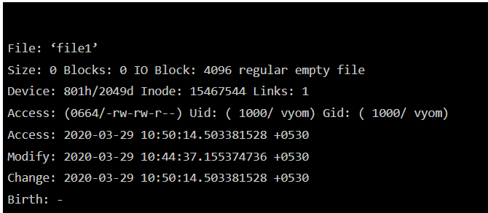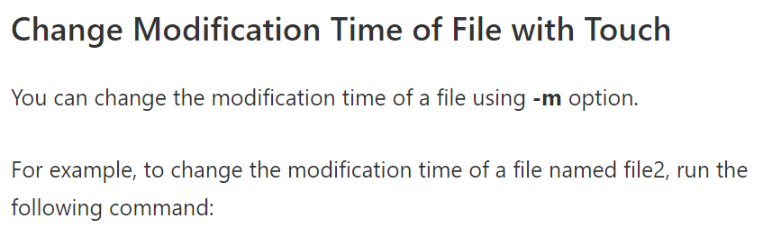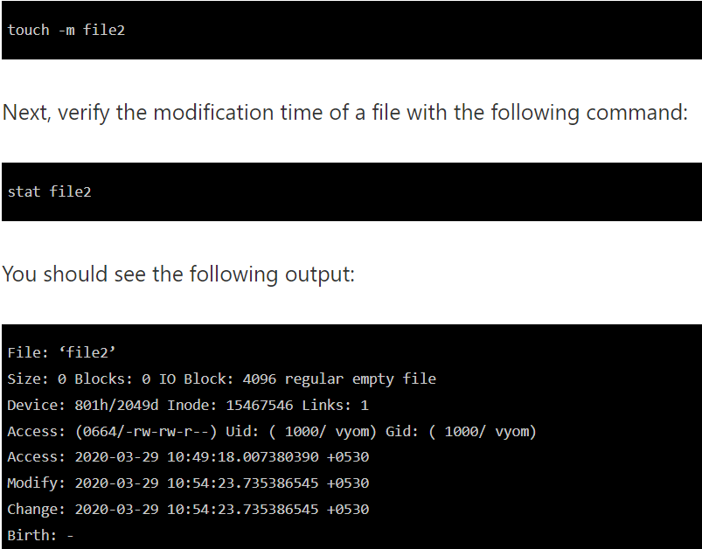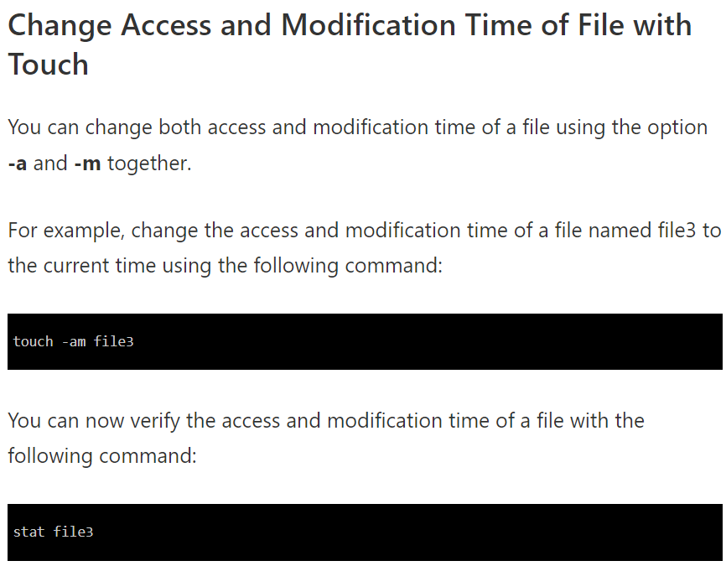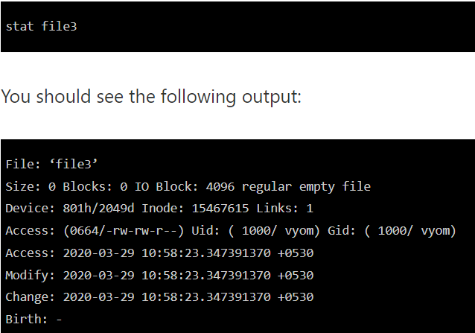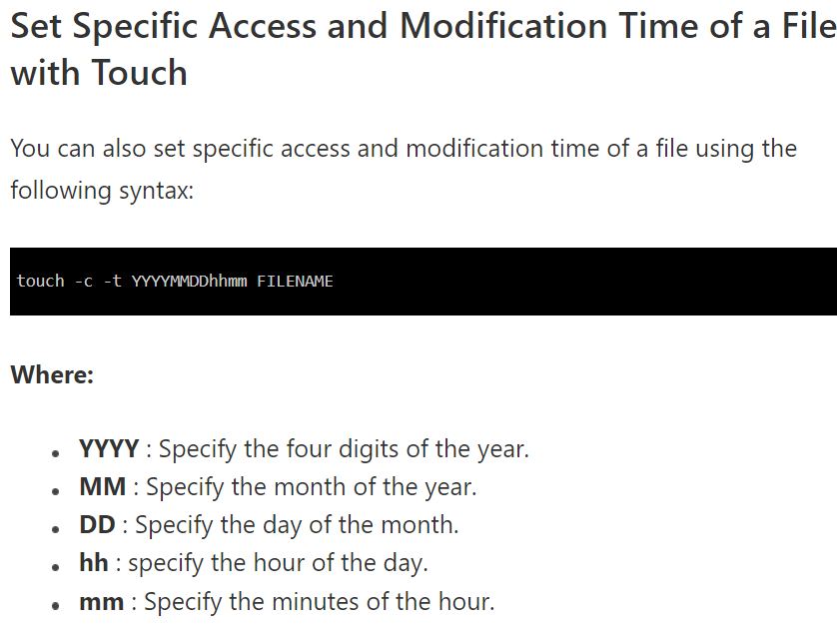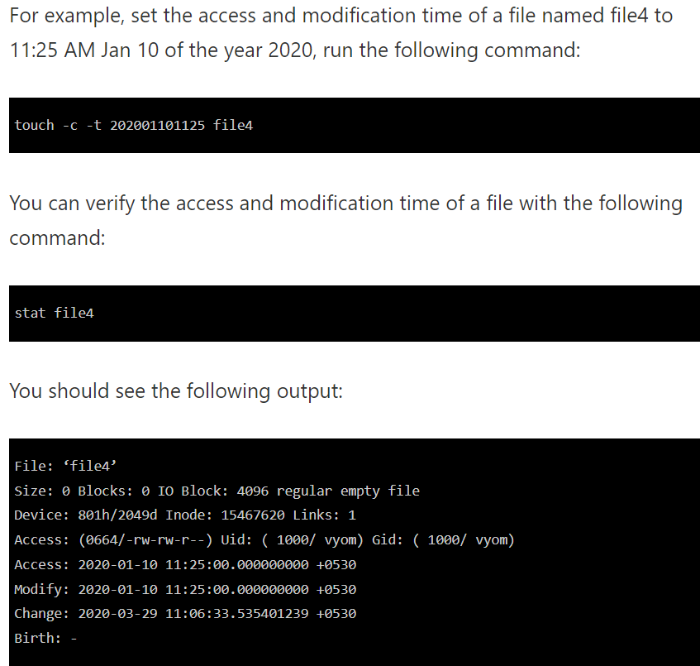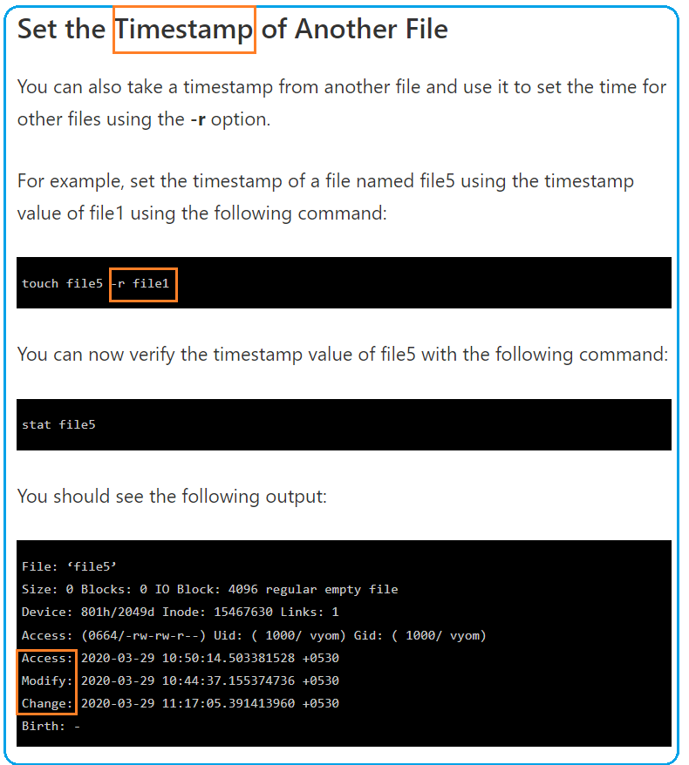

1. **crontab scheduling**

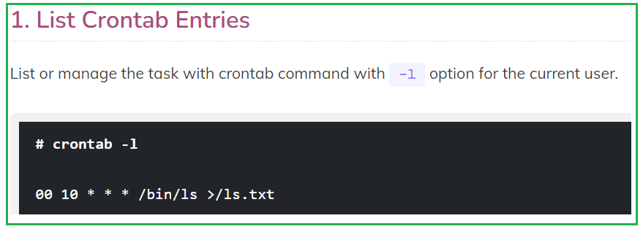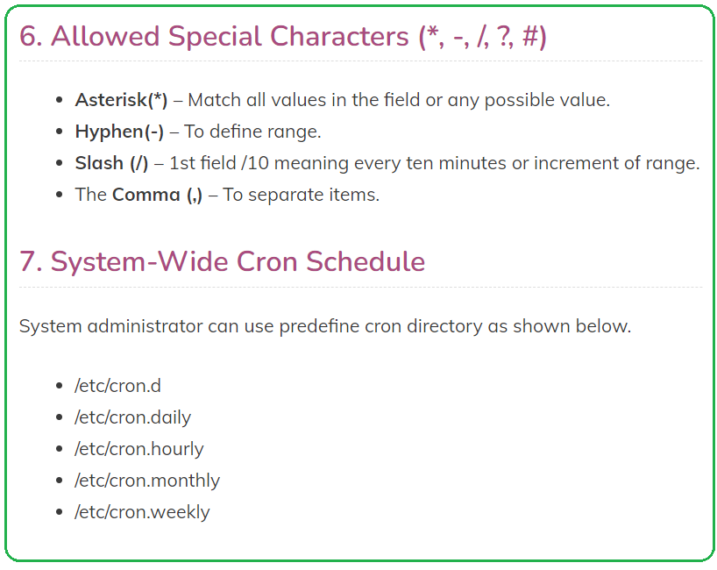 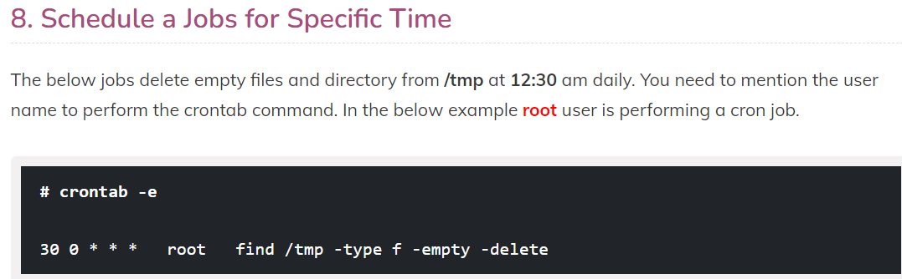

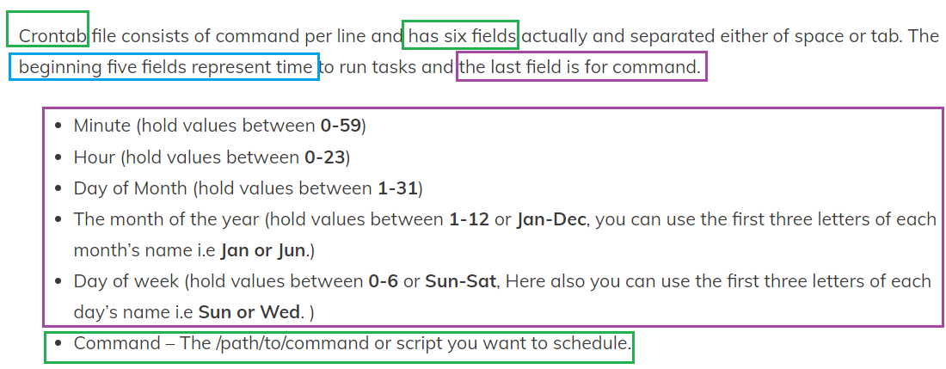 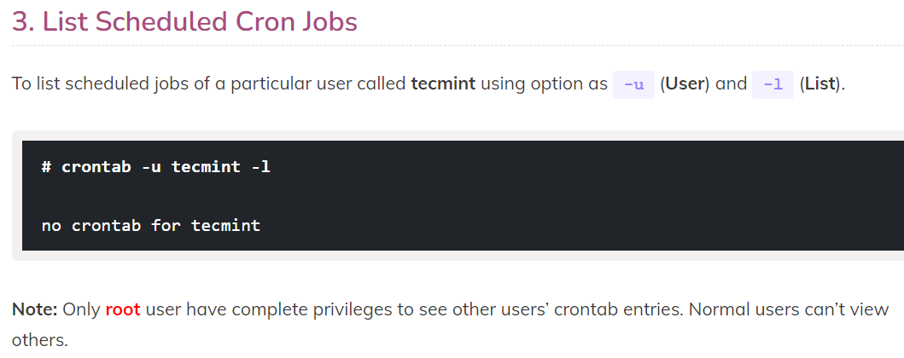 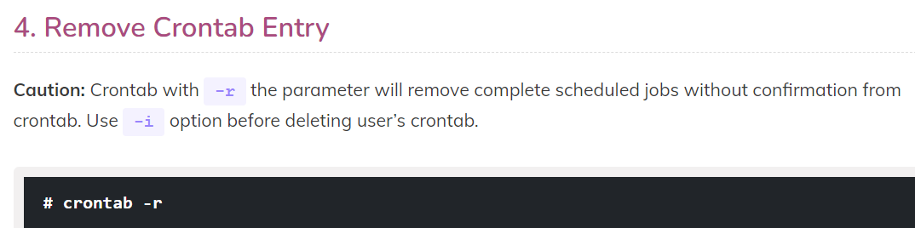 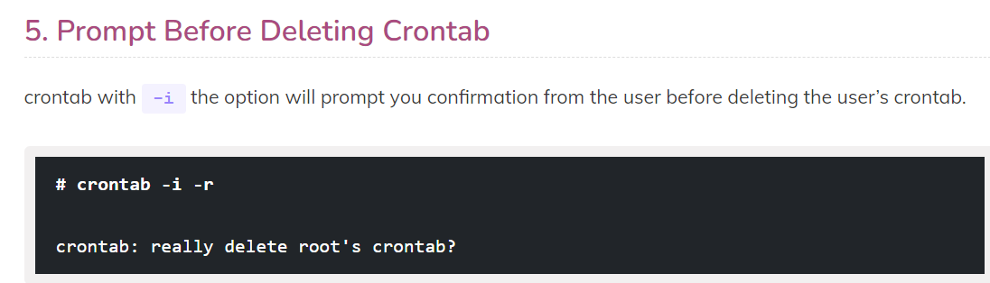

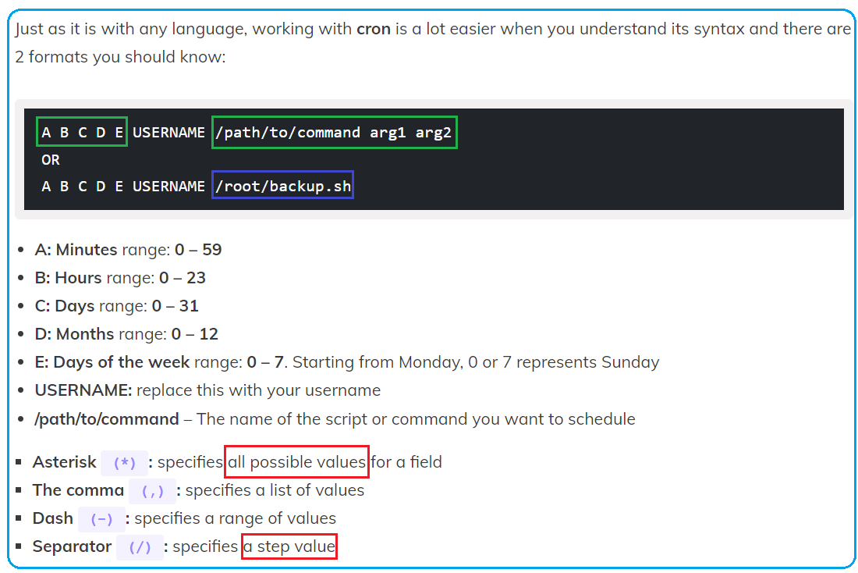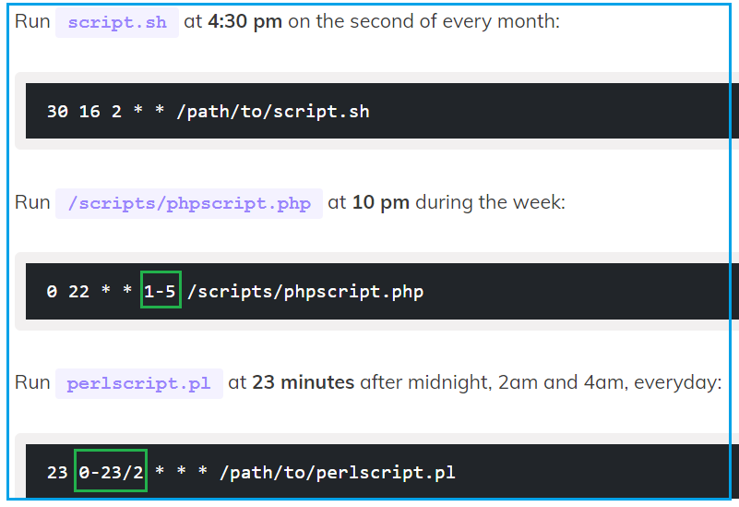 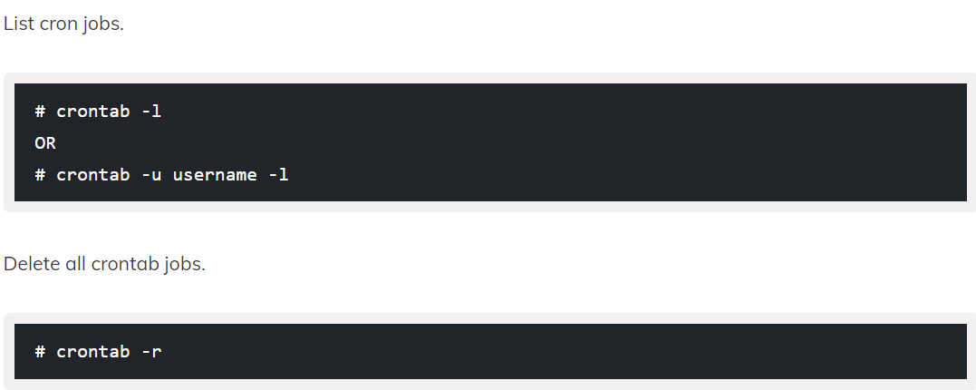 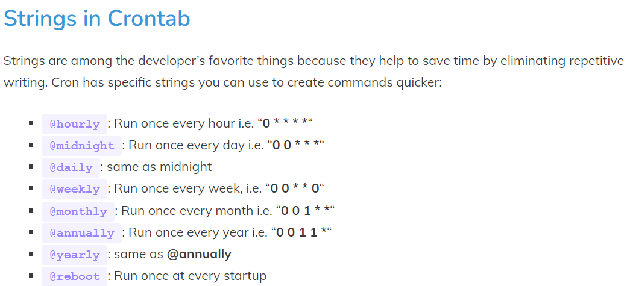

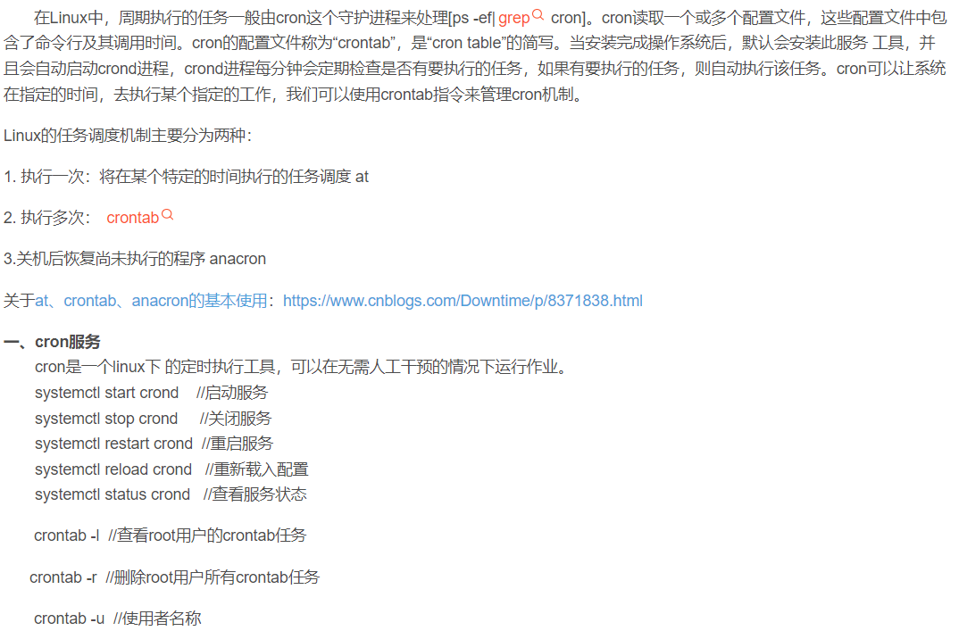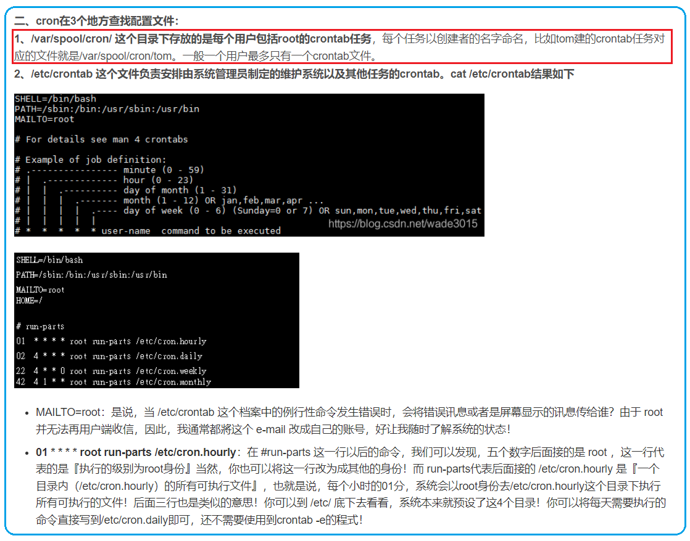  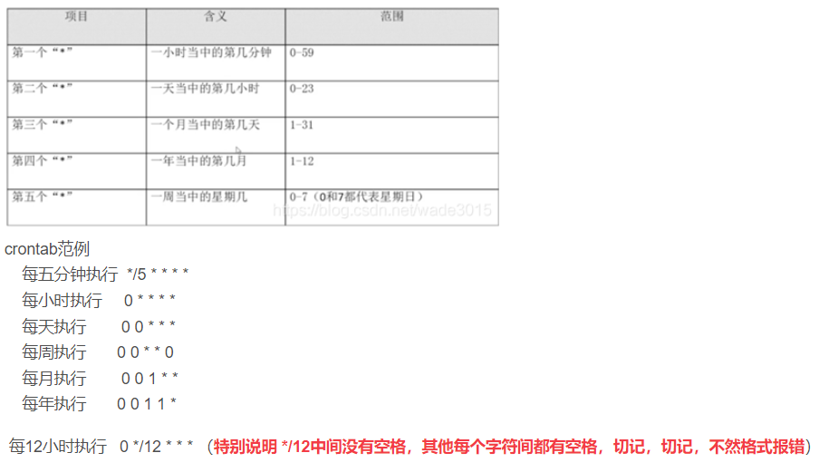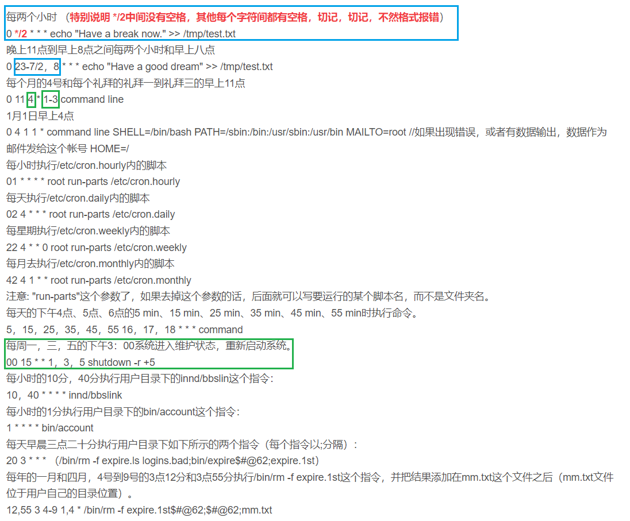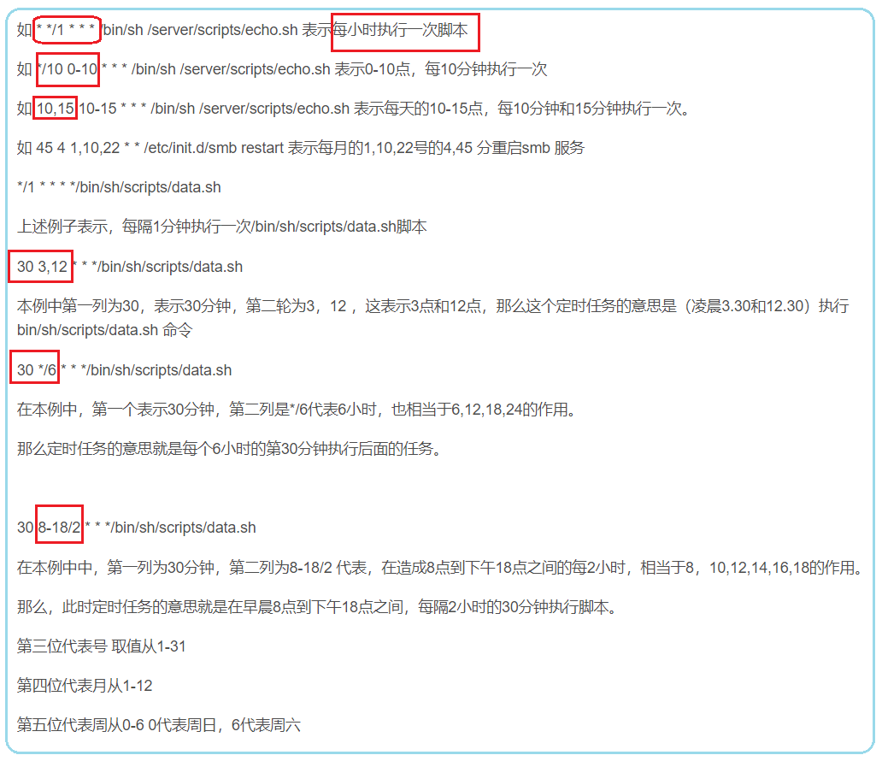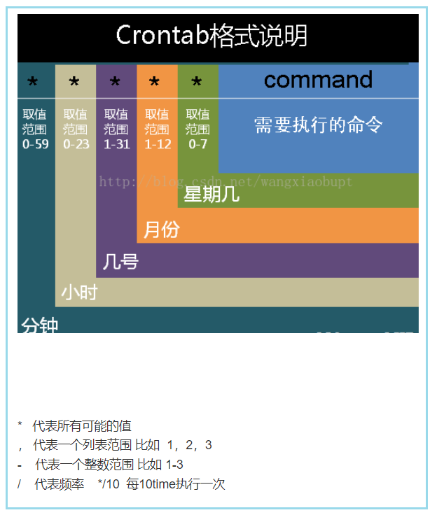 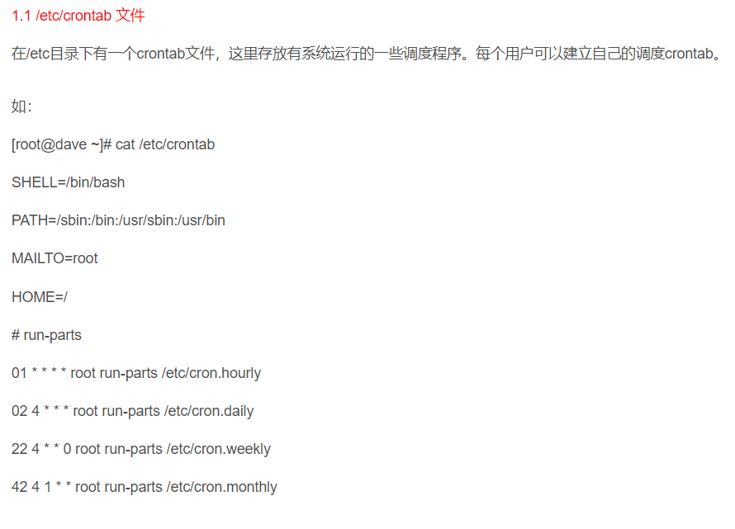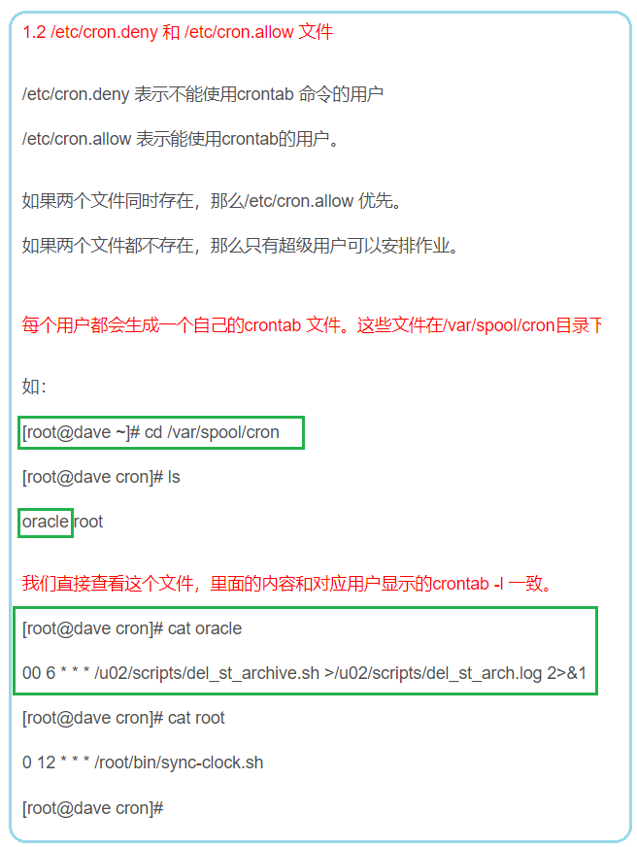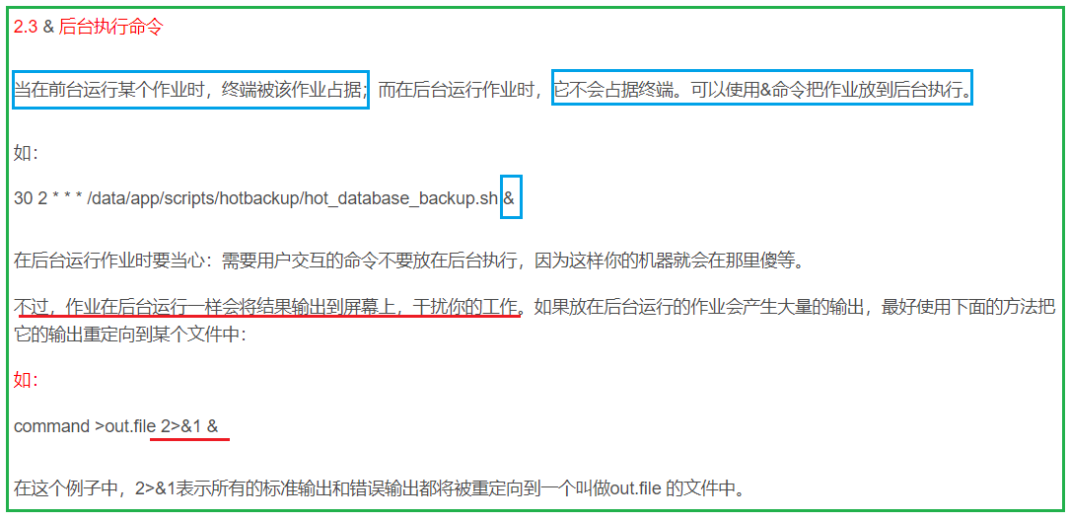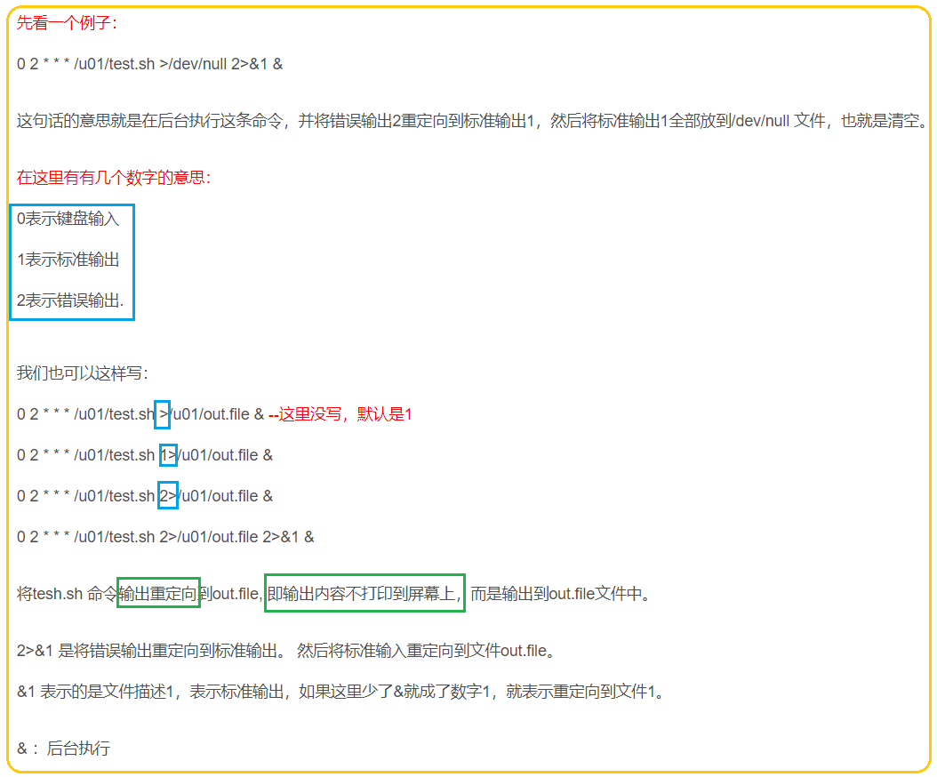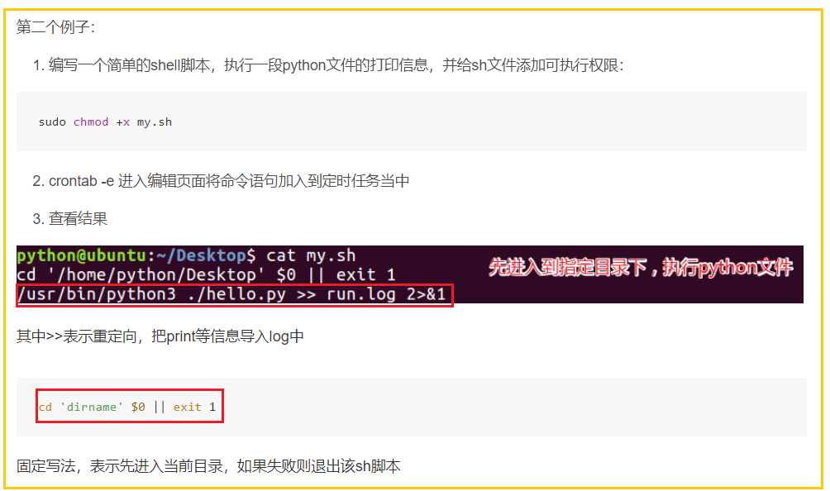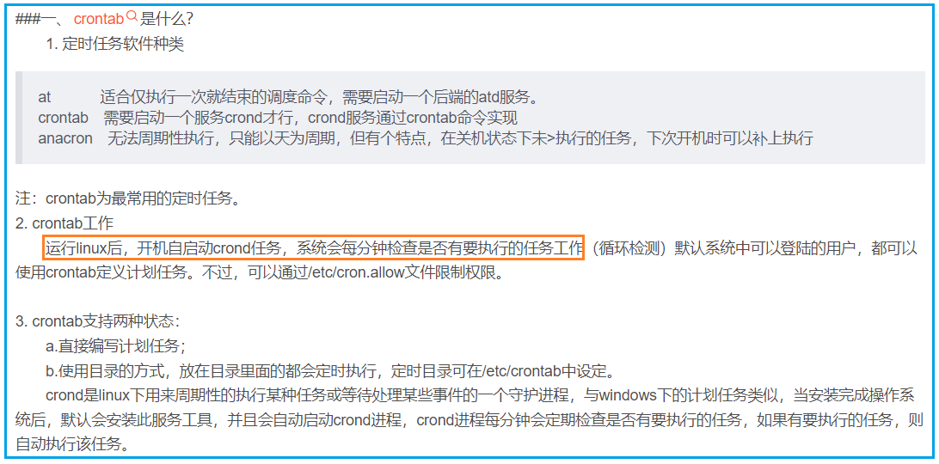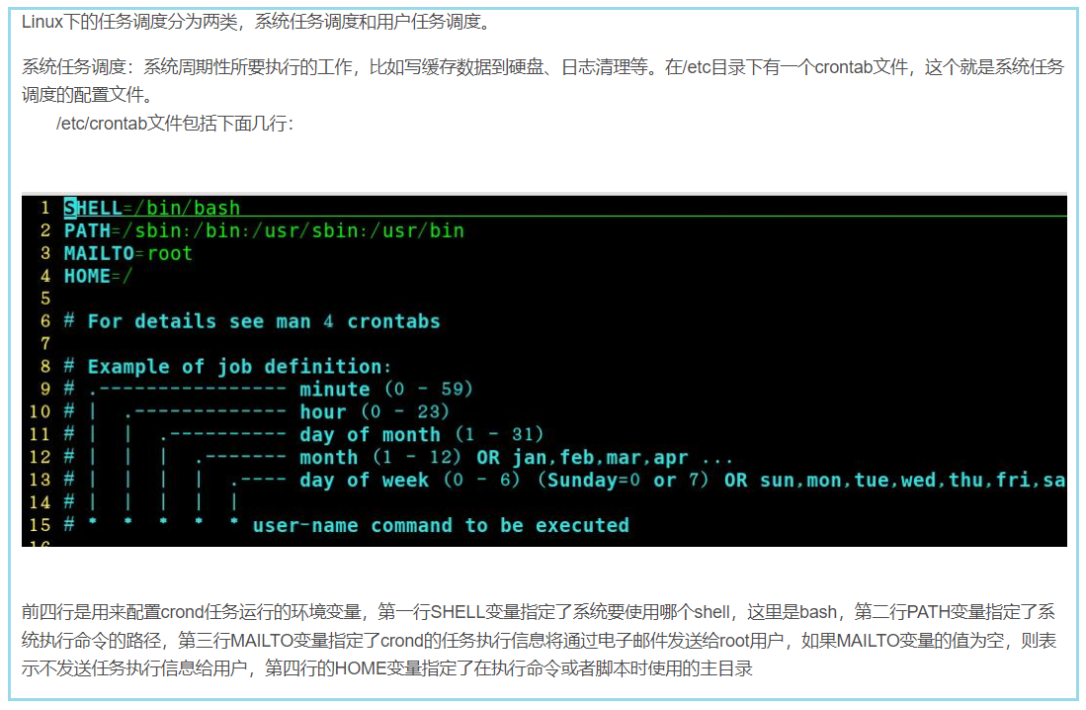 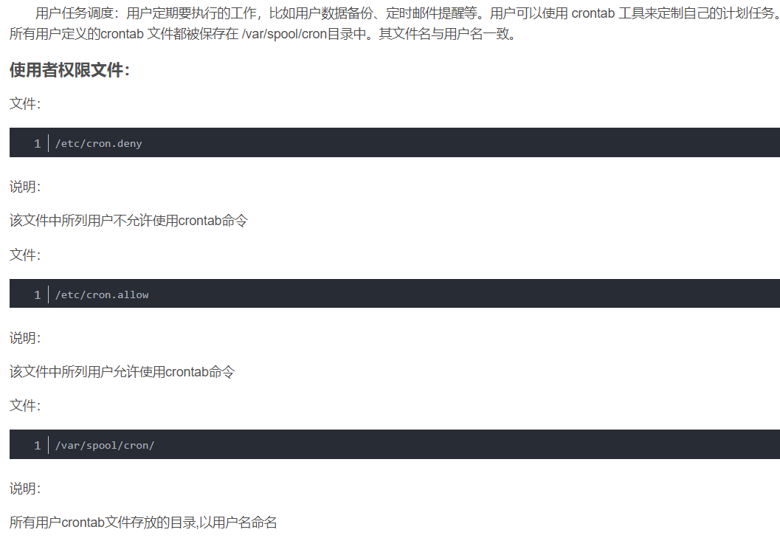 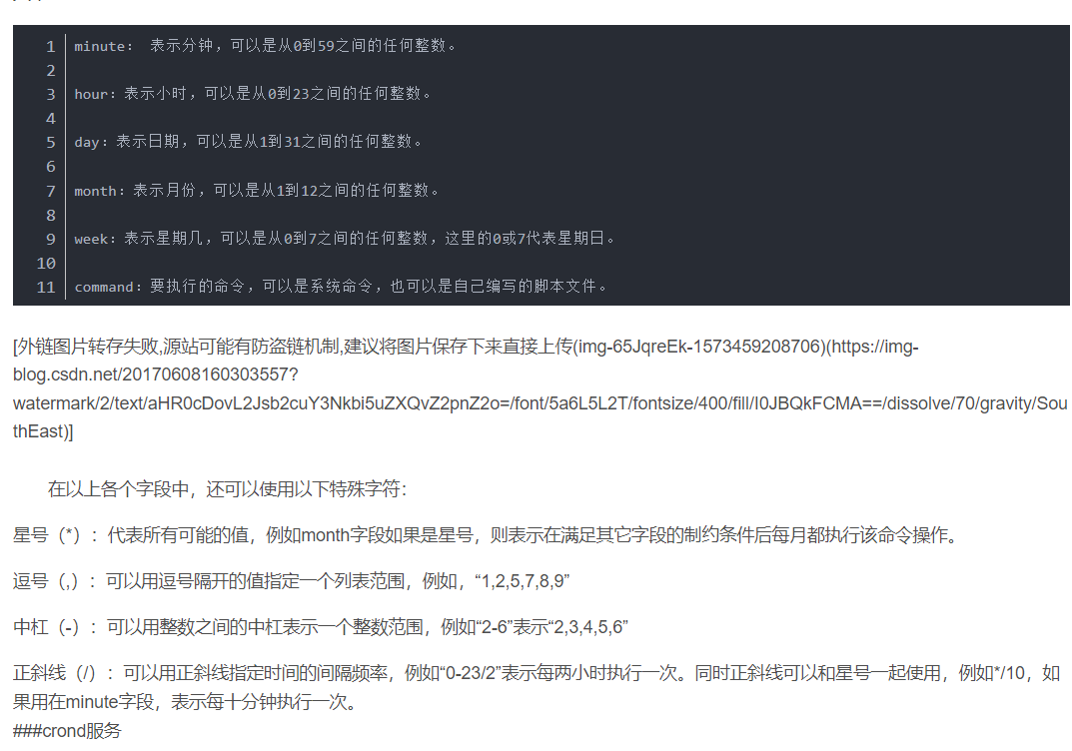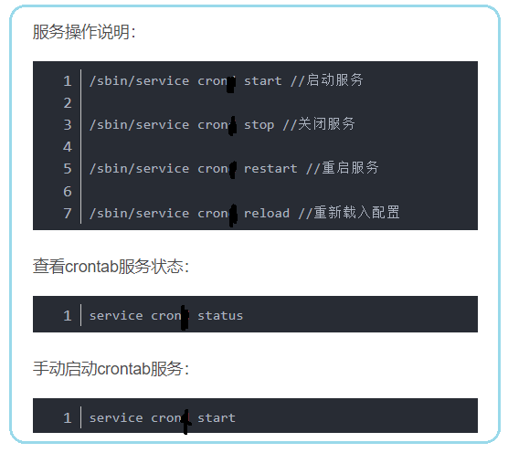 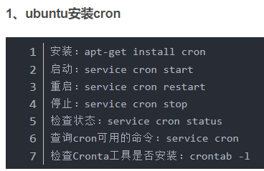 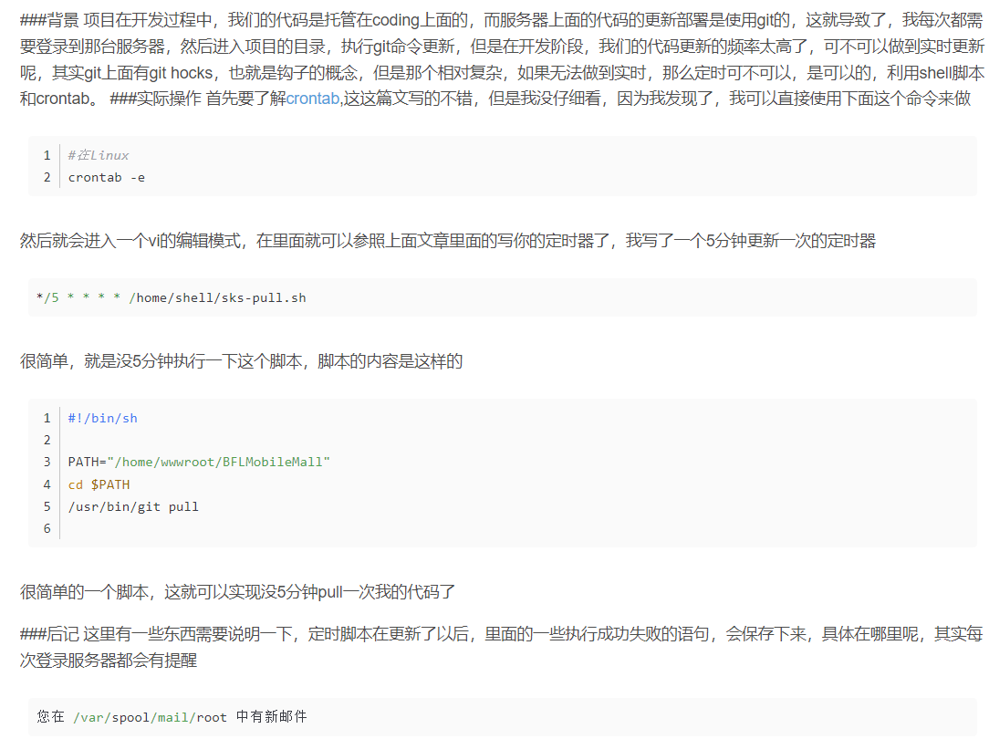 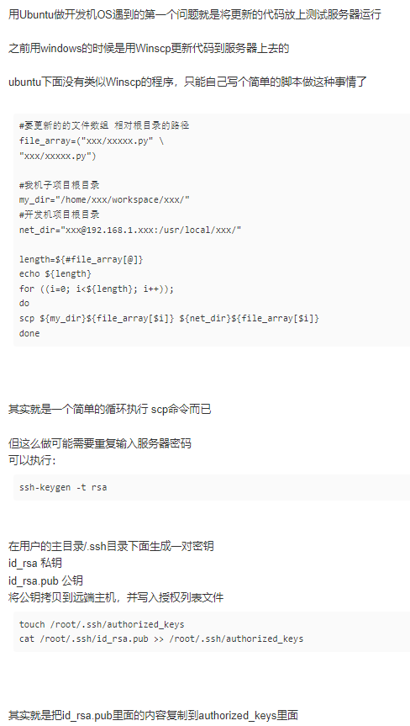

# Linux performance monitoring

# How to use chmod

# Run python script in linux

# Useful Linux Commands for System Administrators

**https://www.tecmint.com/useful-linux-commands-for-system-administrators/**

# Linux Network Configuration and Troubleshooting Commands

# linux git 自动更新,git 利用hook 实现服务器自动更新代码

# 在linux 下安装git 服务器实现代码自动更新

1. **o**

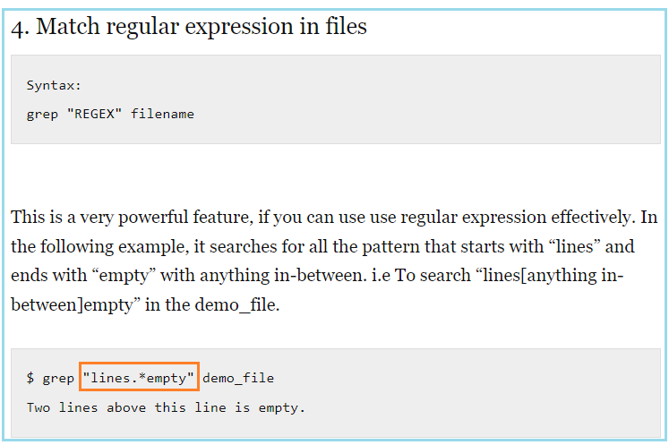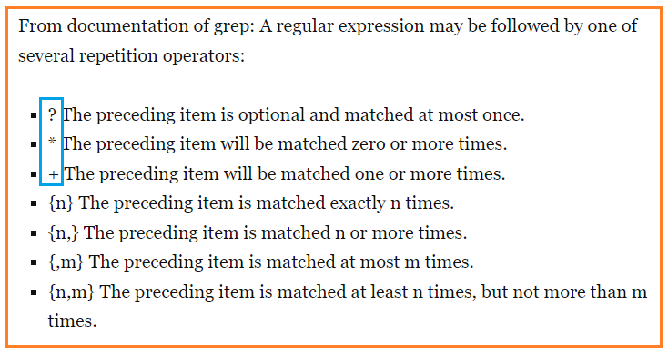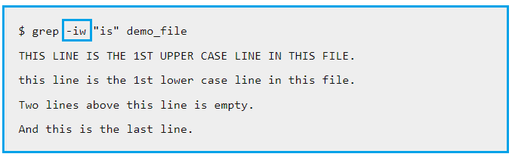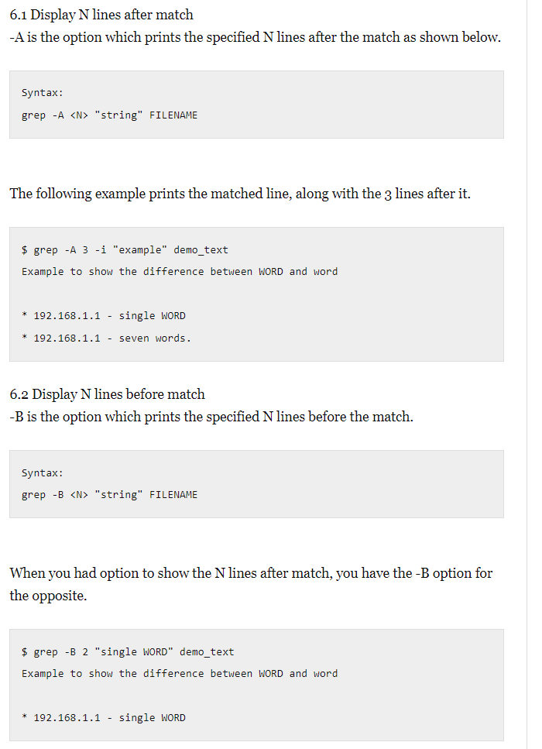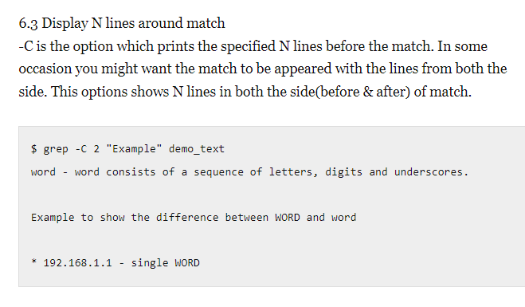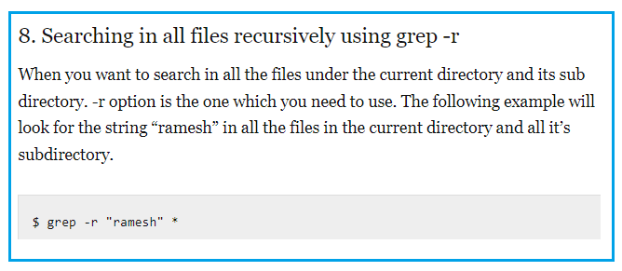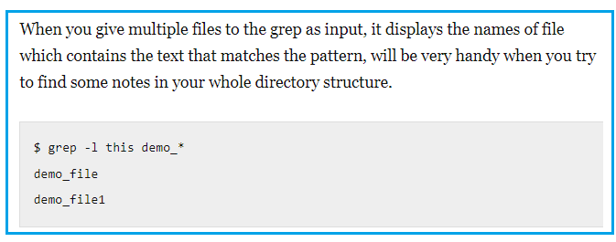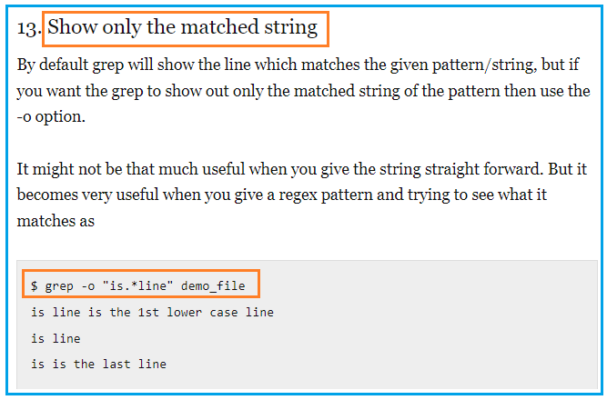

1. **Ubuntu performance monitoring**
2. **Ubuntu admin**

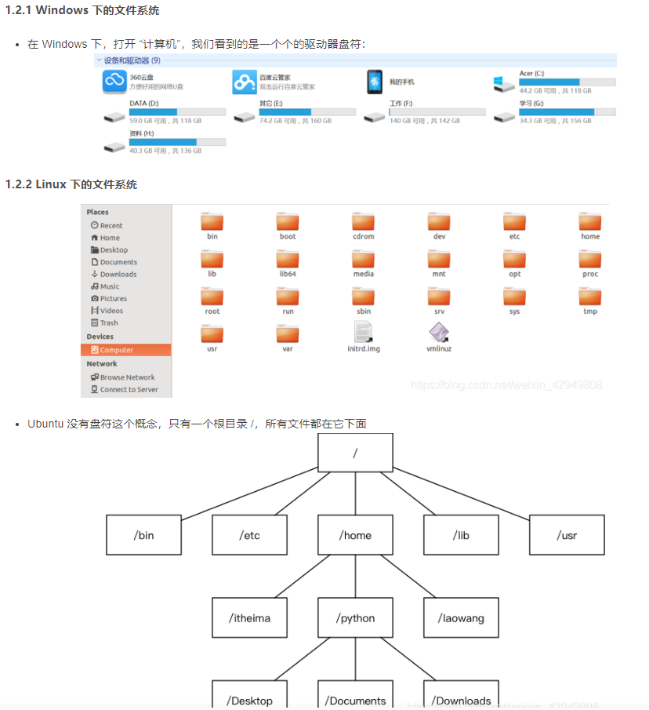

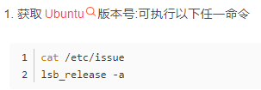

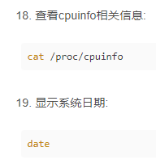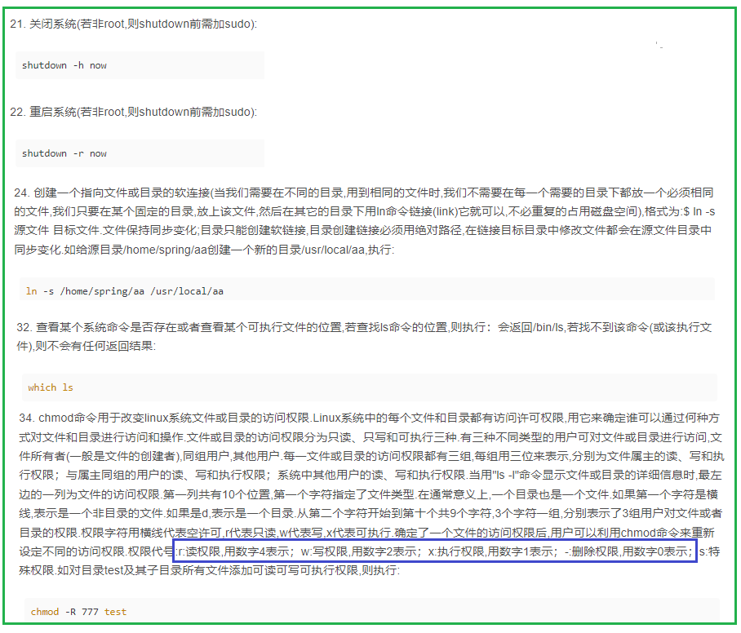

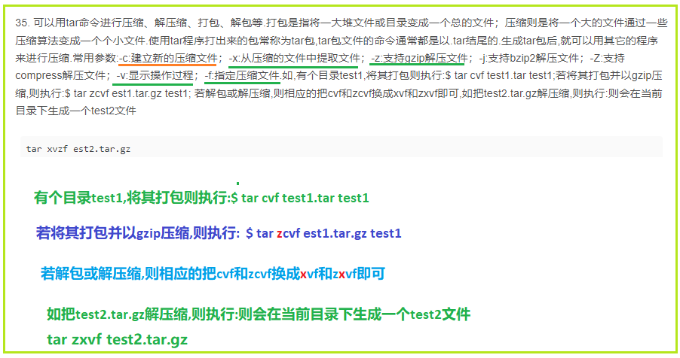

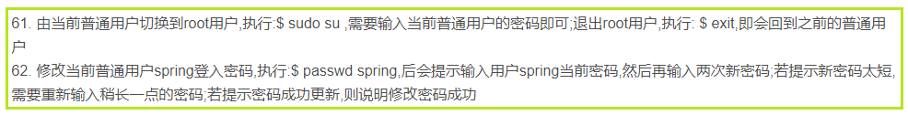

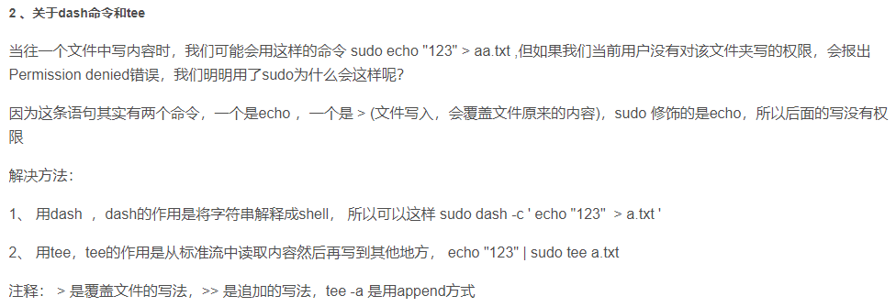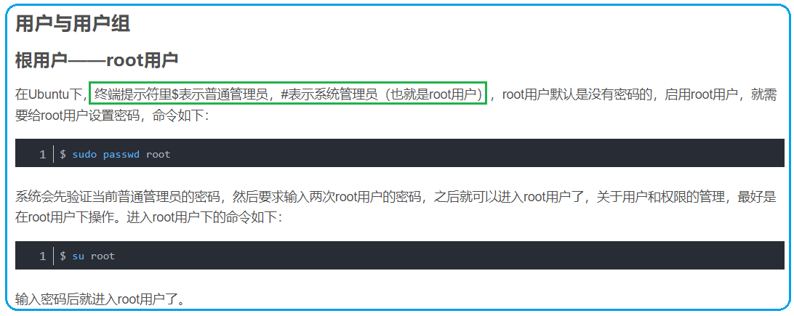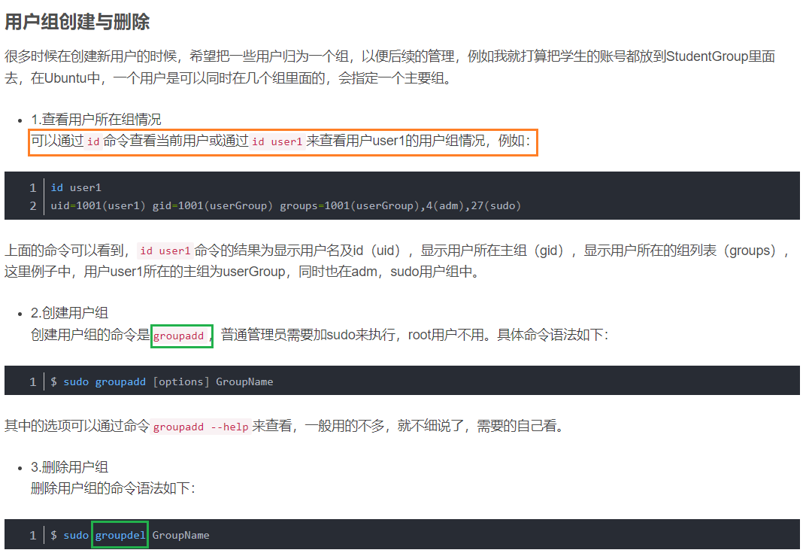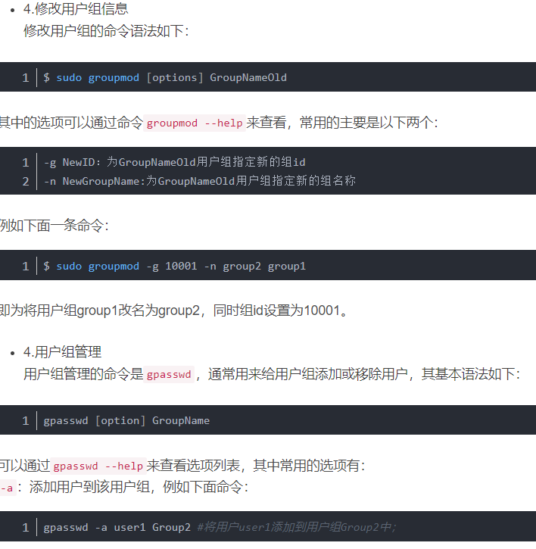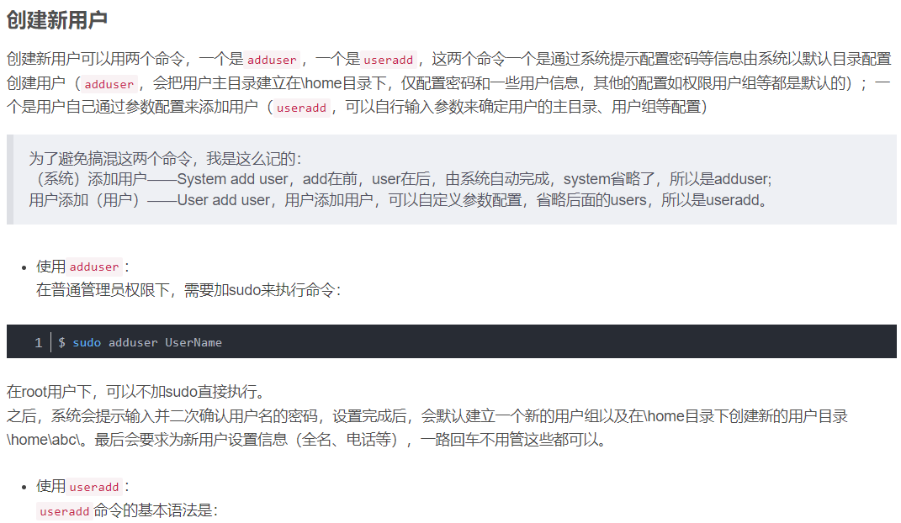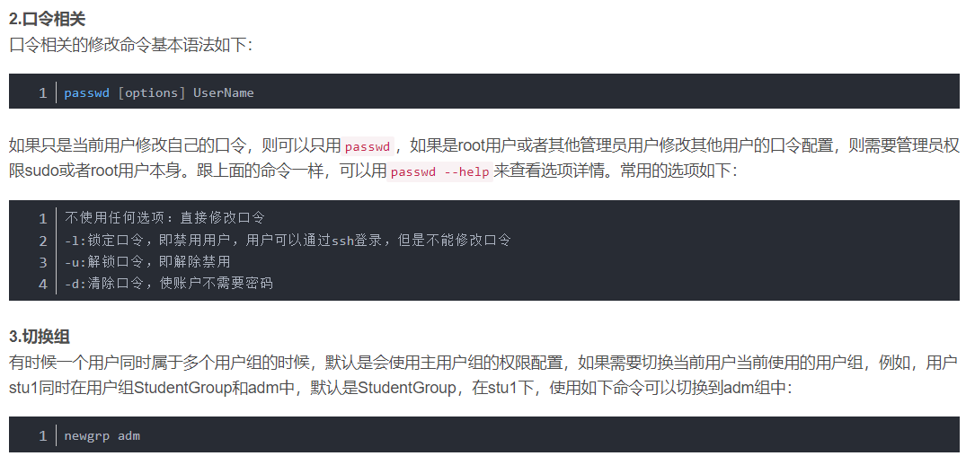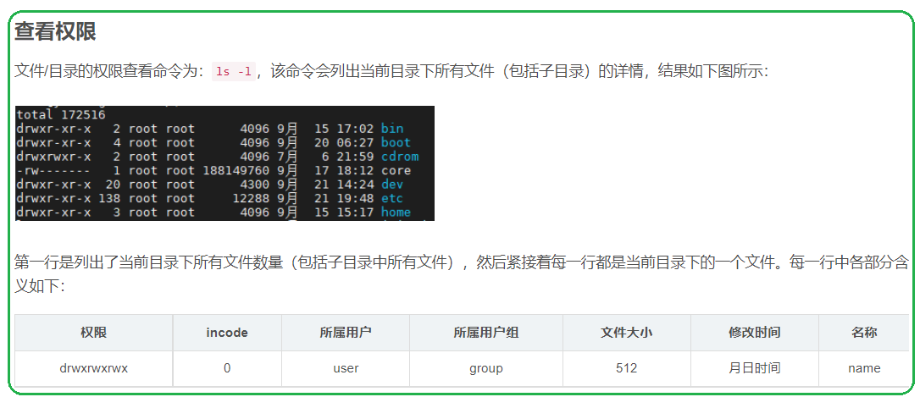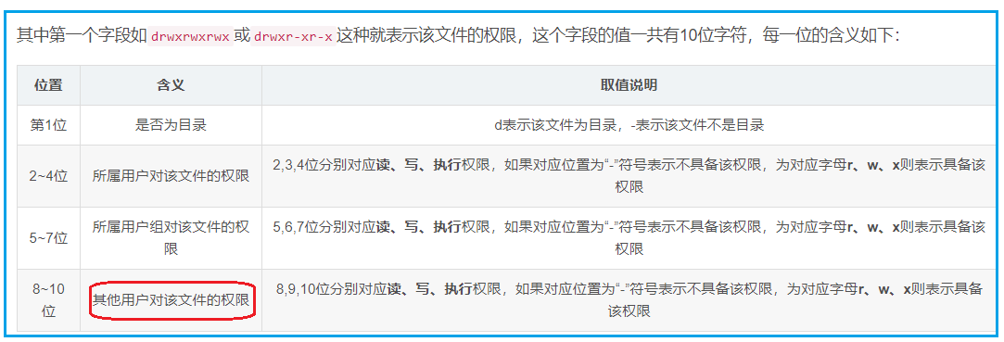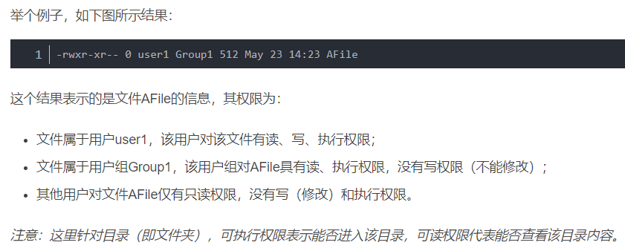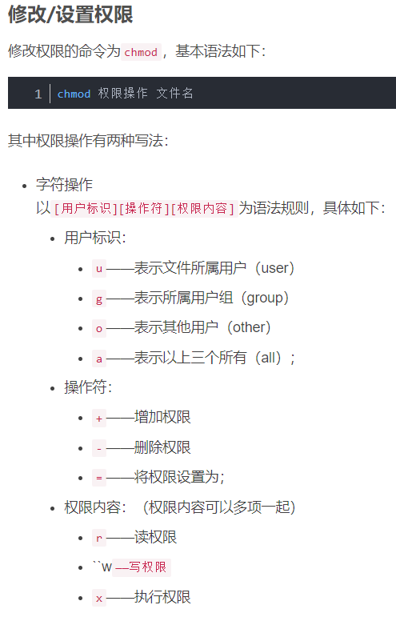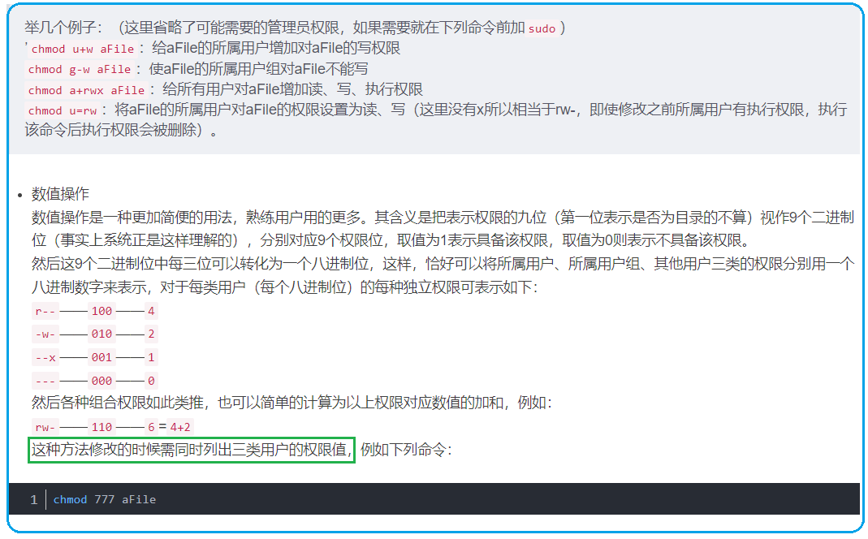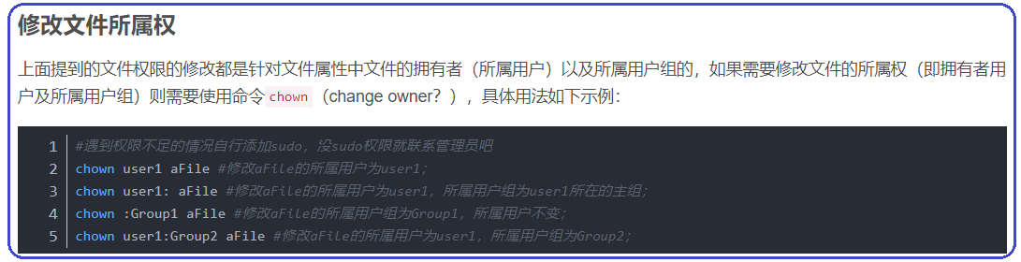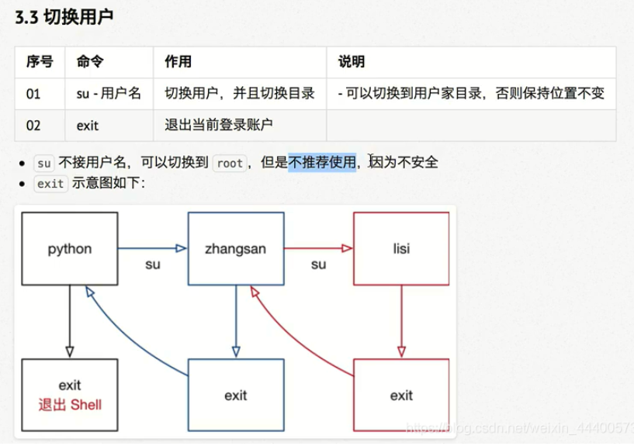

1. **777777**
2. **Uptime**

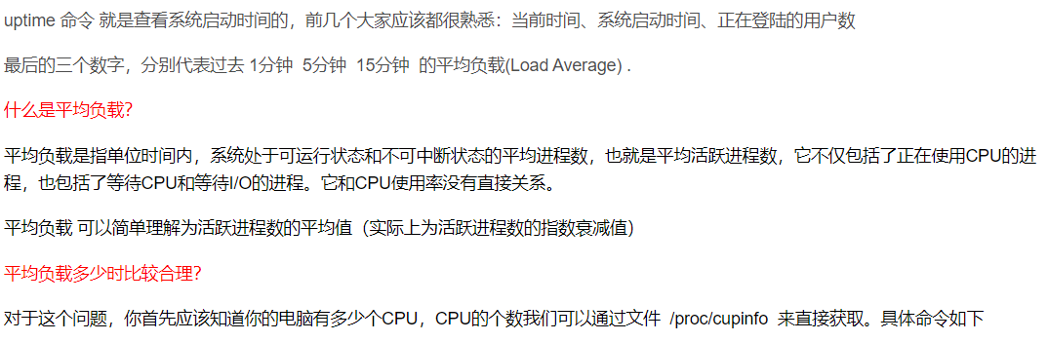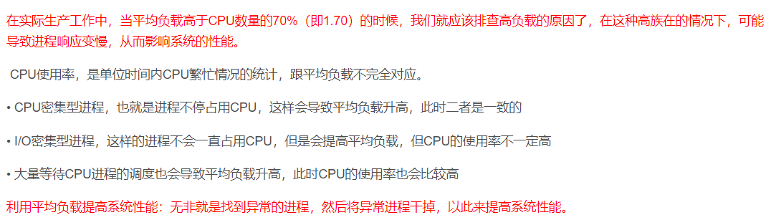

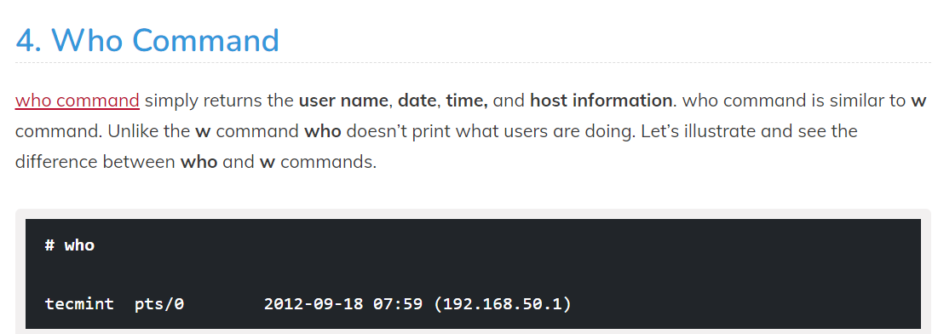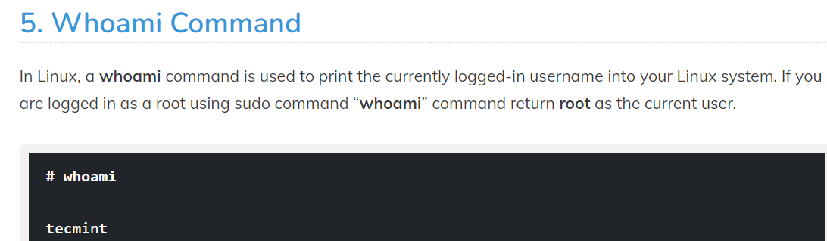

1. **Free**

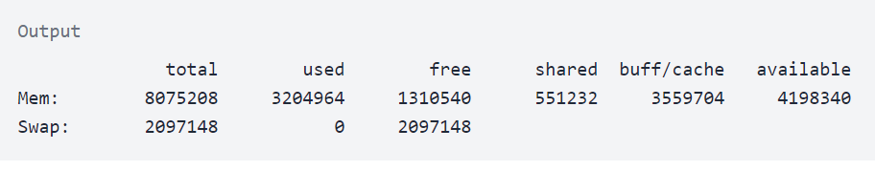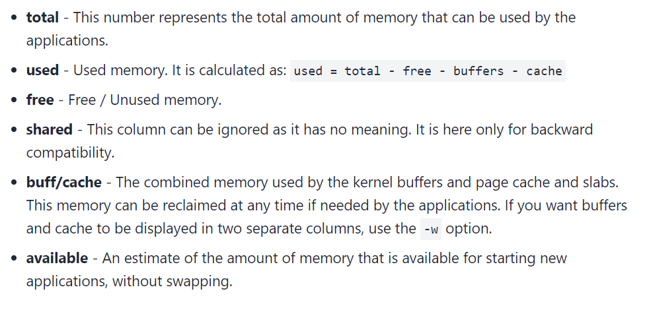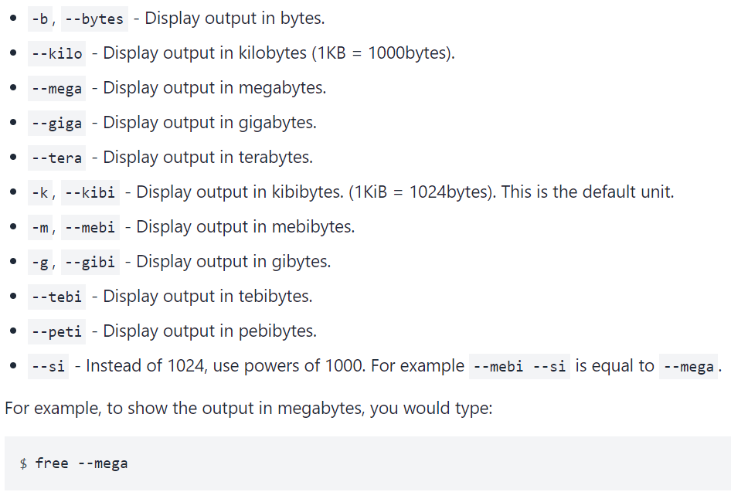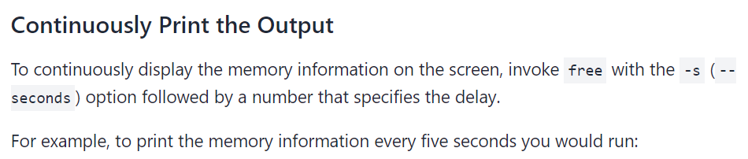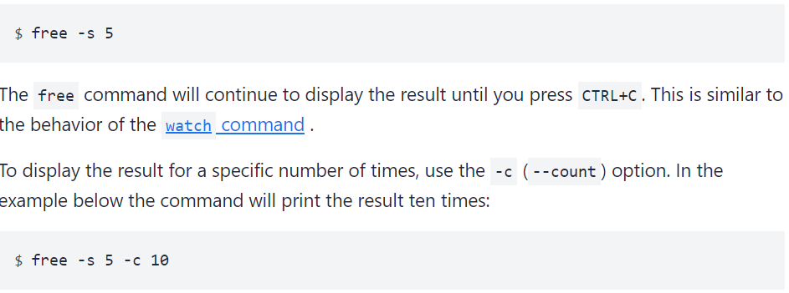

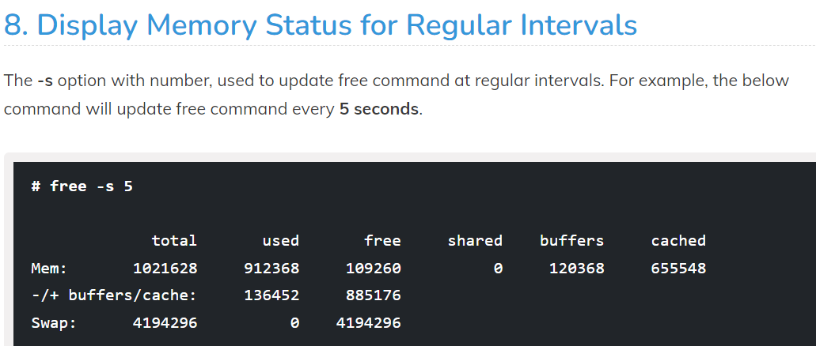

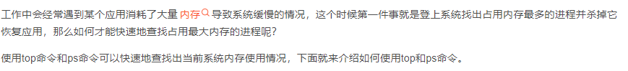

1. **PS**

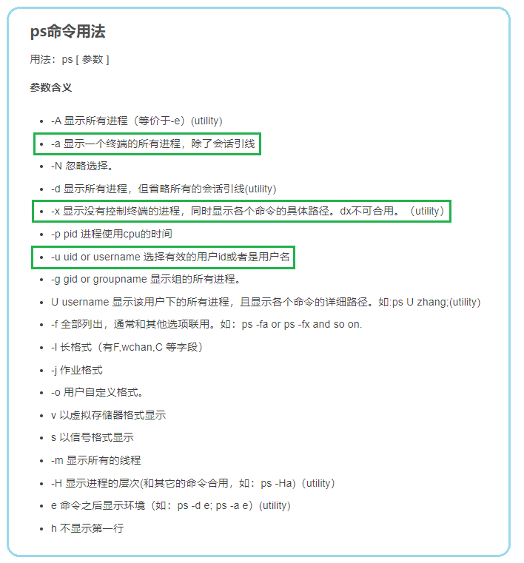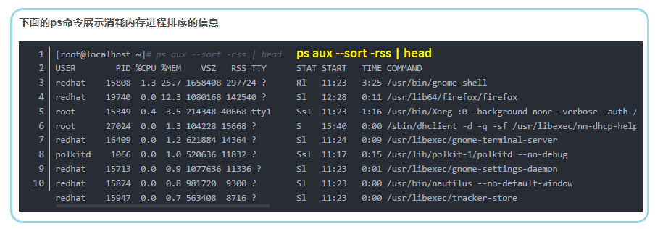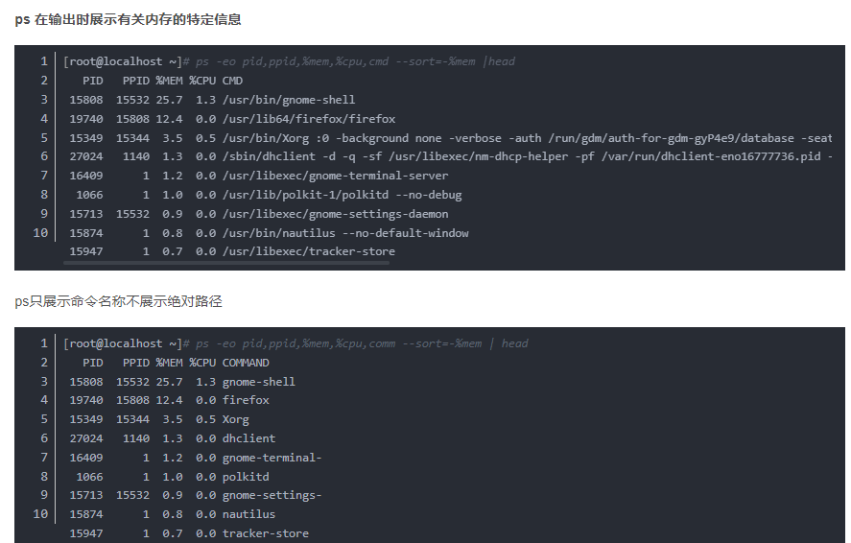

1. **Top**

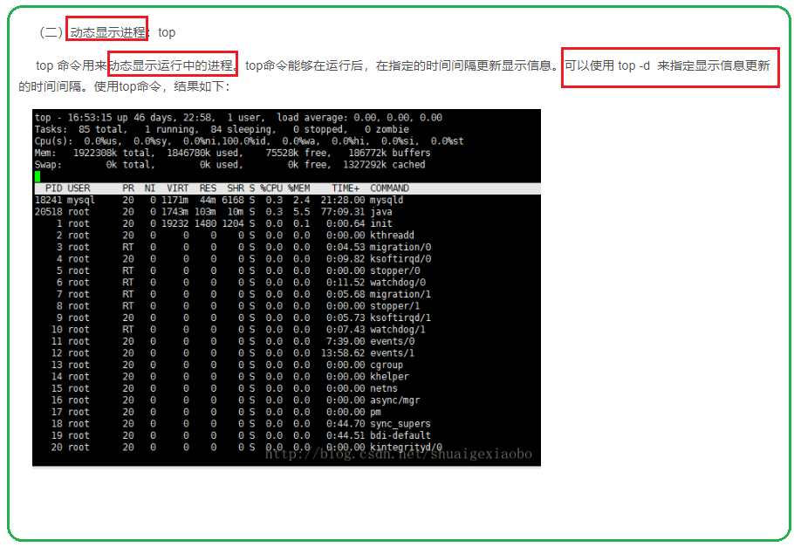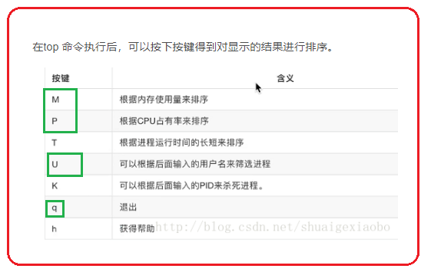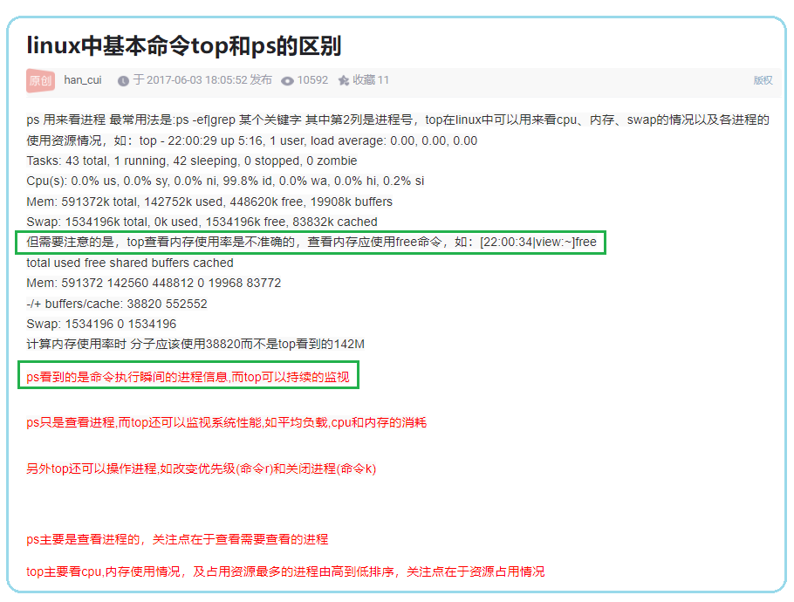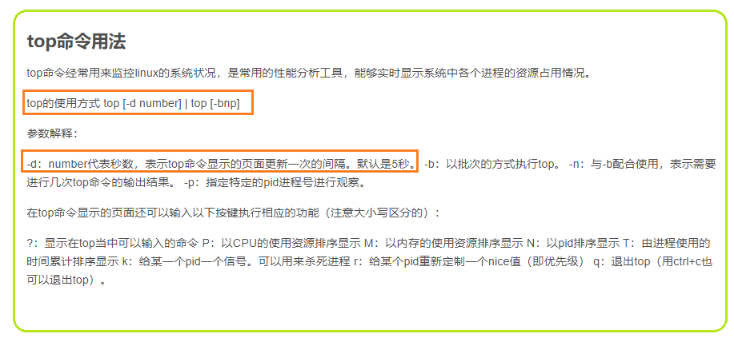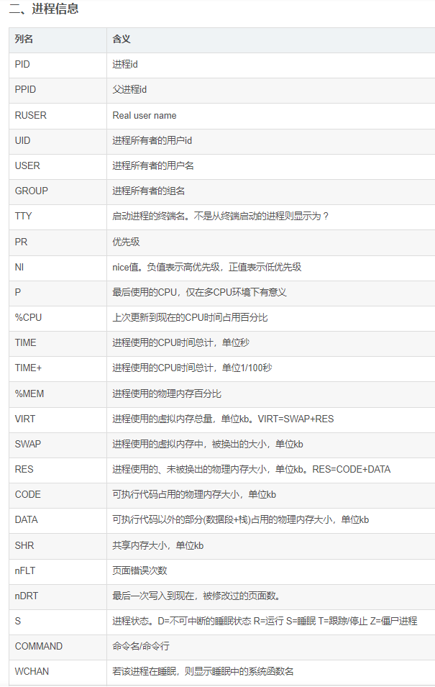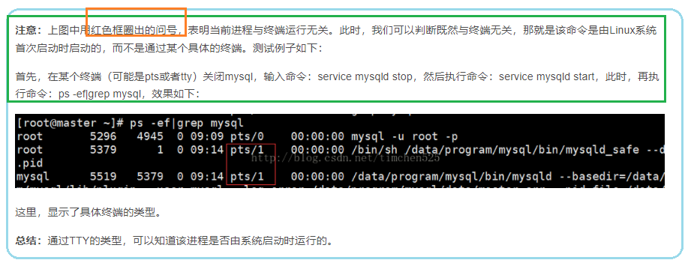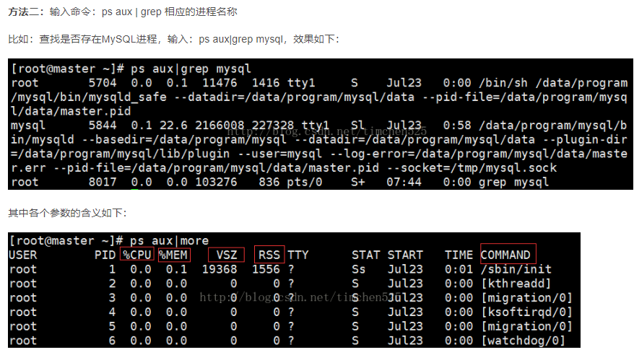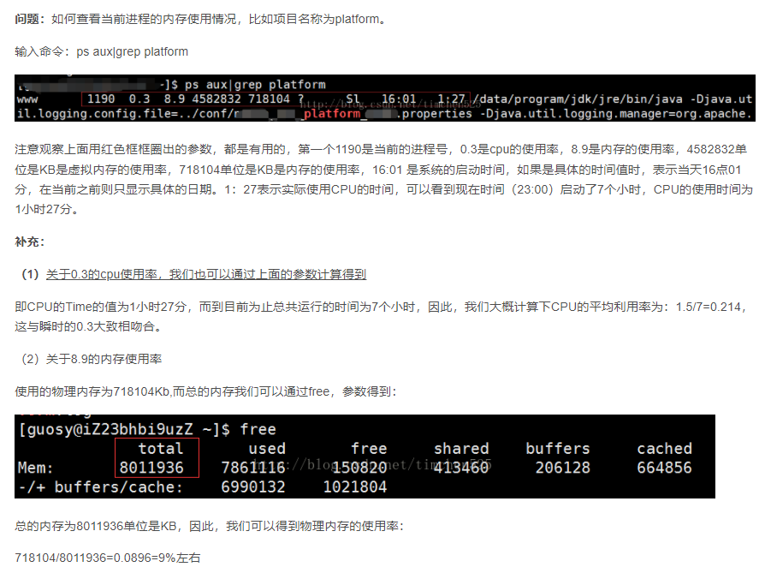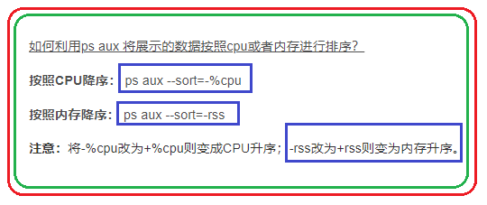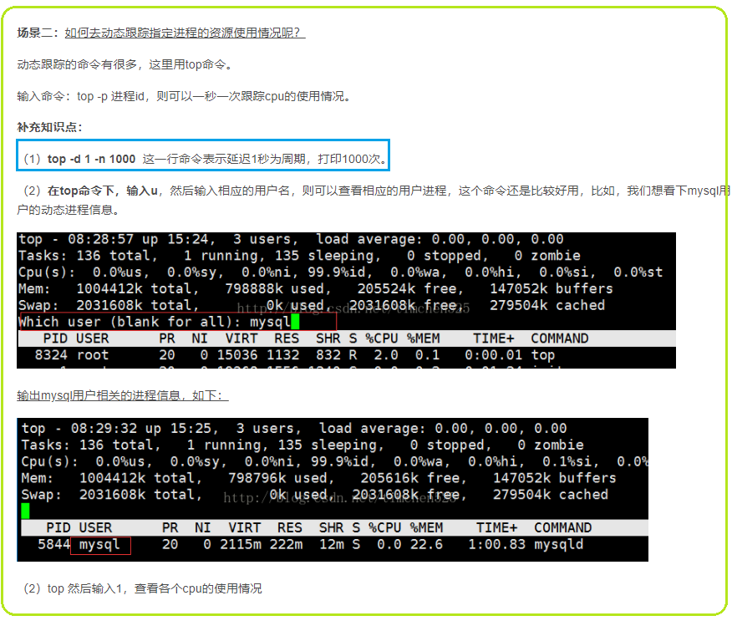

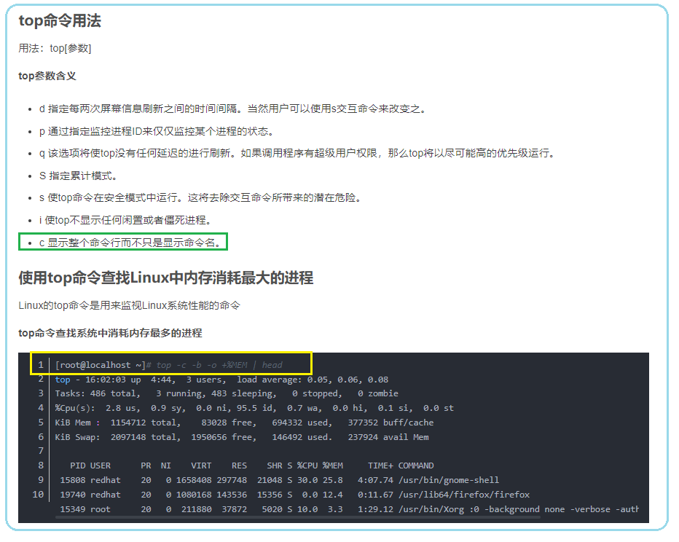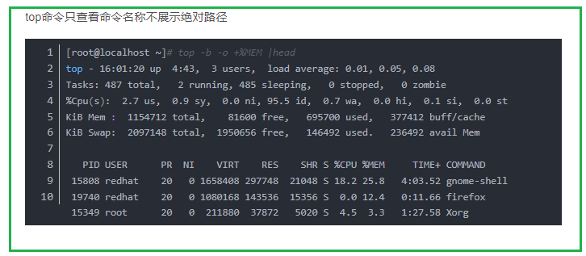

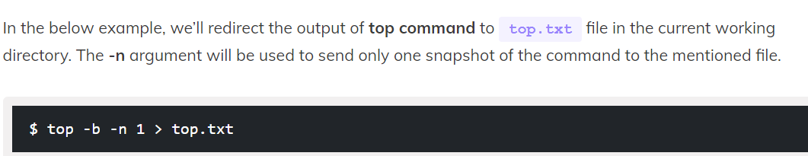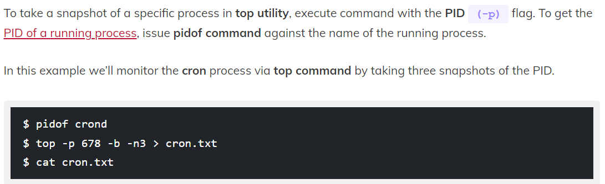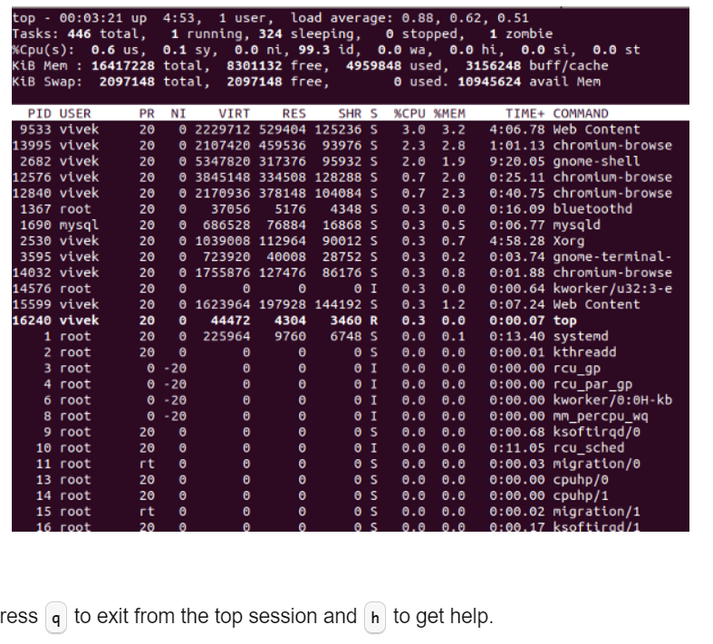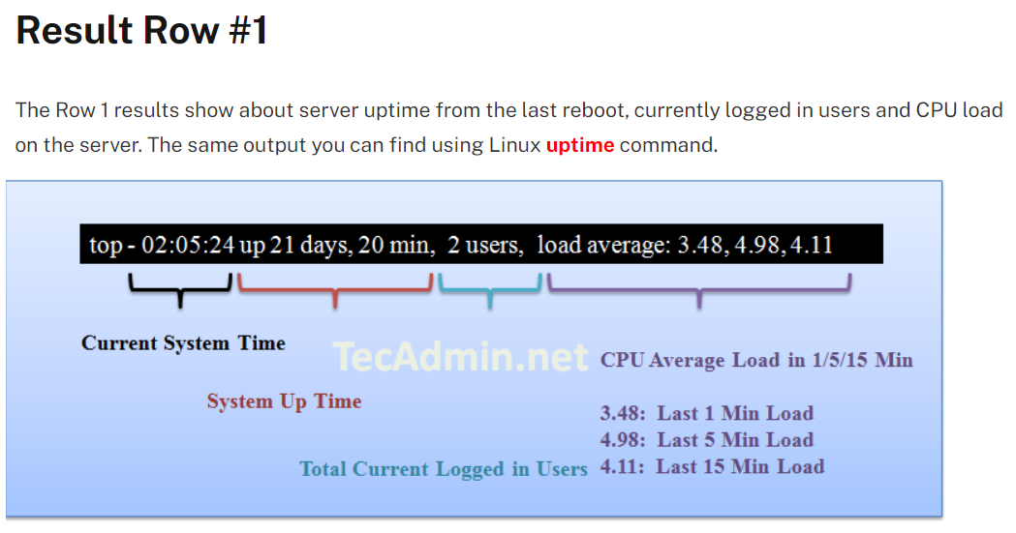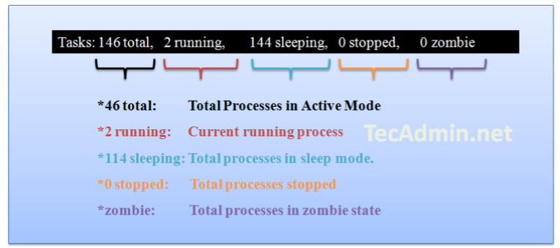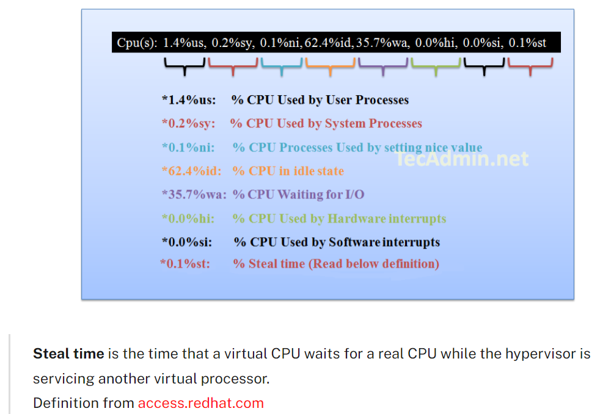

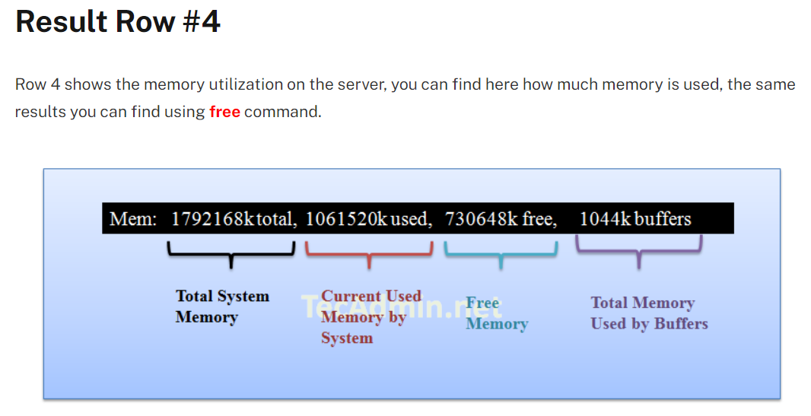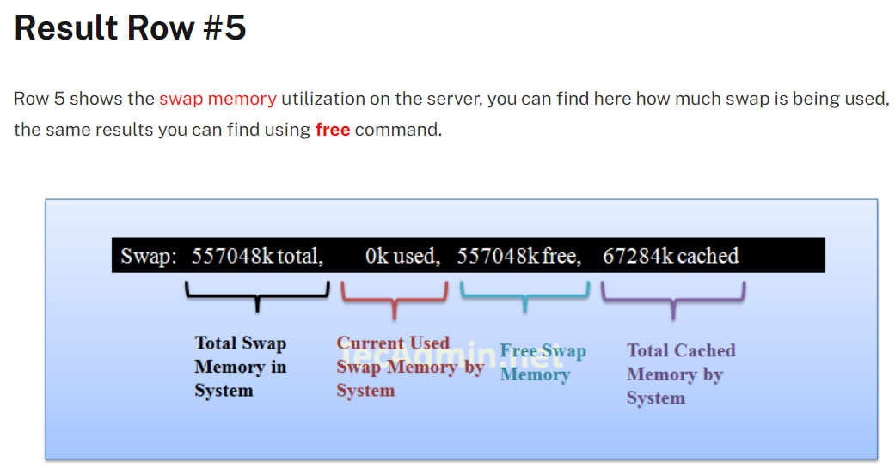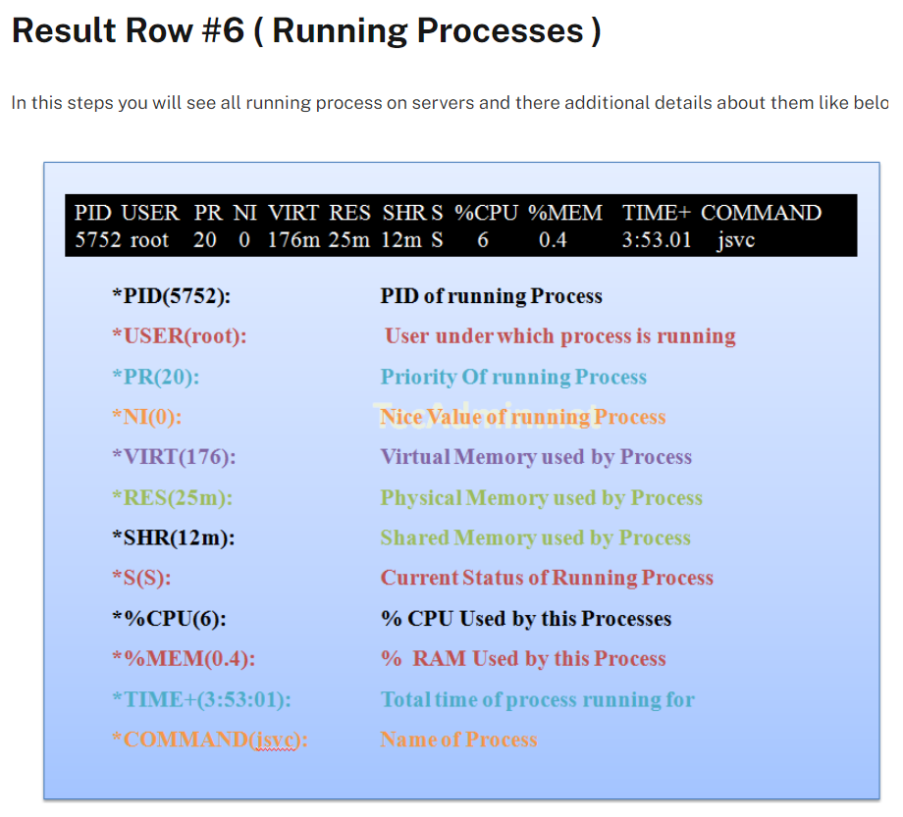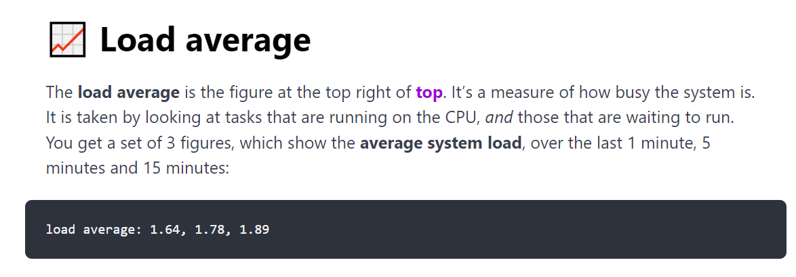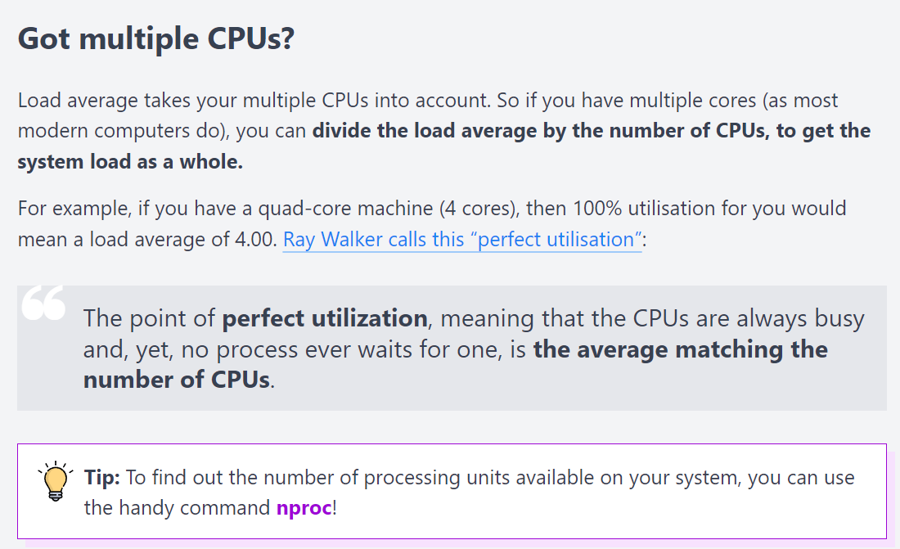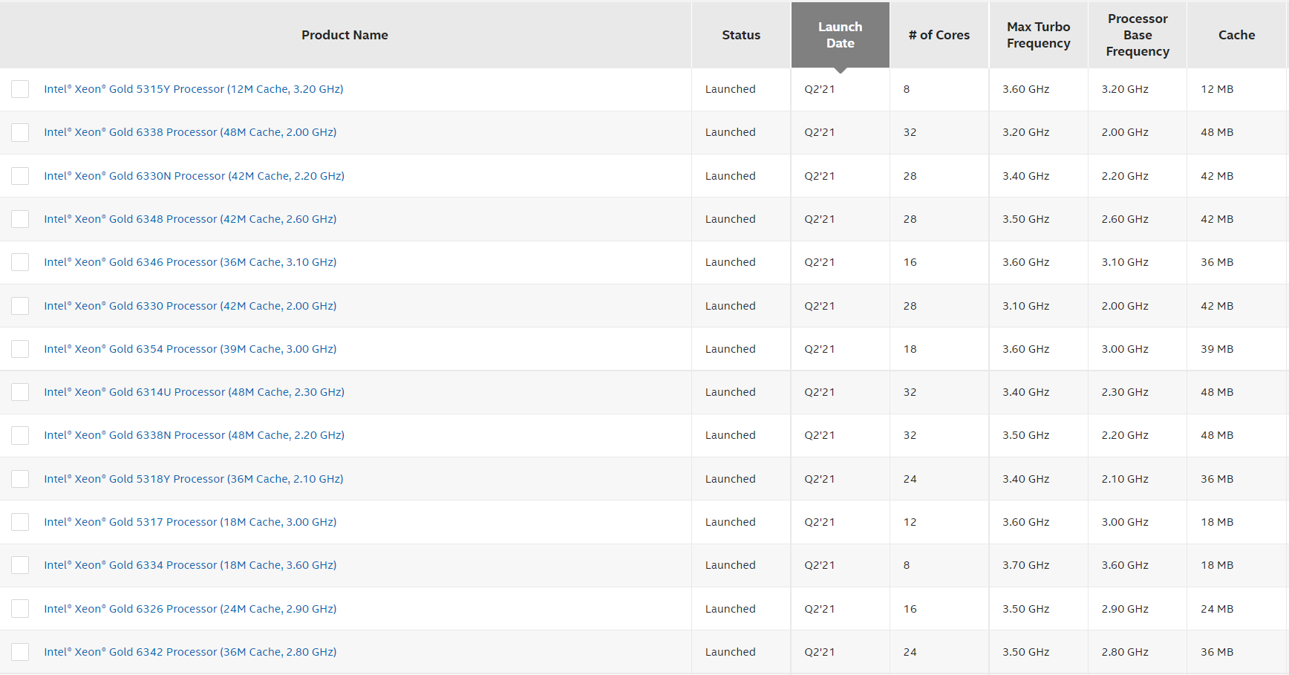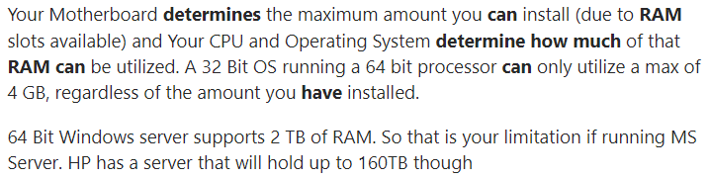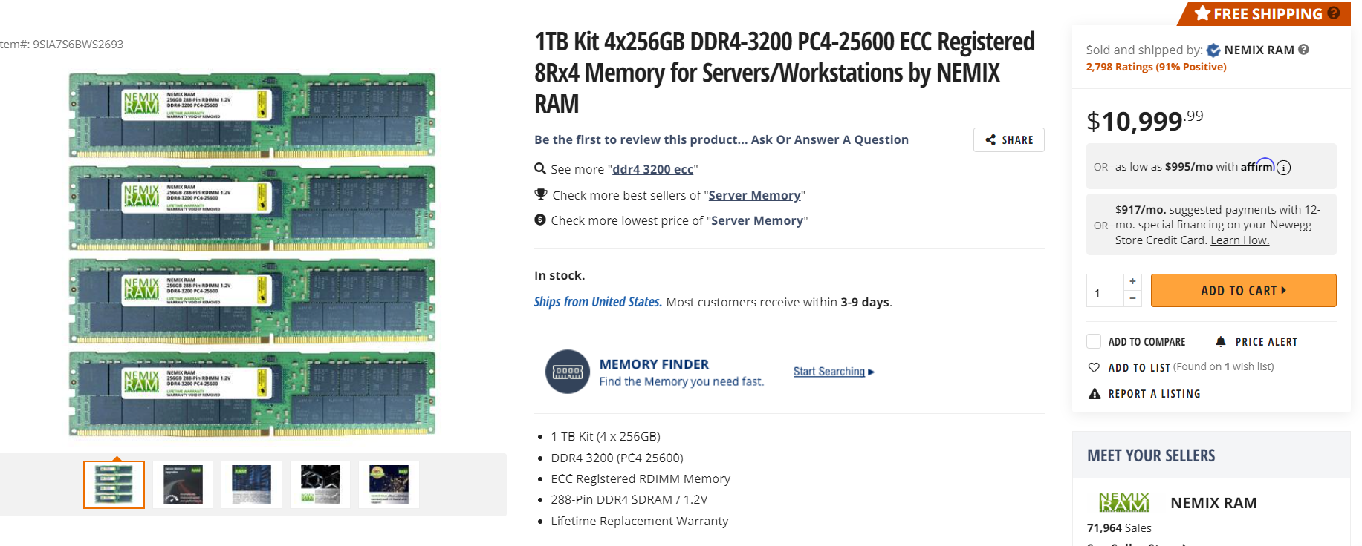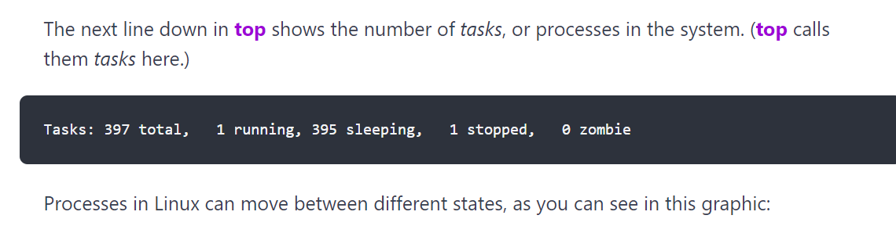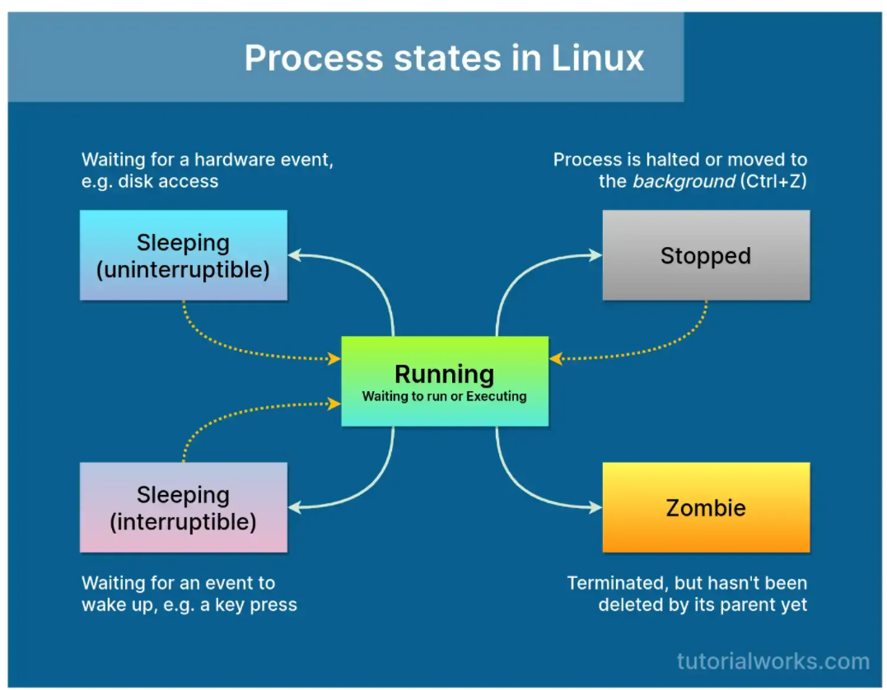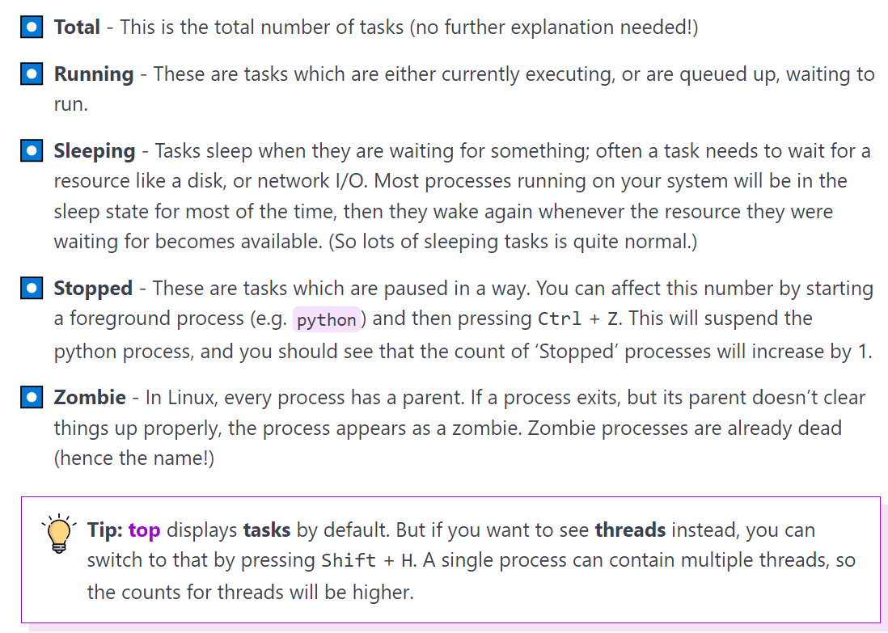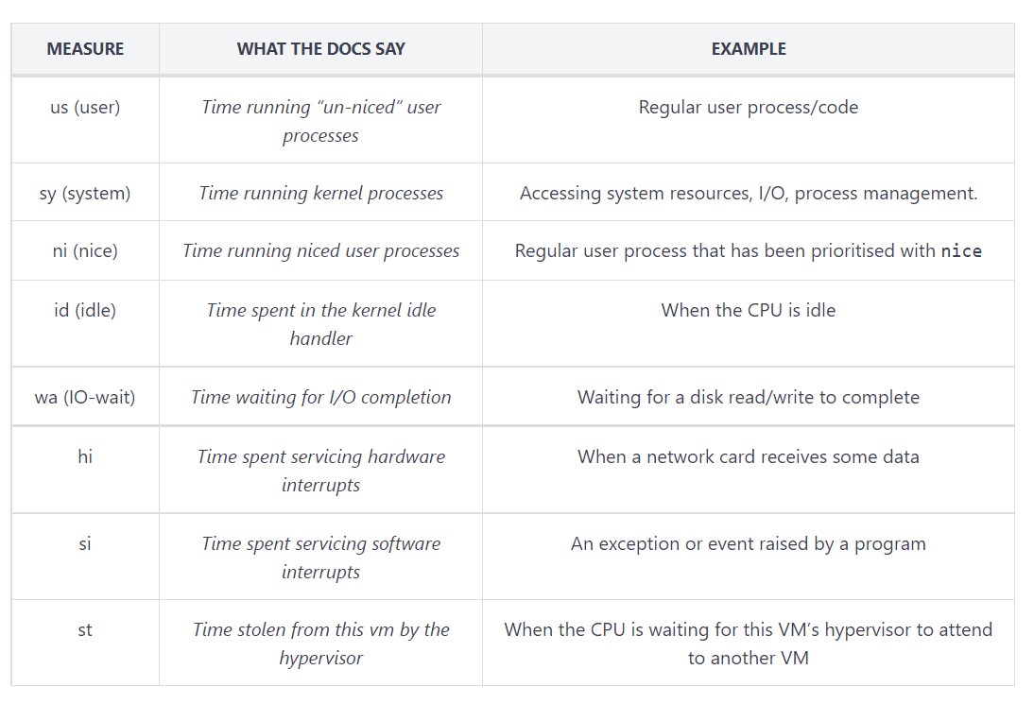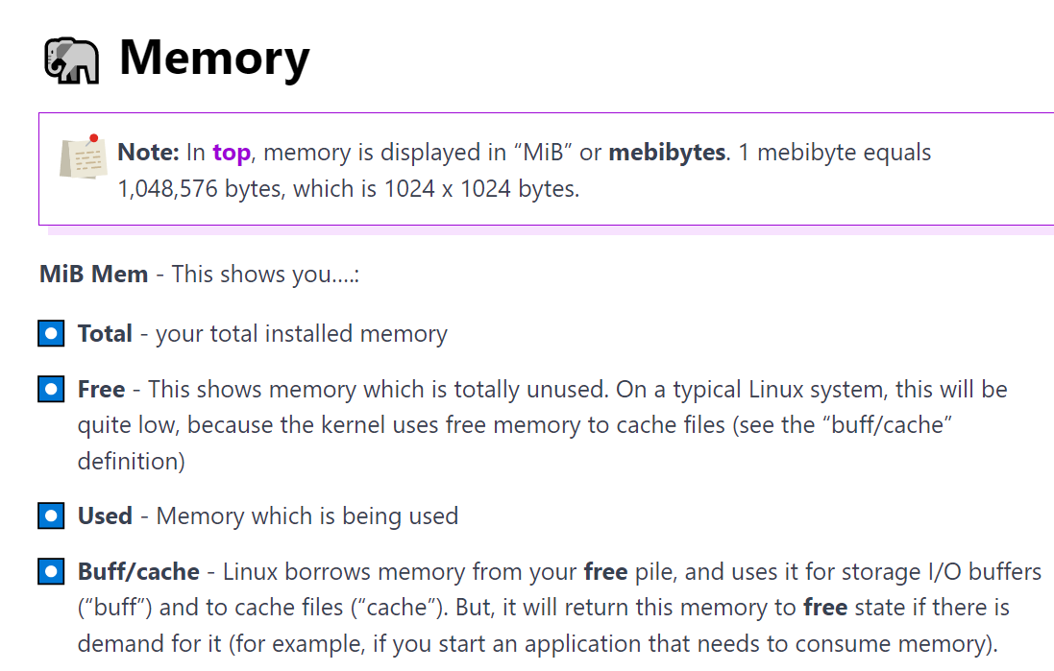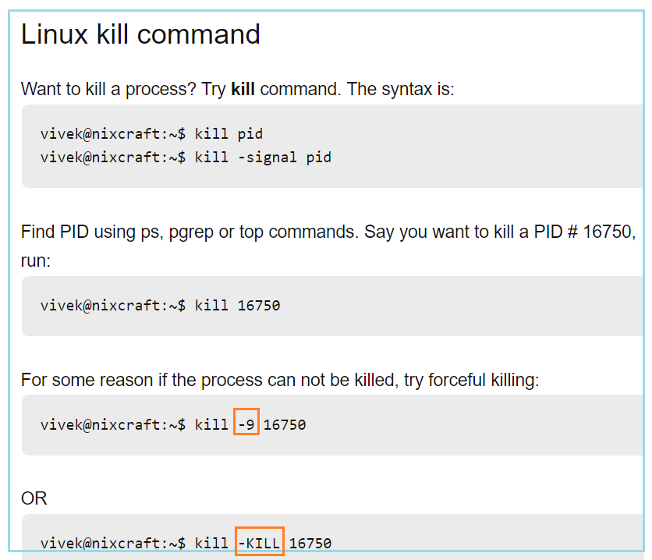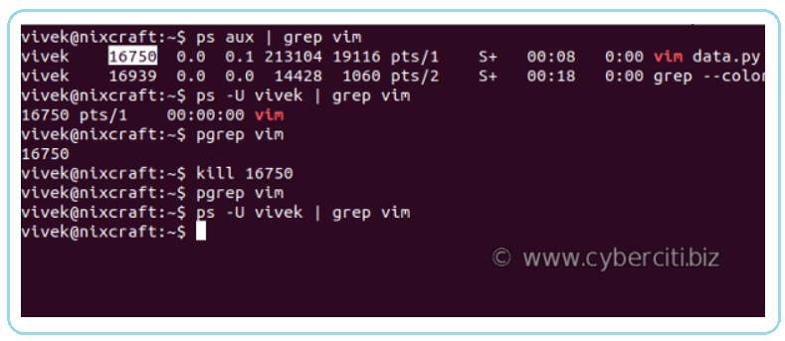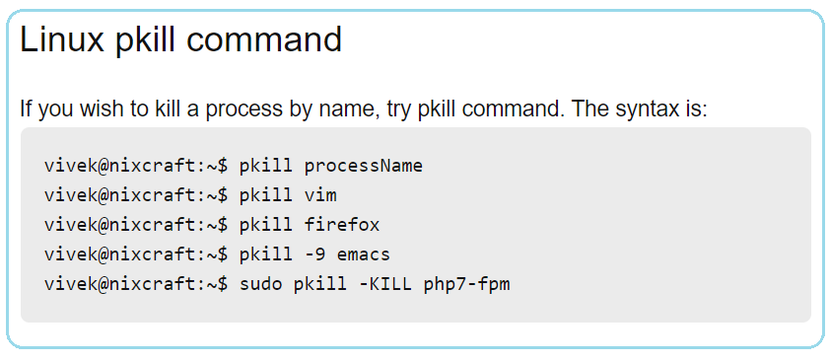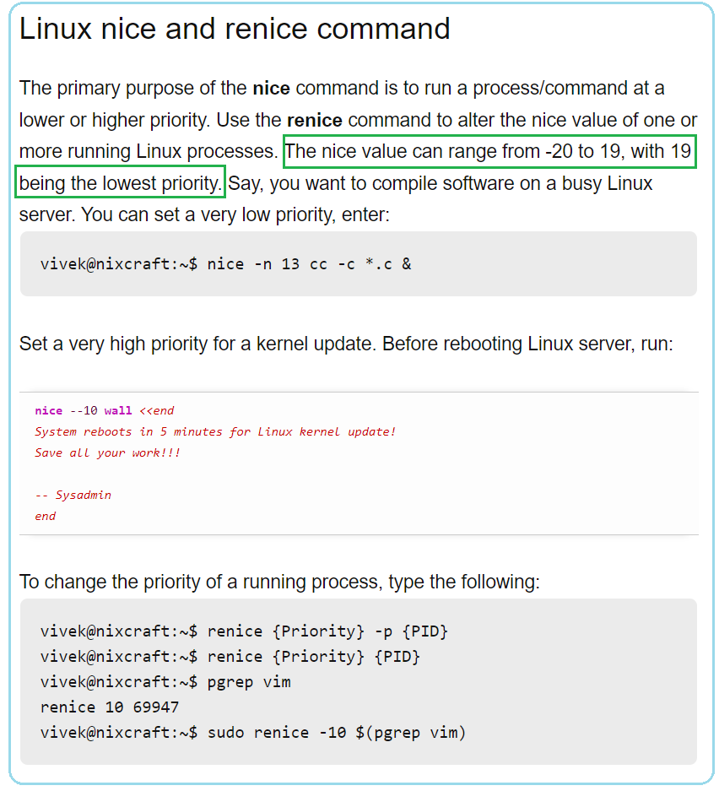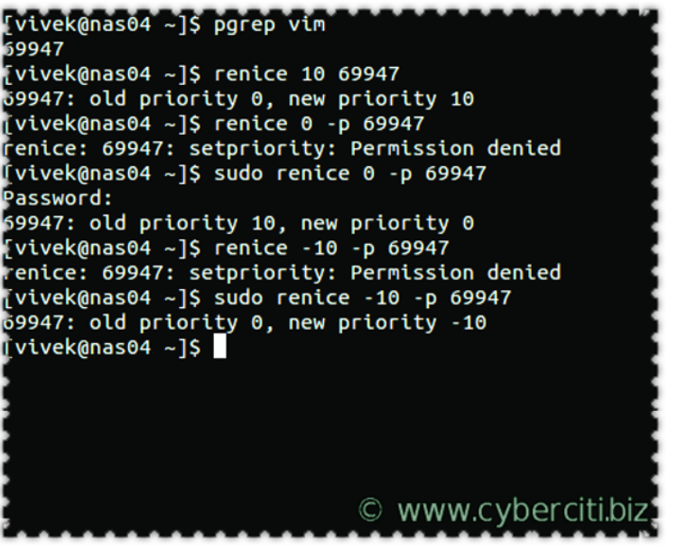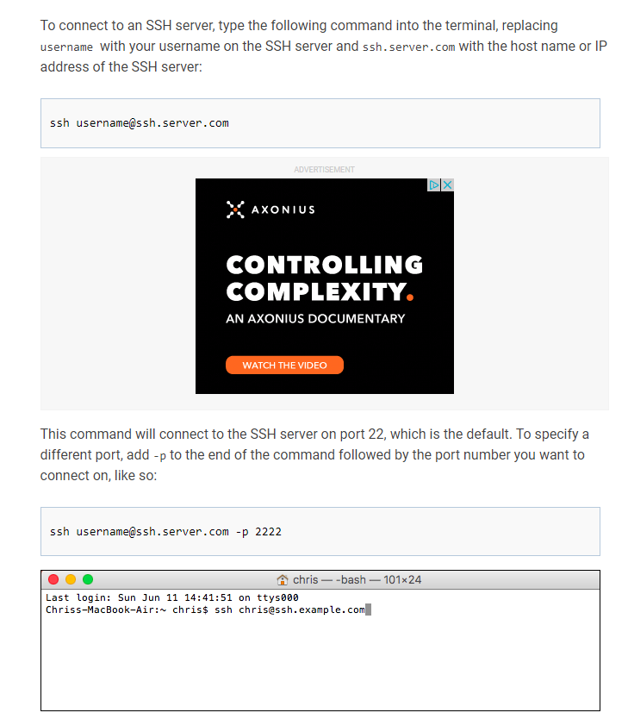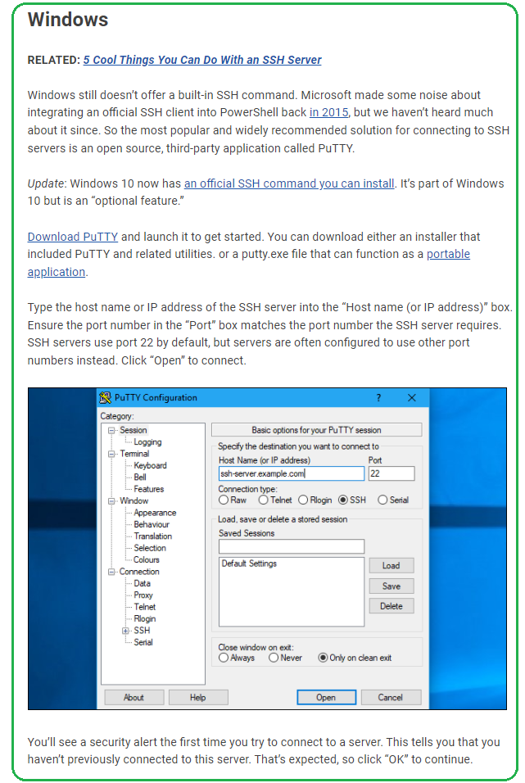

1. **du**

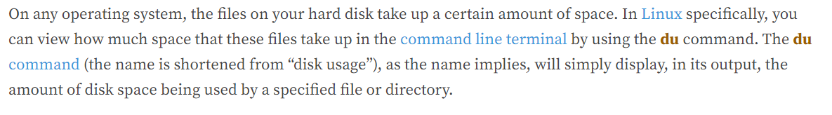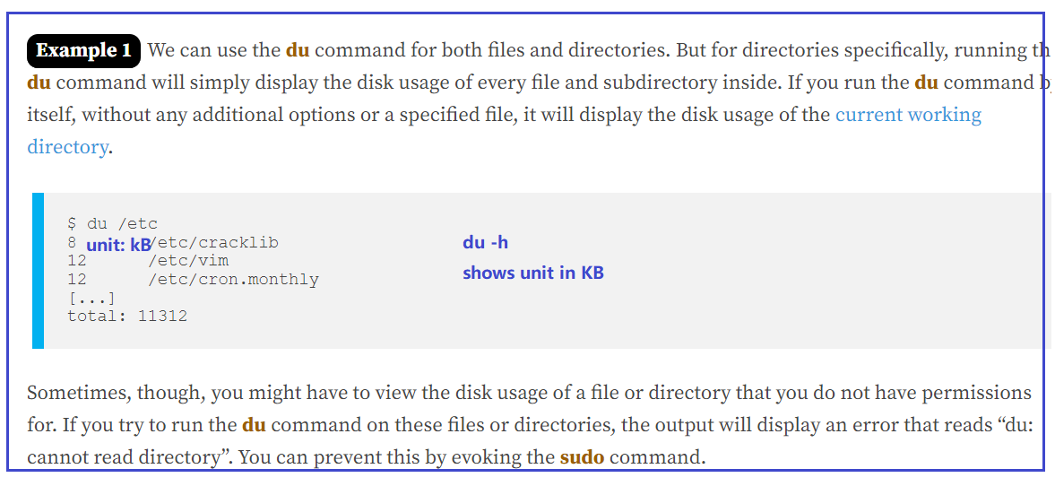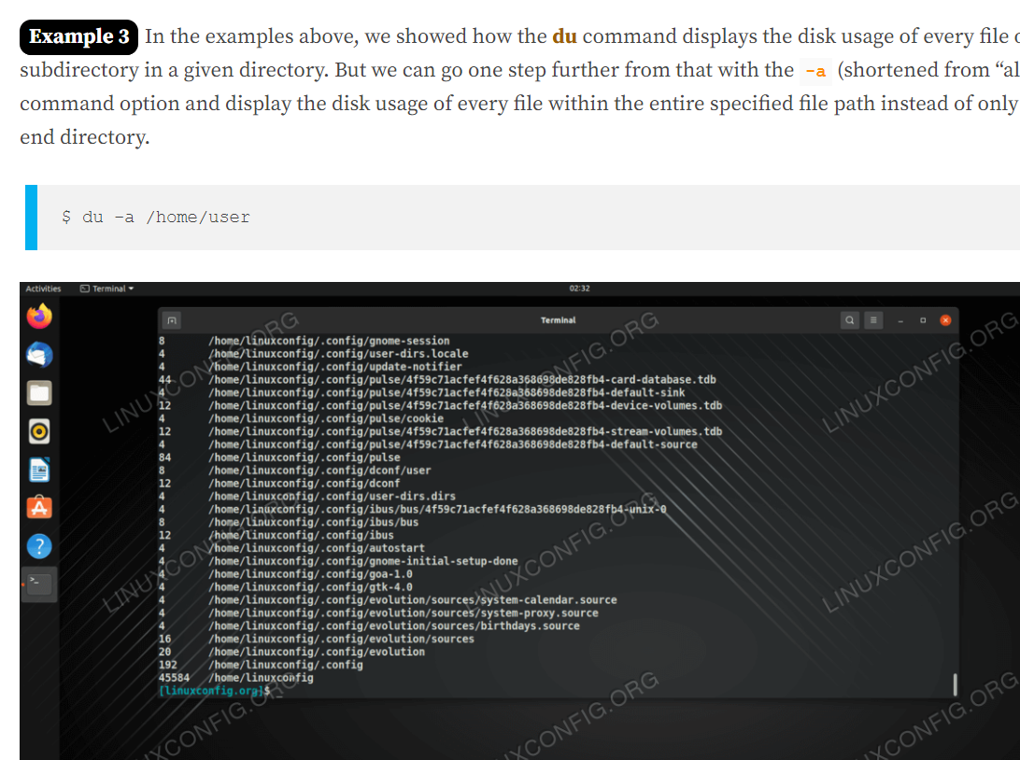

1. **df**

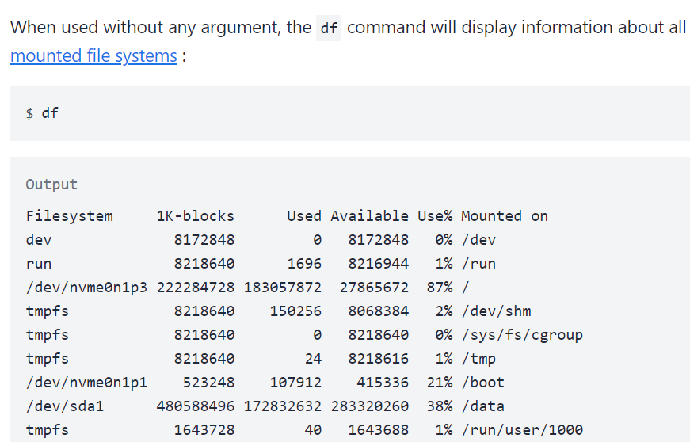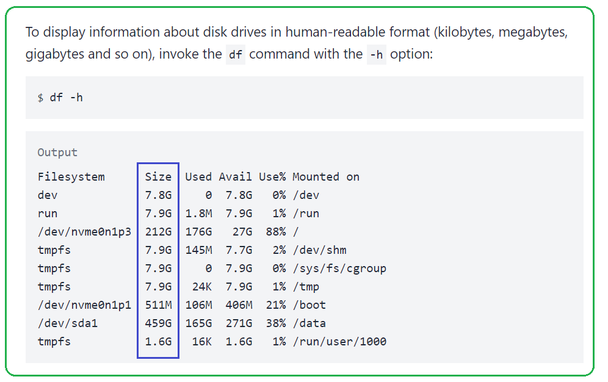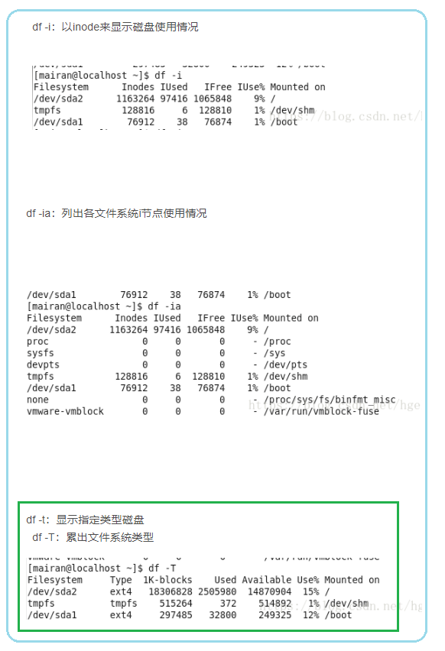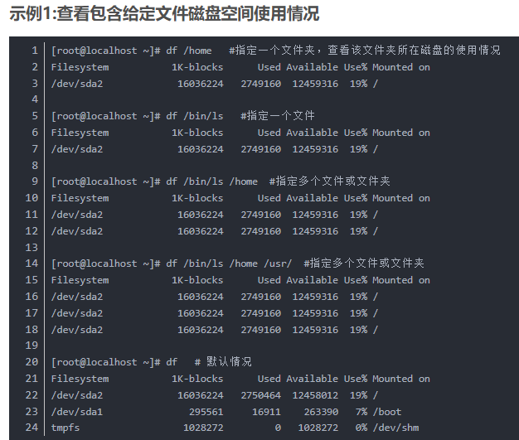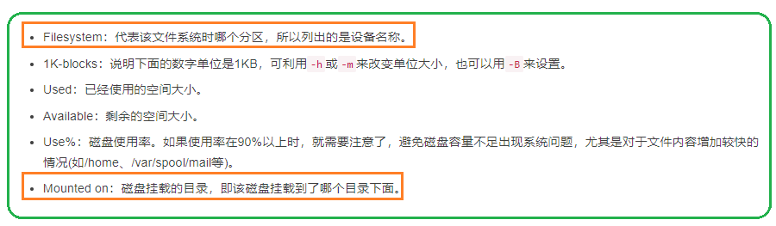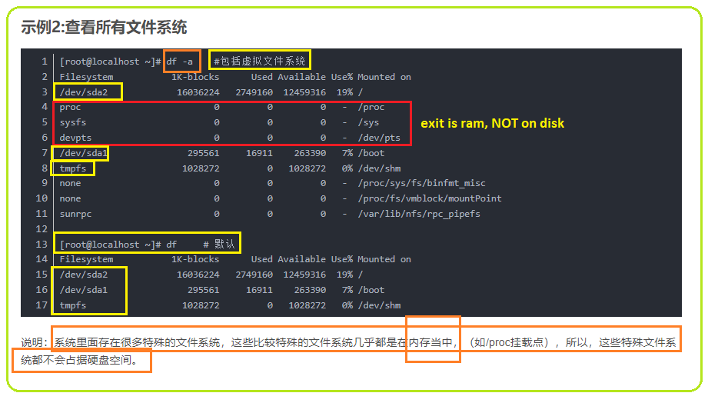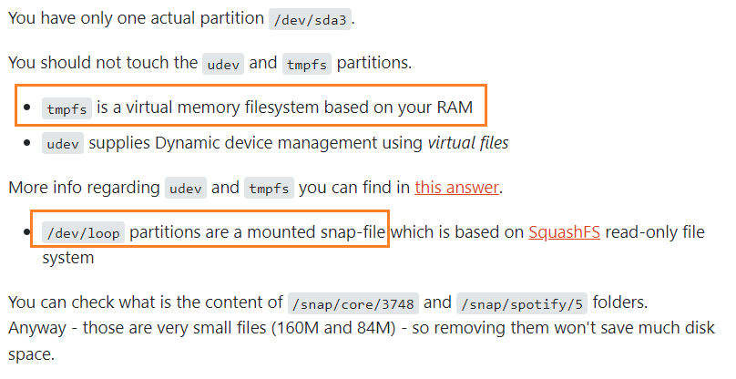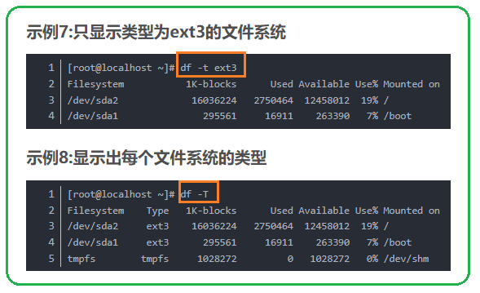

1. **ps**

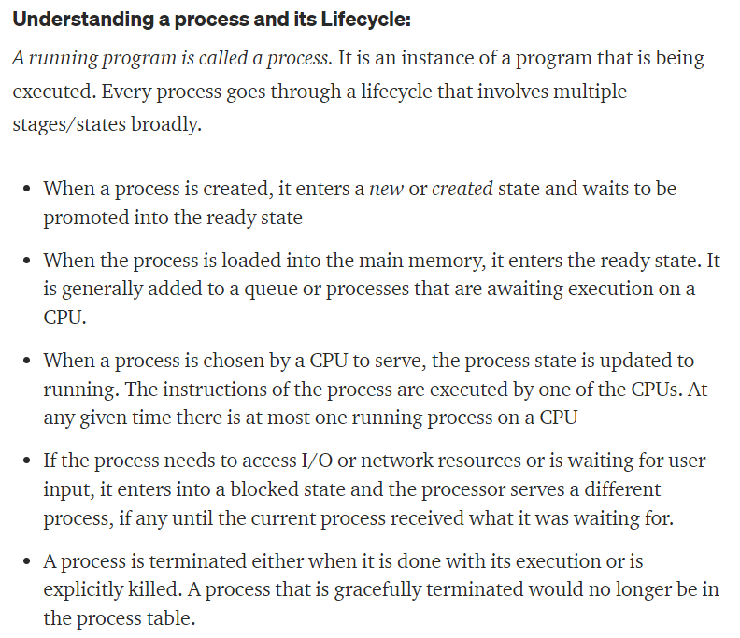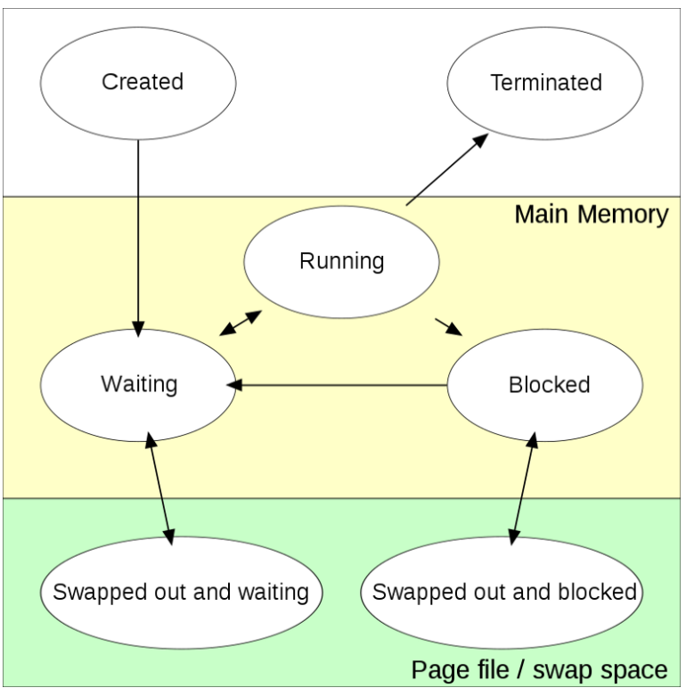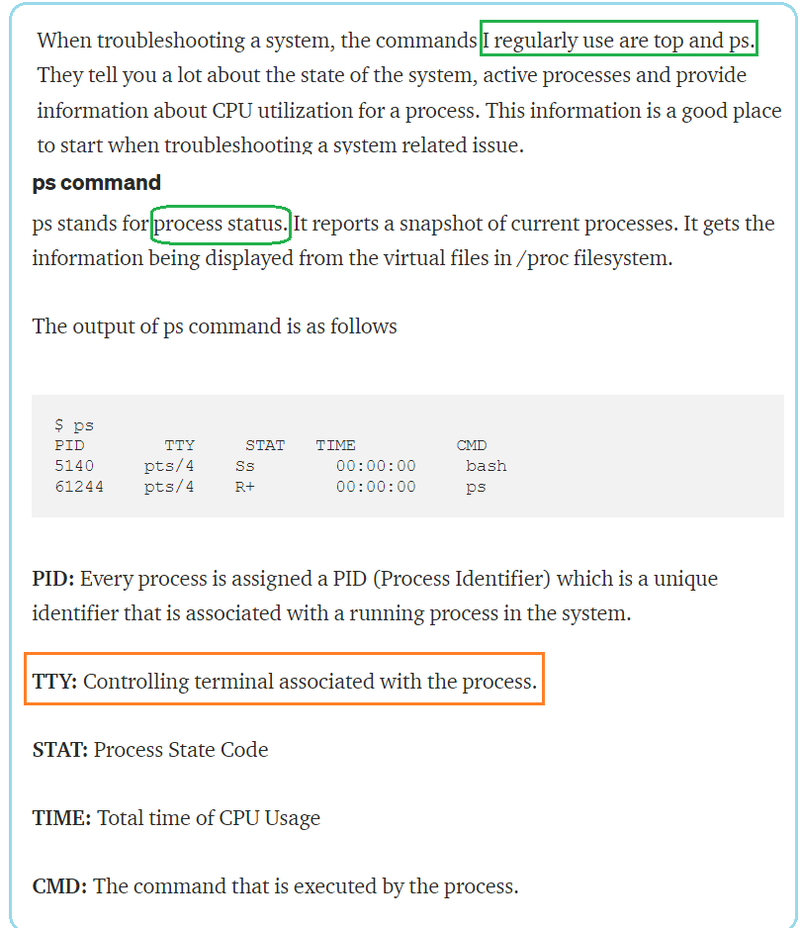

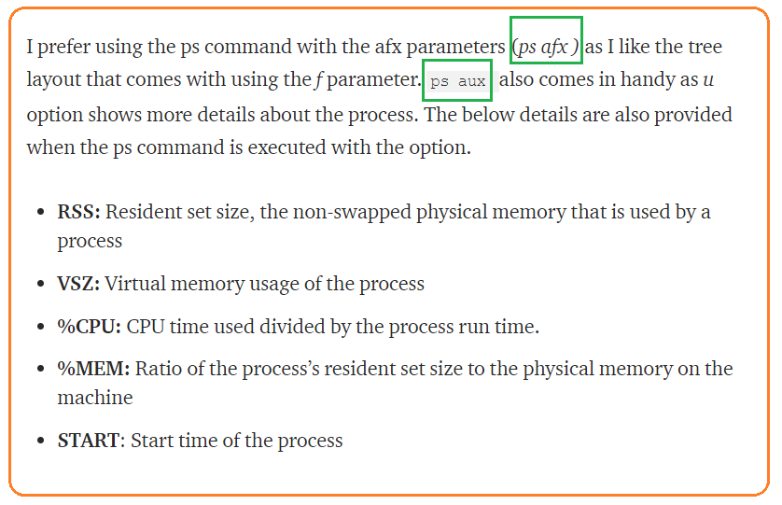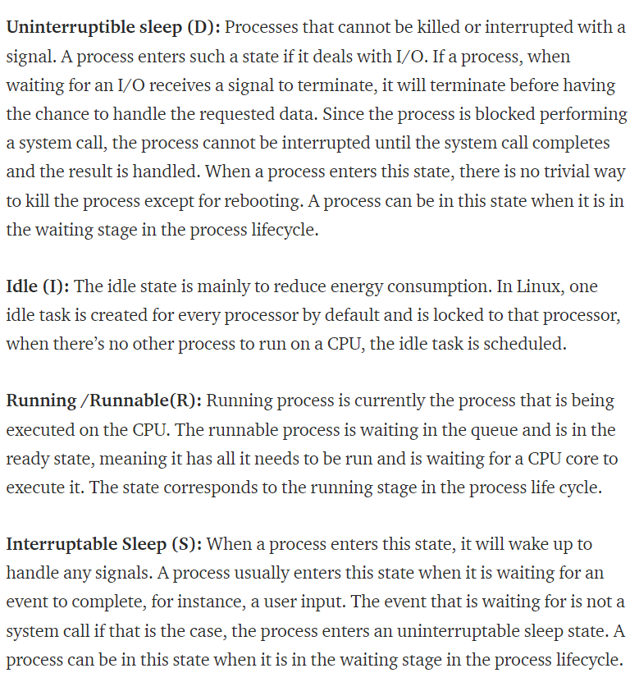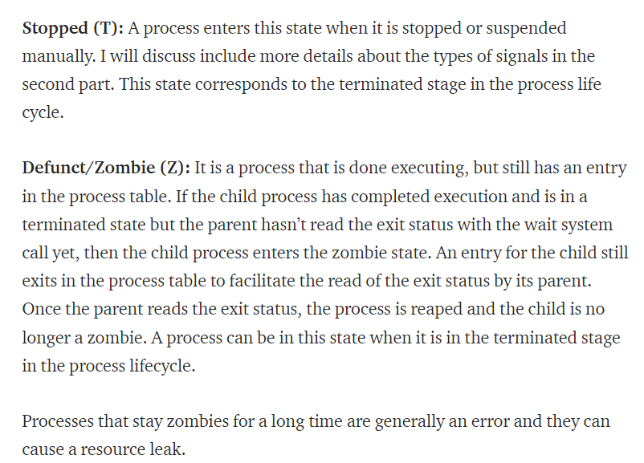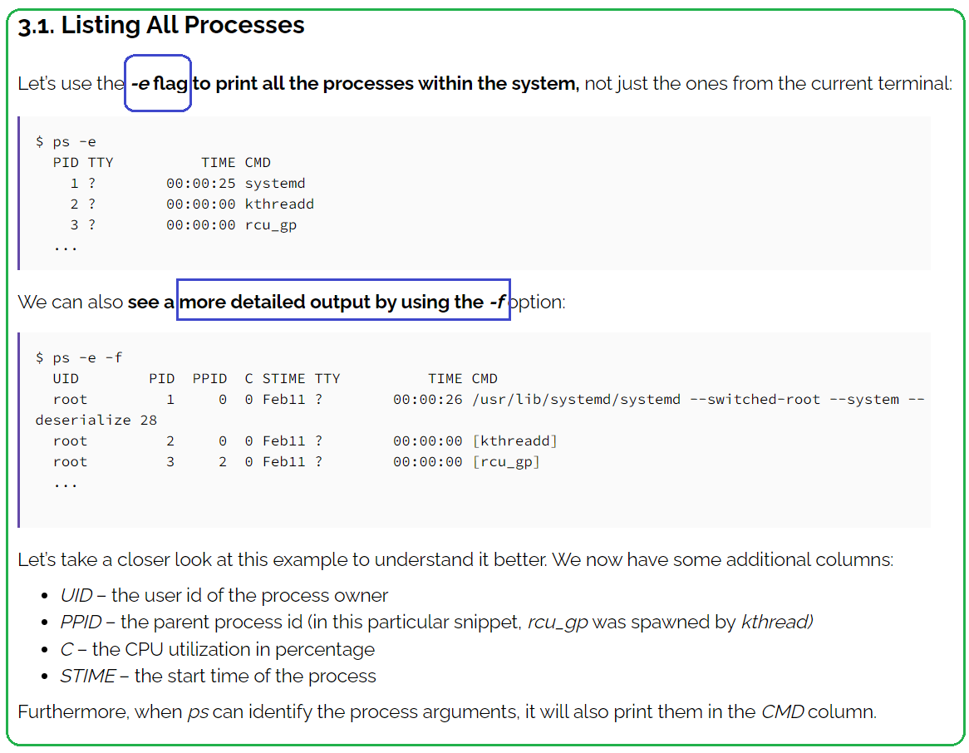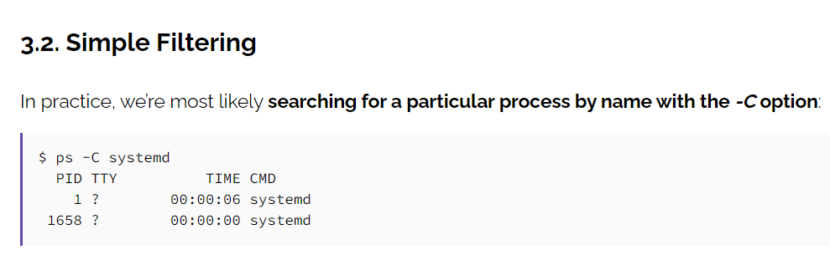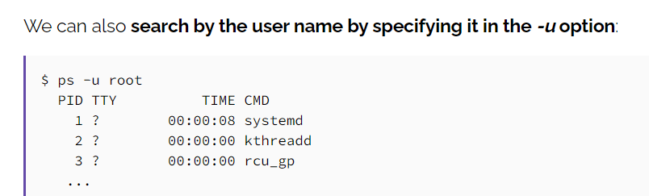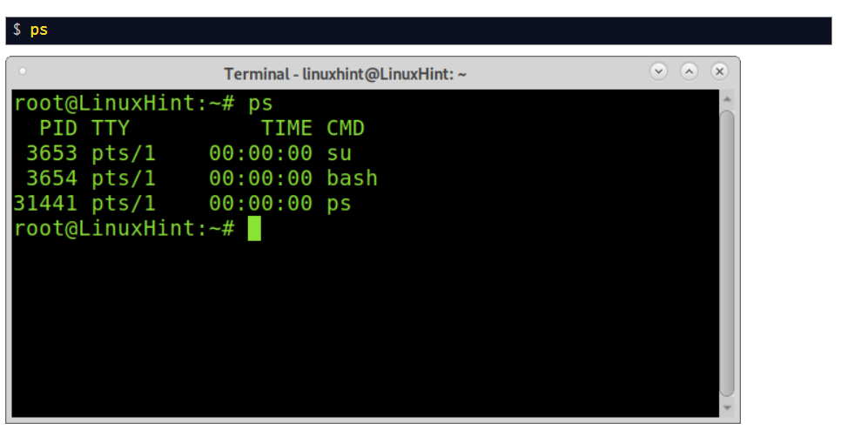If you want to show all users processes you need to add the flag –**ax** as shown below:

*$*ps -ax

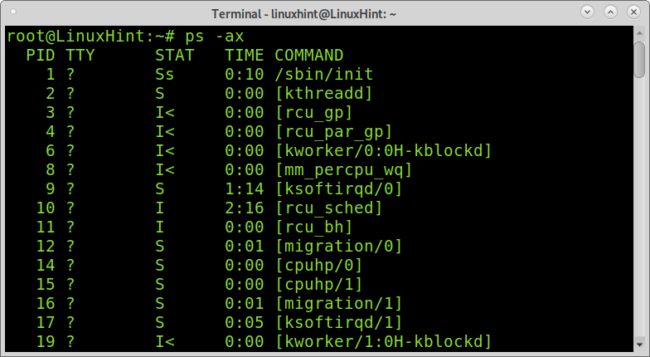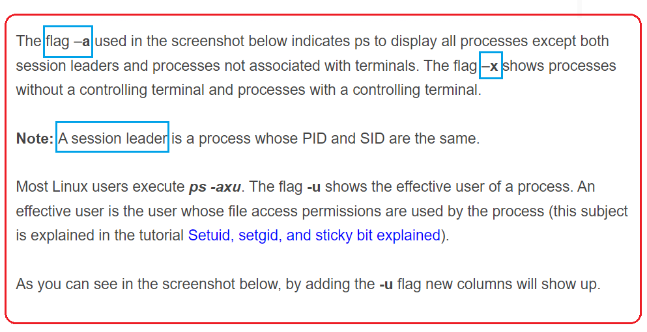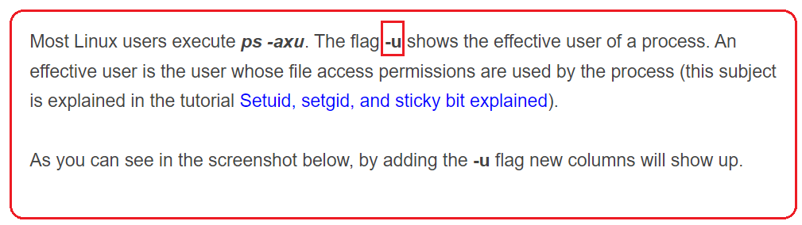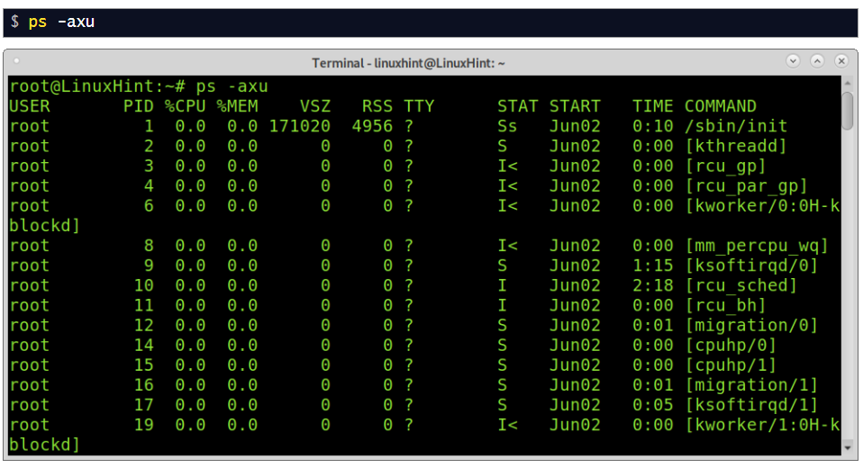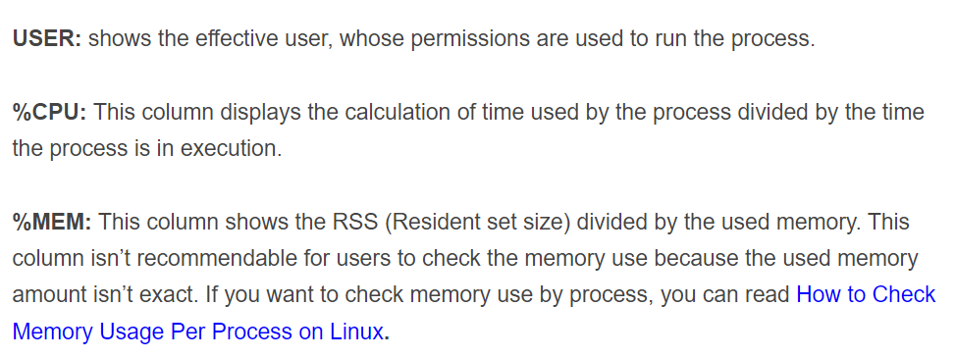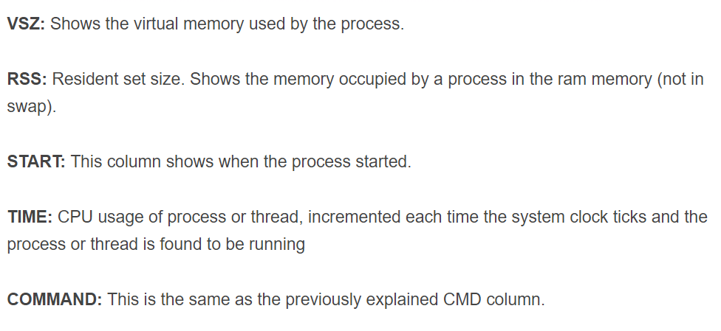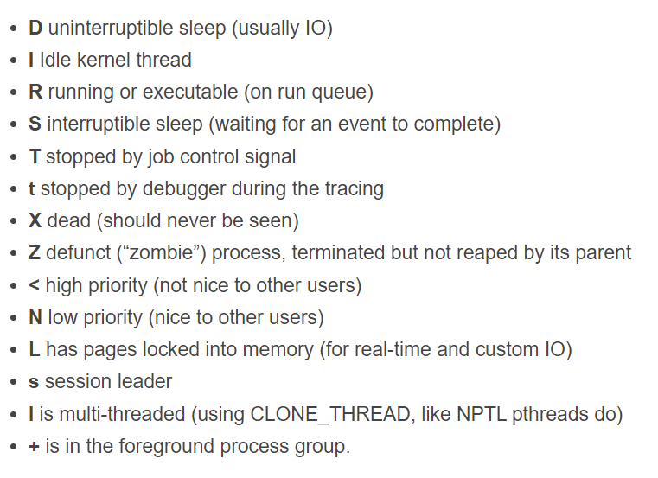

1. **Basic commands**

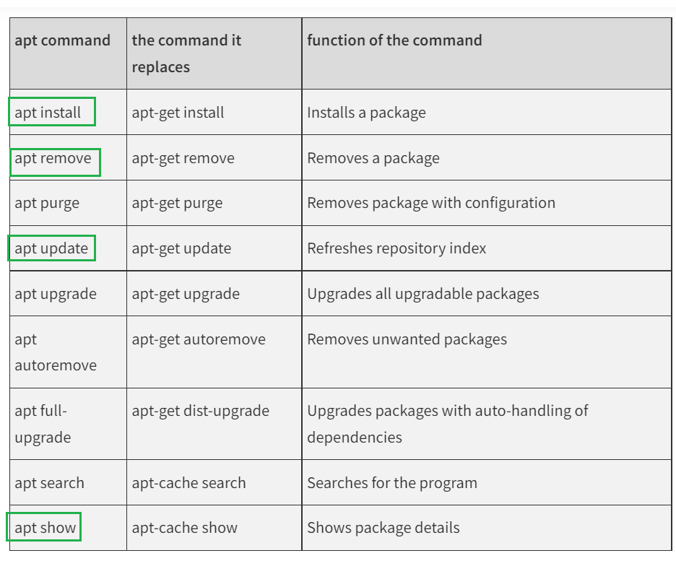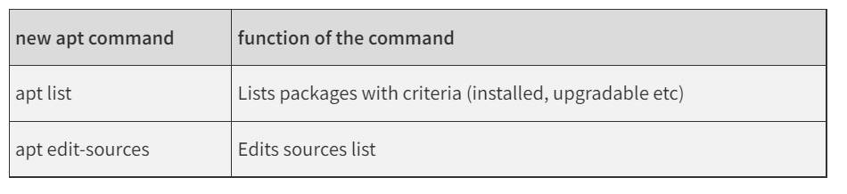

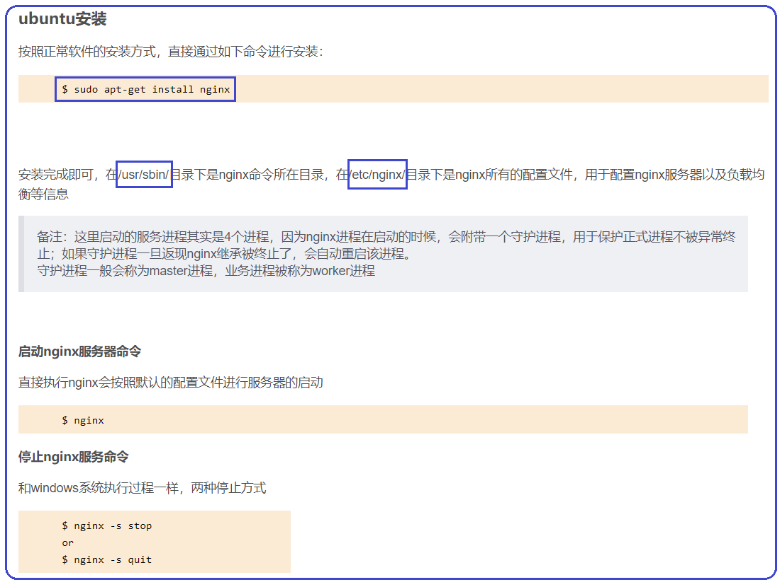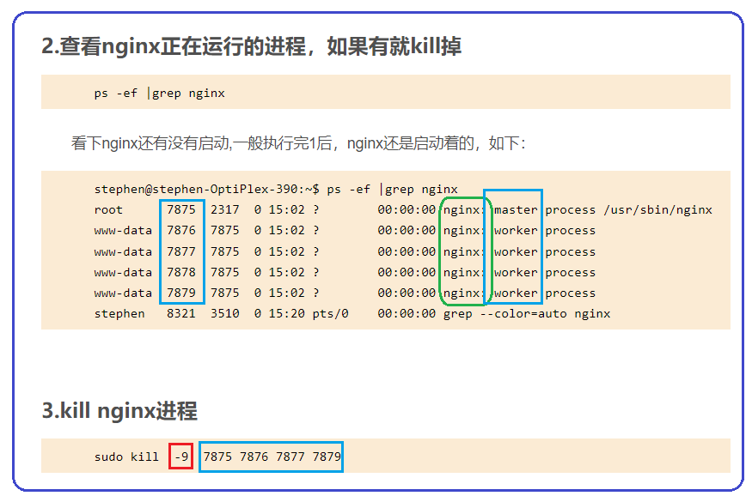

1. **File system**

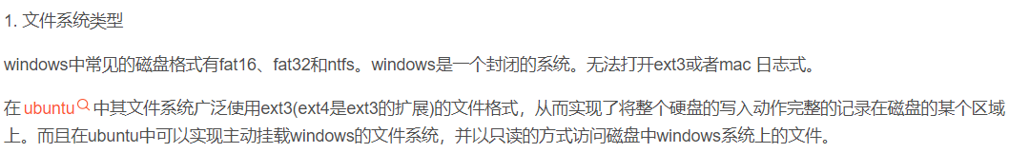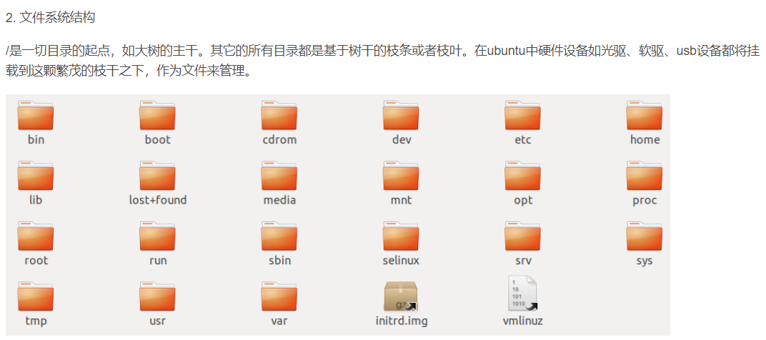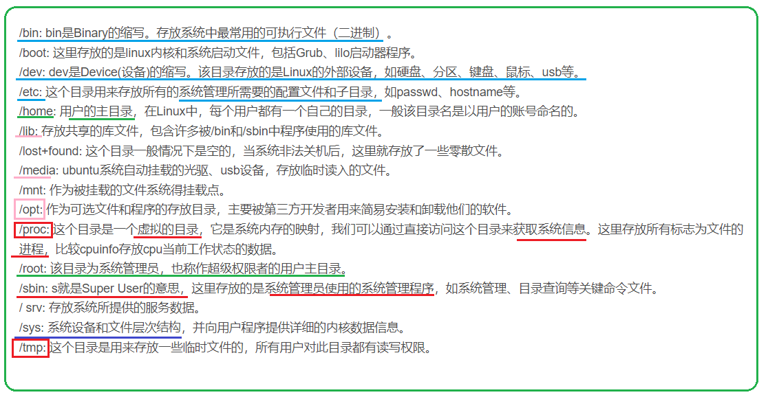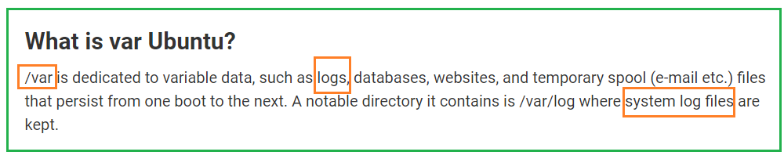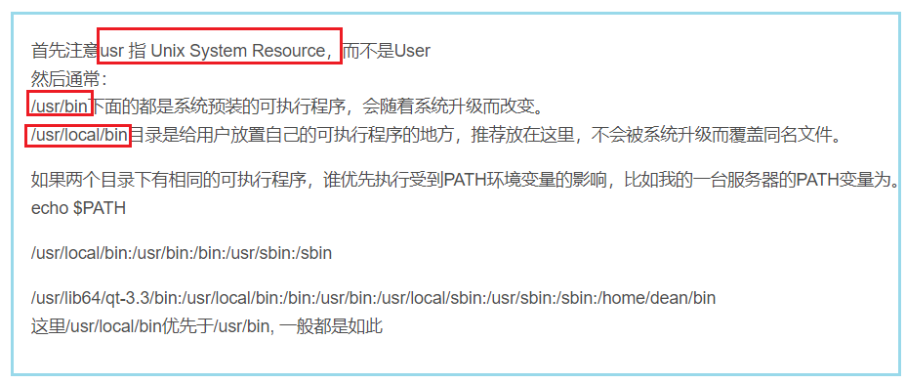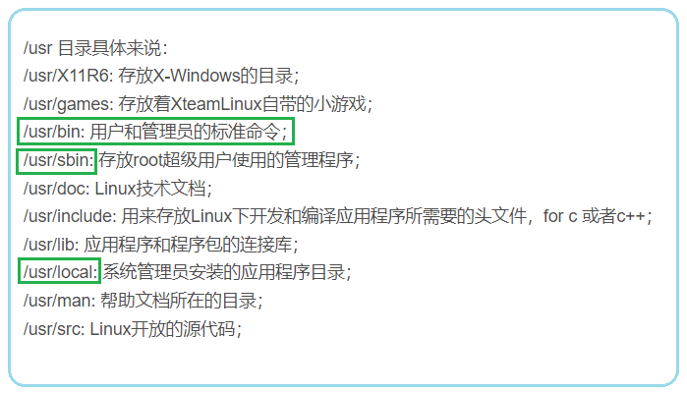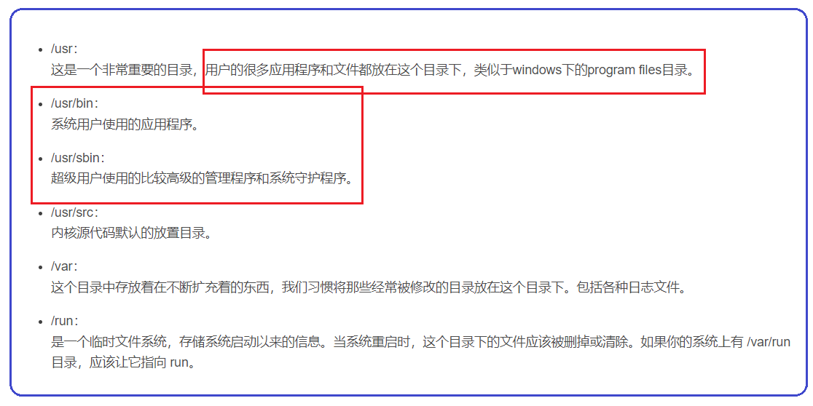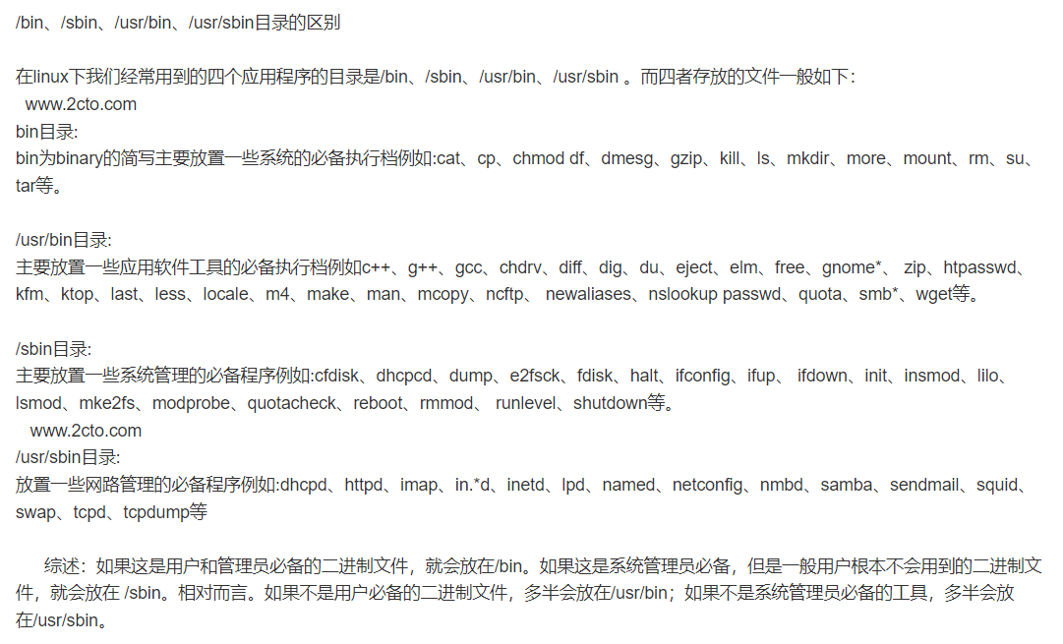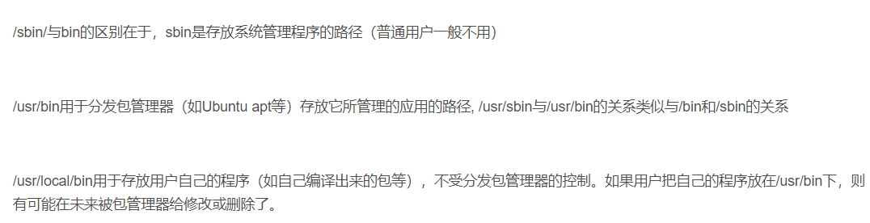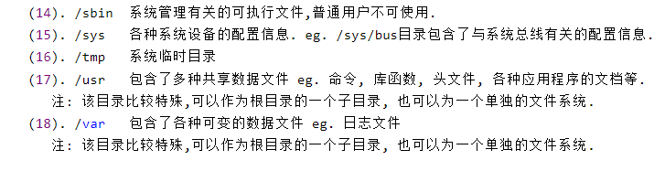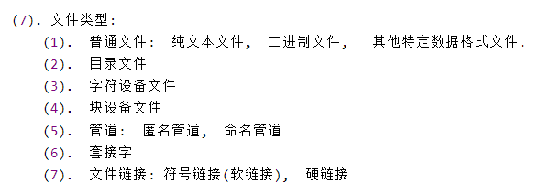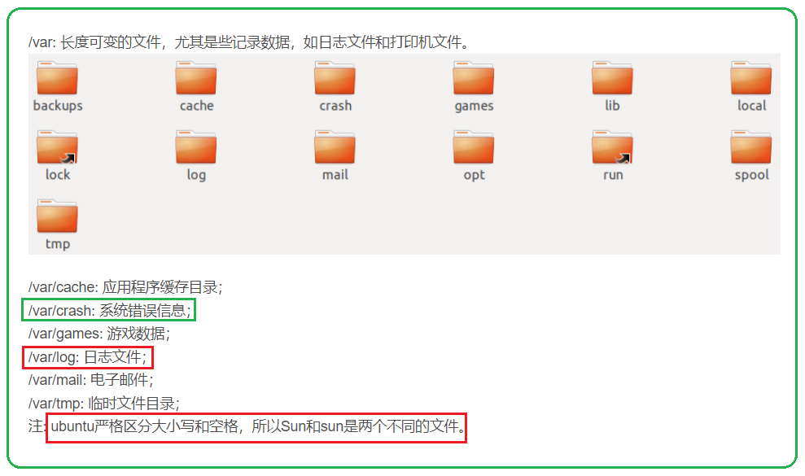

1. **ubuntu设置环境变量**

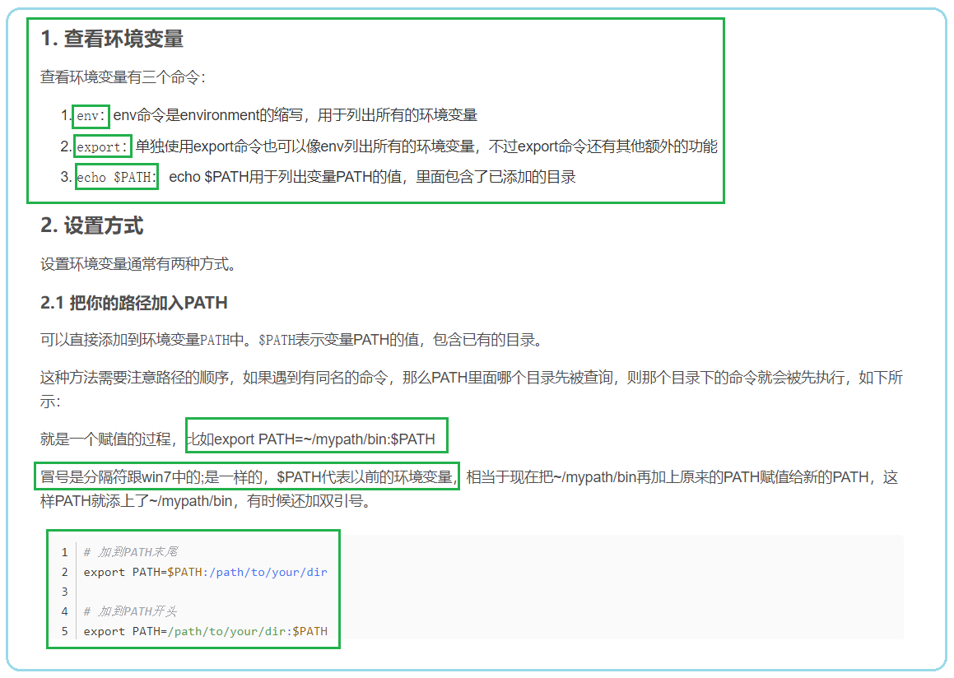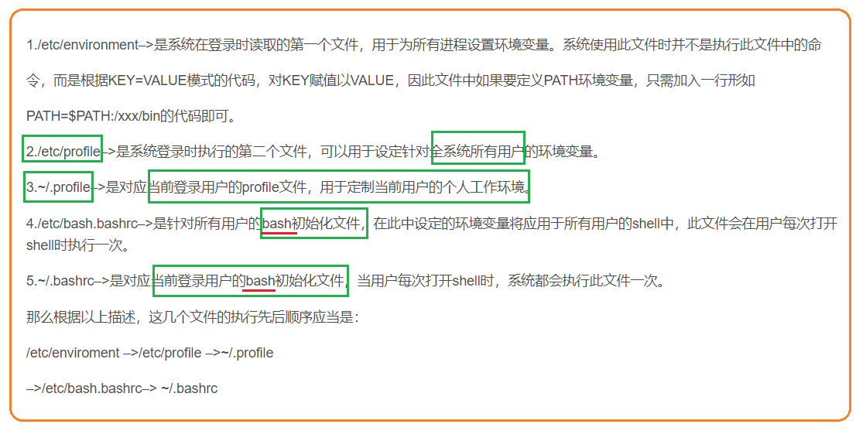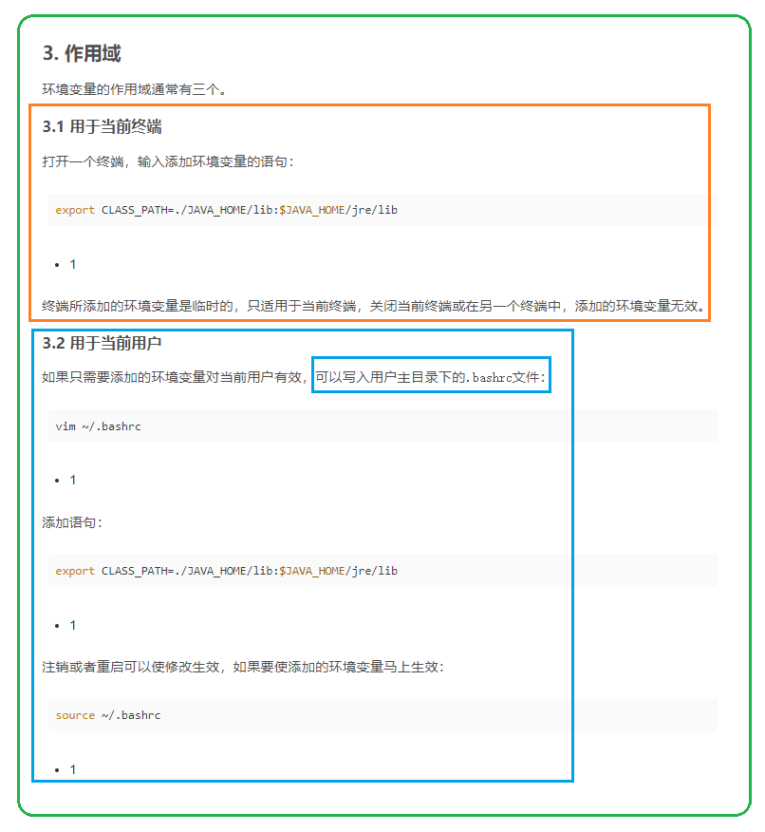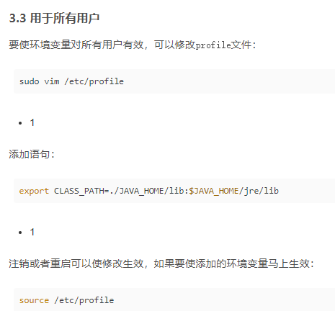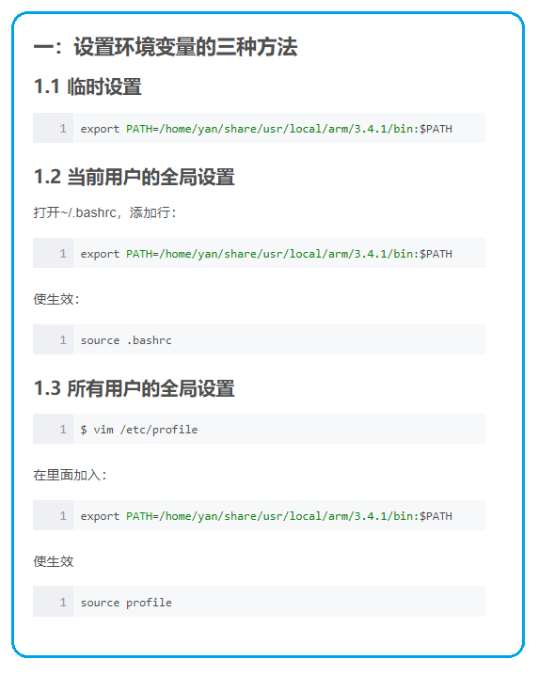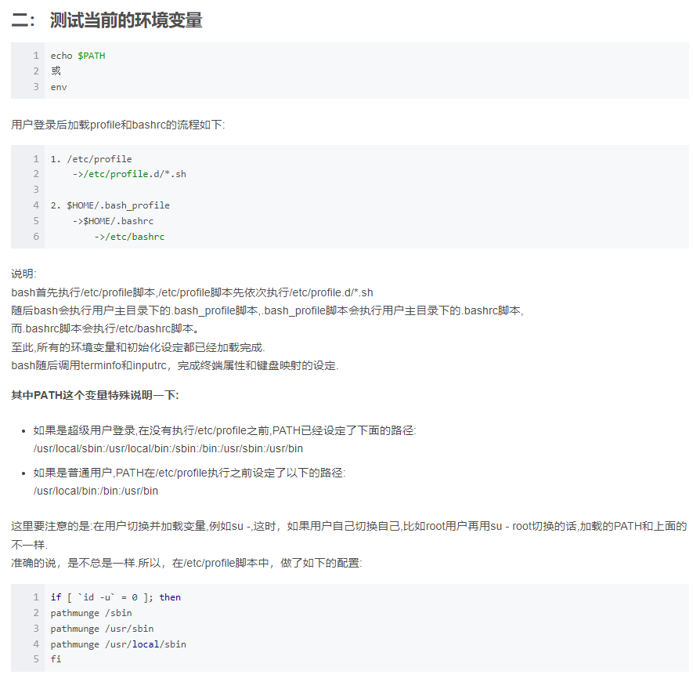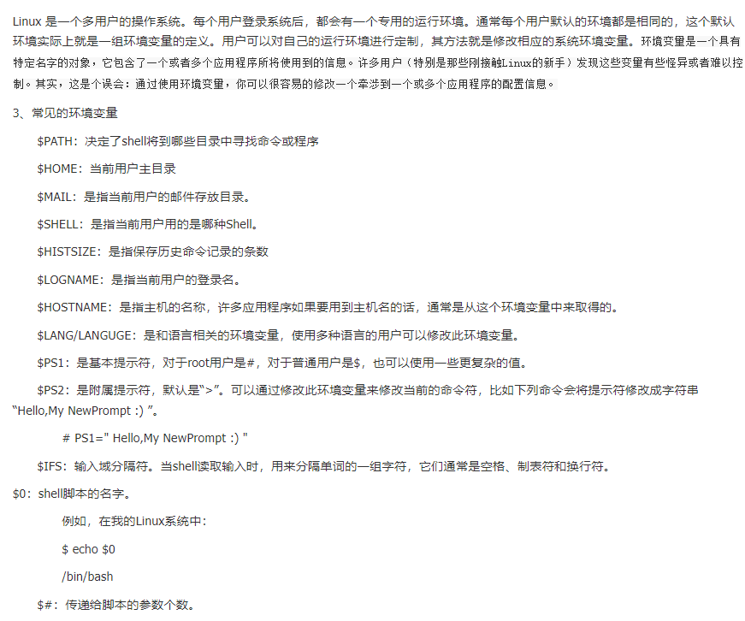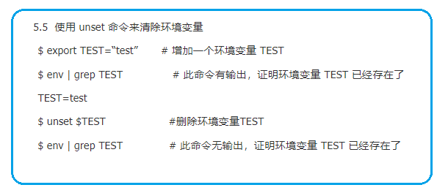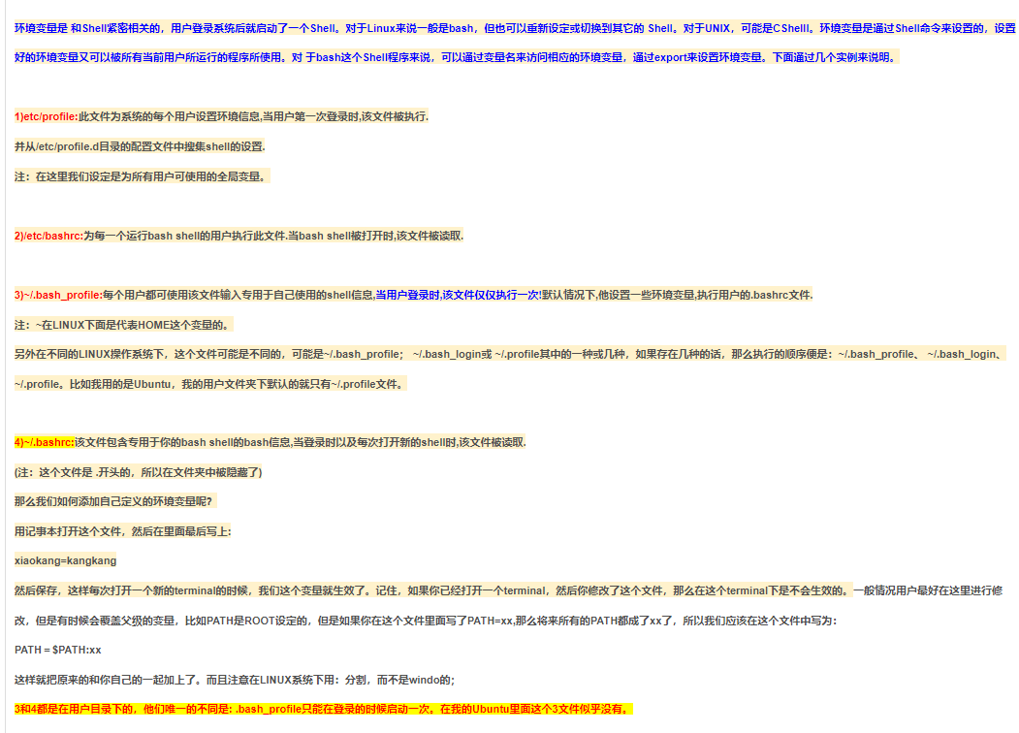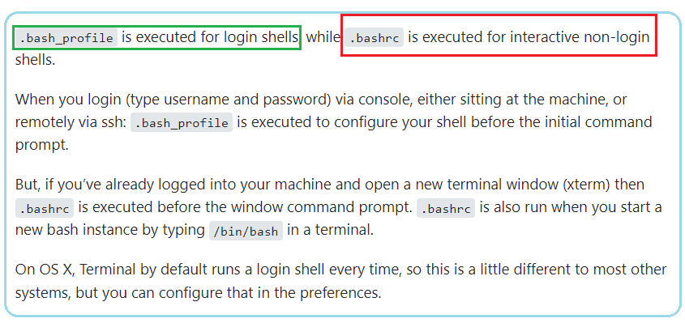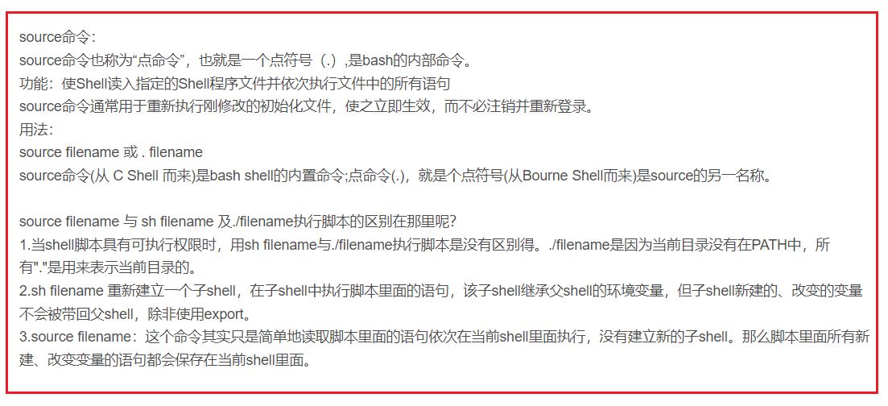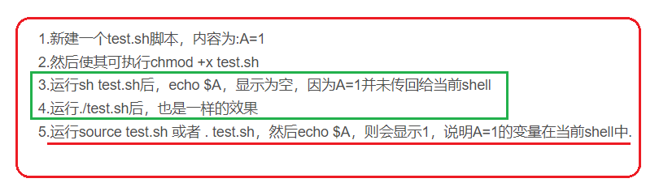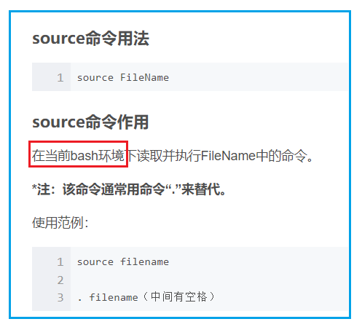

# Linux shell脚本文件的各种执行方式

# 

# 

1. **Echo**
2. **diff, apt-get, echo, file, lsof,last, kill, fork, exec**

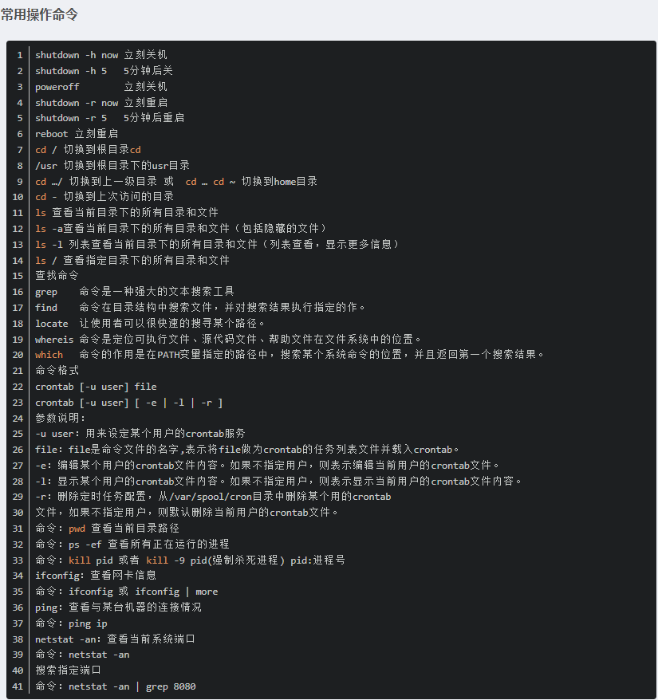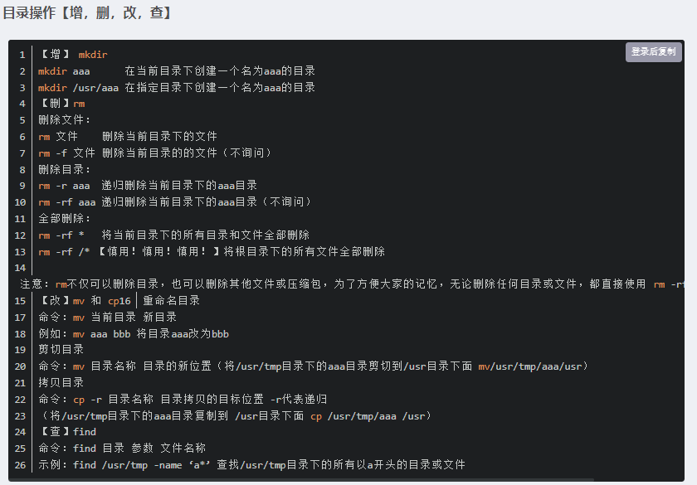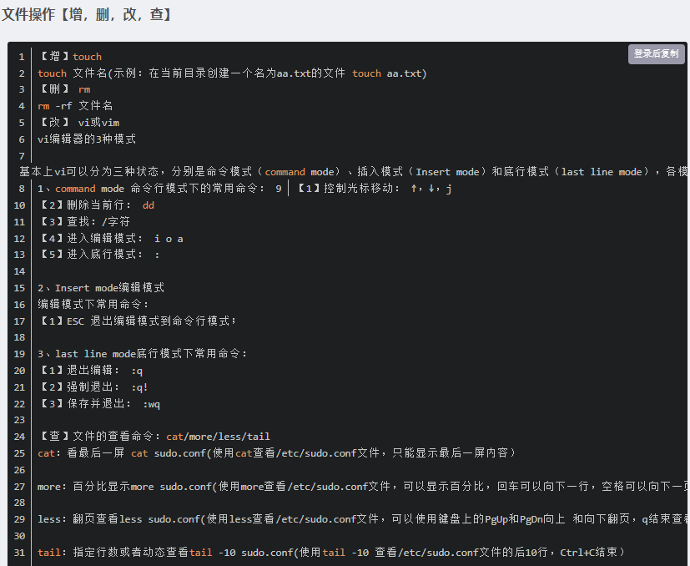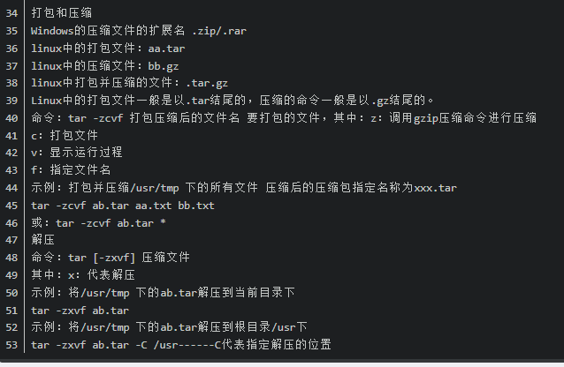

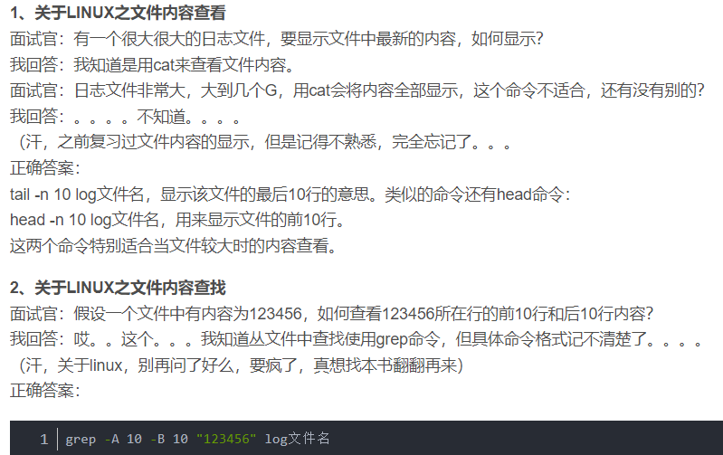

# 软件测试面试linux命令,测试工程师面试经常遇到的linux命令总结

<https://blog.csdn.net/weixin_29988441/article/details/116699289?spm=1001.2101.3001.6650.3&utm_medium=distribute.pc_relevant.none-task-blog-2%7Edefault%7ECTRLIST%7ERate-3.pc_relevant_default&depth_1-utm_source=distribute.pc_relevant.none-task-blog-2%7Edefault%7ECTRLIST%7ERate-3.pc_relevant_default&utm_relevant_index=6>

# 测试开发工程师面试总结（三）——Linux基础篇

<https://blog.csdn.net/sinat_22065775/article/details/106377780?spm=1001.2101.3001.6650.2&utm_medium=distribute.pc_relevant.none-task-blog-2%7Edefault%7ECTRLIST%7ERate-2.pc_relevant_default&depth_1-utm_source=distribute.pc_relevant.none-task-blog-2%7Edefault%7ECTRLIST%7ERate-2.pc_relevant_default&utm_relevant_index=5>

# 软件测试工程师面试突击Linux篇幅

<https://blog.csdn.net/JCY58/article/details/106923180?utm_medium=distribute.pc_relevant.none-task-blog-2~default~baidujs_utm_term~default-1.pc_relevant_default&spm=1001.2101.3001.4242.2&utm_relevant_index=4>

# 软件测试工程师Linux笔试题及答案（三）

https://blog.csdn.net/qq_29914837/article/details/86509420?utm_medium=distribute.pc_relevant.none-task-blog-2~default~baidujs_utm_term~default-0.pc_relevant_default&spm=1001.2101.3001.4242.1&utm_relevant_index=3

1/29

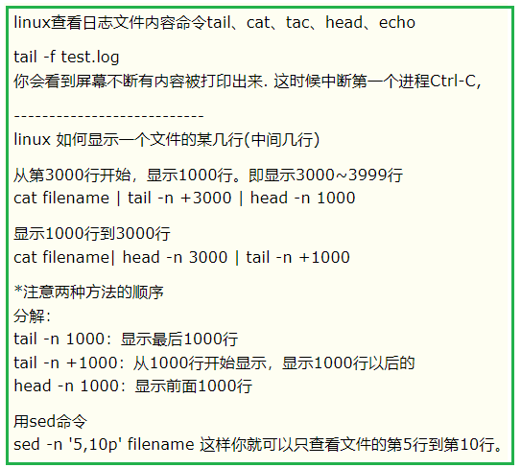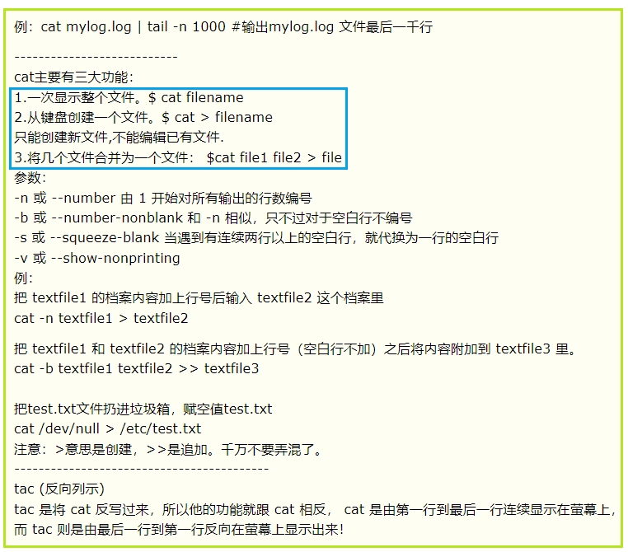-exec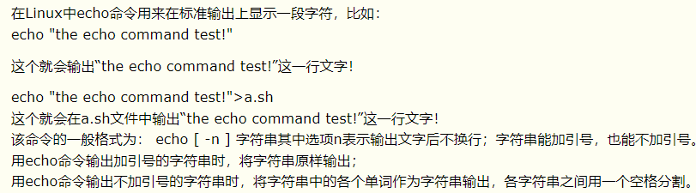

-exec

<https://so.csdn.net/so/search?q=%E6%B5%8B%E8%AF%95%E8%BD%AF%E4%BB%B6%E5%B7%A5%E7%A8%8B%E5%B8%88%E9%9D%A2%E8%AF%95Linux&t=&u=&urw=>

**测试软件工程师面试Linux**

**2021年最强软件测试工程师Linux面试题及答案**

[**https://blog.csdn.net/weixin_53519100/article/details/113437177?ops_request_misc=%257B%2522request%255Fid%2522%253A%2522164332608916780265495326%2522%252C%2522scm%2522%253A%252220140713.130102334.pc%255Fall.%2522%257D&request_id=164332608916780265495326&biz_id=0&utm_medium=distribute.pc_search_result.none-task-blog-2~all~first_rank_ecpm_v1~rank_v31_ecpm-2-113437177.first_rank_v2_pc_rank_v29&utm_term=%E6%B5%8B%E8%AF%95%E8%BD%AF%E4%BB%B6%E5%B7%A5%E7%A8%8B%E5%B8%88%E9%9D%A2%E8%AF%95Linux&spm=1018.2226.3001.4187**](https://blog.csdn.net/weixin_53519100/article/details/113437177?ops_request_misc=%257B%2522request%255Fid%2522%253A%2522164332608916780265495326%2522%252C%2522scm%2522%253A%252220140713.130102334.pc%255Fall.%2522%257D&request_id=164332608916780265495326&biz_id=0&utm_medium=distribute.pc_search_result.none-task-blog-2~all~first_rank_ecpm_v1~rank_v31_ecpm-2-113437177.first_rank_v2_pc_rank_v29&utm_term=%E6%B5%8B%E8%AF%95%E8%BD%AF%E4%BB%B6%E5%B7%A5%E7%A8%8B%E5%B8%88%E9%9D%A2%E8%AF%95Linux&spm=1018.2226.3001.4187)

**linux操作系统测试面试题,软件测试进阶面试题之Linux基础**

[**https://blog.csdn.net/weixin_36102776/article/details/116610574?spm=1001.2101.3001.6650.3&utm_medium=distribute.pc_relevant.none-task-blog-2%7Edefault%7ECTRLIST%7ERate-3.pc_relevant_default&depth_1-utm_source=distribute.pc_relevant.none-task-blog-2%7Edefault%7ECTRLIST%7ERate-3.pc_relevant_default&utm_relevant_index=6**](https://blog.csdn.net/weixin_36102776/article/details/116610574?spm=1001.2101.3001.6650.3&utm_medium=distribute.pc_relevant.none-task-blog-2%7Edefault%7ECTRLIST%7ERate-3.pc_relevant_default&depth_1-utm_source=distribute.pc_relevant.none-task-blog-2%7Edefault%7ECTRLIST%7ERate-3.pc_relevant_default&utm_relevant_index=6)

[**https://blog.csdn.net/weixin_42485712/article/details/108016680?spm=1001.2101.3001.6650.4&utm_medium=distribute.pc_relevant.none-task-blog-2%7Edefault%7ECTRLIST%7ERate-4.pc_relevant_default&depth_1-utm_source=distribute.pc_relevant.none-task-blog-2%7Edefault%7ECTRLIST%7ERate-4.pc_relevant_default&utm_relevant_index=7**](https://blog.csdn.net/weixin_42485712/article/details/108016680?spm=1001.2101.3001.6650.4&utm_medium=distribute.pc_relevant.none-task-blog-2%7Edefault%7ECTRLIST%7ERate-4.pc_relevant_default&depth_1-utm_source=distribute.pc_relevant.none-task-blog-2%7Edefault%7ECTRLIST%7ERate-4.pc_relevant_default&utm_relevant_index=7)

[**https://blog.csdn.net/u012106306/article/details/94722068?utm_medium=distribute.pc_relevant.none-task-blog-2~default~baidujs_baidulandingword~default-0.pc_relevant_default&spm=1001.2101.3001.4242.1&utm_relevant_index=3**](https://blog.csdn.net/u012106306/article/details/94722068?utm_medium=distribute.pc_relevant.none-task-blog-2~default~baidujs_baidulandingword~default-0.pc_relevant_default&spm=1001.2101.3001.4242.1&utm_relevant_index=3)

[**https://blog.csdn.net/qq_36595013/article/details/88389634?spm=1001.2101.3001.6650.2&utm_medium=distribute.pc_relevant.none-task-blog-2%7Edefault%7ECTRLIST%7ERate-2.pc_relevant_default&depth_1-utm_source=distribute.pc_relevant.none-task-blog-2%7Edefault%7ECTRLIST%7ERate-2.pc_relevant_default&utm_relevant_index=5**](https://blog.csdn.net/qq_36595013/article/details/88389634?spm=1001.2101.3001.6650.2&utm_medium=distribute.pc_relevant.none-task-blog-2%7Edefault%7ECTRLIST%7ERate-2.pc_relevant_default&depth_1-utm_source=distribute.pc_relevant.none-task-blog-2%7Edefault%7ECTRLIST%7ERate-2.pc_relevant_default&utm_relevant_index=5)

[**https://blog.csdn.net/weixin_46341320/article/details/106045144?utm_medium=distribute.pc_relevant.none-task-blog-2~default~baidujs_baidulandingword~default-5.pc_relevant_default&spm=1001.2101.3001.4242.4&utm_relevant_index=8**](https://blog.csdn.net/weixin_46341320/article/details/106045144?utm_medium=distribute.pc_relevant.none-task-blog-2~default~baidujs_baidulandingword~default-5.pc_relevant_default&spm=1001.2101.3001.4242.4&utm_relevant_index=8)

[**https://blog.csdn.net/qq_41470573/article/details/104731195?spm=1001.2101.3001.6650.3&utm_medium=distribute.pc_relevant.none-task-blog-2%7Edefault%7EBlogCommendFromBaidu%7ERate-3.pc_relevant_default&depth_1-utm_source=distribute.pc_relevant.none-task-blog-2%7Edefault%7EBlogCommendFromBaidu%7ERate-3.pc_relevant_default&utm_relevant_index=6**](https://blog.csdn.net/qq_41470573/article/details/104731195?spm=1001.2101.3001.6650.3&utm_medium=distribute.pc_relevant.none-task-blog-2%7Edefault%7EBlogCommendFromBaidu%7ERate-3.pc_relevant_default&depth_1-utm_source=distribute.pc_relevant.none-task-blog-2%7Edefault%7EBlogCommendFromBaidu%7ERate-3.pc_relevant_default&utm_relevant_index=6)

[**https://blog.csdn.net/hailang2ll/article/details/104529036?utm_medium=distribute.pc_relevant.none-task-blog-2~default~baidujs_baidulandingword~default-0.pc_relevant_default&spm=1001.2101.3001.4242.1&utm_relevant_index=3**](https://blog.csdn.net/hailang2ll/article/details/104529036?utm_medium=distribute.pc_relevant.none-task-blog-2~default~baidujs_baidulandingword~default-0.pc_relevant_default&spm=1001.2101.3001.4242.1&utm_relevant_index=3)

[**https://blog.csdn.net/qq_43523503/article/details/108934818?spm=1001.2101.3001.6650.6&utm_medium=distribute.pc_relevant.none-task-blog-2%7Edefault%7ELandingCtr%7EHighlightScore-6.queryctrv2&depth_1-utm_source=distribute.pc_relevant.none-task-blog-2%7Edefault%7ELandingCtr%7EHighlightScore-6.queryctrv2&utm_relevant_index=9**](https://blog.csdn.net/qq_43523503/article/details/108934818?spm=1001.2101.3001.6650.6&utm_medium=distribute.pc_relevant.none-task-blog-2%7Edefault%7ELandingCtr%7EHighlightScore-6.queryctrv2&depth_1-utm_source=distribute.pc_relevant.none-task-blog-2%7Edefault%7ELandingCtr%7EHighlightScore-6.queryctrv2&utm_relevant_index=9)

[**https://blog.csdn.net/qq_38271800/article/details/90401139?spm=1001.2101.3001.6650.9&utm_medium=distribute.pc_relevant.none-task-blog-2%7Edefault%7EBlogCommendFromBaidu%7EHighlightScore-9.queryctrv2&depth_1-utm_source=distribute.pc_relevant.none-task-blog-2%7Edefault%7EBlogCommendFromBaidu%7EHighlightScore-9.queryctrv2&utm_relevant_index=12**](https://blog.csdn.net/qq_38271800/article/details/90401139?spm=1001.2101.3001.6650.9&utm_medium=distribute.pc_relevant.none-task-blog-2%7Edefault%7EBlogCommendFromBaidu%7EHighlightScore-9.queryctrv2&depth_1-utm_source=distribute.pc_relevant.none-task-blog-2%7Edefault%7EBlogCommendFromBaidu%7EHighlightScore-9.queryctrv2&utm_relevant_index=12)

**https://blog.csdn.net/weixin_42139375/article/details/82749823?utm_medium=distribute.pc_relevant.none-task-blog-2~default~baidujs_baidulandingword~default-1.pc_relevant_default&spm=1001.2101.3001.4242.2&utm_relevant_index=4**